UNITED STATES
SECURITIES AND EXCHANGE COMMISSION
Washington, D.C. 20549

FORM 6-K

Report of Foreign Private Issuer
Pursuant to Rule 13a-16 or 15d-16 of
the Securities Exchange Act of 1934

For the month of September 2025

Commission File No. 001-42797

BULLISH

10A Building A, 60 Nexus Way, Camana Bay,
George Town, Grand Cayman, Cayman Islands, KY1-9005
(Address of principal executive office)

Indicate by check mark whether the registrant files or will file annual reports under cover of Form 20-F or Form 40-F.

Form 20-F ☒ Form 40-F ☐

INFORMATION CONTAINED IN THIS REPORT ON FORM 6-K

On September 17, 2025, Bullish issued a press release titled “Bullish Reports Second Quarter 2025 Results.” A copy of the press release, the unaudited second quarter 2025 results and the earnings presentation are furnished as Exhibits 99.1, 99.2 and 99.3, respectively, to this report on Form 6-K.

Incorporation By Reference

The unaudited condensed consolidated statements of profit or loss and other comprehensive income/(loss), unaudited condensed consolidated balance sheets, unaudited condensed consolidated statements of changes in equity and unaudited condensed consolidated statements of cash flows attached as Exhibit 99.2 to this report on Form 6-K are hereby incorporated by reference into Bullish’s registration statement on Form S-8 (Registration No. 333- 289553) (including any prospectuses forming a part of such registration statement), to be a part thereof from the date on which this report is submitted, to the extent not superseded by documents or reports subsequently filed or furnished.

INDEX TO EXHIBITS

Exhibit No. | Description
99.1 | Bullish Reports Second Quarter 2025 Results
99.2 | Second Quarter 2025 Unaudited Condensed Consolidated Financial Statements
99.3 | Second Quarter 2025 Earnings Presentation

SIGNATURES

Pursuant to the requirements of the Securities Exchange Act of 1934, the registrant has duly caused this report to be signed on its behalf by the undersigned, thereunto duly authorized.

 | BULLISH
Date: September 17, 2025 | By: | /s/ David W. Bonanno
 |  | David W. Bonanno
 |  | Chief Financial Officer

Exhibit 99.1

Bullish Reports Second Quarter 2025 Results

 | ● | Bullish obtains New York DFS BitLicense, unlocking Q4’2025 US market entry
 | ● | Q2’2025 Digital asset sales of $58.6 billion and net income of $108.3 million
 | ● | Q2’2025 Adjusted Revenue of $57.0 million and Adjusted EBITDA of $8.1 million
 | ● | Q3’2025 Adjusted Revenue Guidance of $69.0 to $76.0 million and Adjusted EBITDA of $25.0 to $28.0 million

Cayman Islands, September 17, 2025 – Bullish (NYSE: BLSH), an institutionally focused global digital asset platform that provides market infrastructure and information services, today announced financial results for the second quarter ended June 30, 2025.

Tom Farley, CEO: ”We are pleased with our results for the quarter - we saw exciting liquidity services growth, executed on a successful Consensus conference, and prepared for what would be a successful IPO. We’re excited that the work we did in the second quarter is already directly contributing to strong business momentum in the third quarter and beyond. Our recent receipt of the prestigious New York DFS Bitlicense is testament to our institutional rigor and truly global reach.”

David Bonanno, CFO: "We believe that our first quarterly earnings report as a public company demonstrates the resilience of our business model and the importance of revenue diversification. We are excited to welcome our new public shareholders and look forward to updating you on our progress going forward."

Q2 2025 Financial Highlights

All amounts compared to Q2 2024

 | - | Digital asset sales were $58.6 billion vs. $49.6 billion
 | - | Net income (loss) was $108.3 million or $0.93 per diluted share vs. $(116.4) million or $(1.03) per diluted share
 | - | Adjusted revenue (non-IFRS) was $57.0 million vs. $60.7 million
 | - | Adjusted transaction revenue (non-IFRS) was $24.1 million vs. $34.9 million
 | - | Adjusted net income (non-IFRS) was $(6.0) million vs. $4.8 million
 | - | Adjusted EBITDA (non-IFRS) was $8.1 million vs. $14.7 million

Q2 2025 Key Business Metrics

All amounts compared to Q2 2024

 | - | Trading volume totaled $179.6 billion vs. $133.0 billion
 | - | Average daily volume totaled 1.974 billion vs. 1.462 billion
 | - | Average trading spread of 1.3 bps vs. 2.6 bps

Business Highlights

 | - | Expanded Regulatory Footprint: Secured the prestigious New York DFS Bitlicense in September 2025, becoming only the third entity to receive both the Bitlicense and the New York MTL since 2023. This approval, along with the recent MiCA license uplift in the EU, and our Hong Kong SFC licenses, gives Bullish a truly global regulatory footprint which complements our one global order book.
 | - | Strong and Diversified Revenue Growth: Subscription, Services and Other (SS&O) revenue grew to $32.9 million in Q2, representing a 61.4% sequential increase and 27.4% year-over-year growth.
 | - | Significant Client Wins and Cross-Selling Success: Signed multi-year, multi-product agreements with high-profile partners like Igloo Inc., the owner of Pudgy Penguins. The partnership leverages the company's liquidity services, CoinDesk Data, and Insights offerings, showcasing the power of the business's cross-sell strategy and a "flight to quality" among institutional clients.
 | - | Robust Information Services Growth: CoinDesk Indices ended the quarter with $41 billion in assets under management (AUM), an increase of over $9 billion from Q1. This growth, along with a newly launched stablecoin benchmark interest rate, CoinDesk Overnight Rates, underscores the value of our information services offering.
 | - | Strategic Product Development and Launch: Progressed well towards an anticipated full launch of the options trading platform in Q4, which is already in a limited mobilization phase with select clients.

Q3 2025 Guidance

To give investors insight into our business and expectations, management is providing the following guidance for the third quarter 2025:

 | - | Trading Volume of $133.0 billion to $142.0 billion
 | - | Adjusted Transaction Revenue (non-IFRS) of $25.5 million to $28.0 million
 | - | Subscriptions, Services & Other Revenue (non-IFRS) of $43.5 million to $48.0 million
 | - | Adjusted EBITDA (non-IFRS) of $25.0 million to $28.0 million
 | - | Adjusted Net Income (non-IFRS) of $12.0 million to $17.0 million

Conference Call Webcast and Q&A Information

Bullish will host a call to discuss its results at 5:30 p.m. ET today. The live webcast can be accessed at investors.bullish.com, along with supplemental slides. Following the call, a replay and transcript will be available at investors.bullish.com.

About Bullish

Bullish is an institutionally focused global digital asset platform that provides market infrastructure and information services. These include: Bullish Exchange – a regulated and institutionally focused digital assets spot and derivatives exchange, integrating a high-performance central limit order book matching engine with automated market making to provide deep and predictable liquidity. Bullish Exchange is regulated in the United States, Germany, Hong Kong, and Gibraltar. CoinDesk Indices – a collection of tradable proprietary and single-asset benchmarks and indices that track the performance of digital assets for global institutions in the digital assets and traditional finance industries. CoinDesk Data – a broad suite of digital assets market data and analytics, providing real-time insights into prices, trends, and market dynamics. CoinDesk Insights – a digital asset media and events provider and operator of Coindesk.com, a digital media platform that covers news and insights about digital assets, the underlying markets, policy, and blockchain technology. For more information, please visit bullish.com and follow LinkedIn and X.

Use of Websites to Distribute Material Company Information

We use the Bullish Investor Relations website (investors.bullish.com) and our X account (x.com/bullish) to publicize information relevant to investors, including information that may be deemed material, in addition to filings we make with the U.S. Securities and Exchange Commission (SEC) and press releases. We encourage investors to regularly review the information posted on our website and X account in addition to our SEC filings and press releases to be informed of the latest developments.

Contacts

Media: media@bullish.com

Investor Relations: investors@bullish.com

Source: Bullish

Non-IFRS financial measures and key performance indicators

This communication includes certain financial measures that are not recognized by the International Financial Reporting Standards (“IFRS”). These non-IFRS financial measures are “adjusted transaction revenue,” “adjusted revenue,” “adjusted net income (loss)” and “adjusted EBITDA,” “gross liquid assets” and “net liquid assets”, and “adjusted operating expense.” These non-IFRS financial measures should not be considered in isolation or as an alternative to net income, cash flows from operations or other measures of profitability, liquidity or performance under IFRS. We believe these non-IFRS financial measures provide useful information to management and investors regarding certain financial and business trends. These non-IFRS financial measures are subject to inherent limitations as they reflect the exercise of judgments about which items of expense and income are excluded or included in determining these non-IFRS financial measures. Refer to the section “Reconciliation of Non-IFRS Measures” for further details and a reconciliation of the non-IFRS financial measures presented to their most directly comparable IFRS financial measures.

This communication also provides our forward-looking “adjusted transaction revenue,” “subscription, services & other revenue,” “adjusted EBITDA,” and “adjusted net income” guidance for the upcoming fiscal quarter. Information reconciling upcoming fiscal quarter “adjusted transaction revenue,” “subscription, services & other revenue,” “adjusted EBITDA,” and “adjusted net income” to their most directly comparable IFRS financial measures is unavailable to us without unreasonable effort due to the high variability, complexity and lack of visibility in making accurate forecasts and projections to certain reconciling items. These items cannot be reasonably and accurately predicated without the investment of undue time, costs and other resources, and accordingly, no reconciliation of the forward-looking non-IFRS financial measures is included. These reconciling items could be material to our actual results for the period.

In addition, management is providing forward-looking guidance on the following key performance indicator, Trading Volume, for the upcoming fiscal quarter. Refer to the section “Definitions of Certain Metrics” in this communication for definitions of key performance indicators.

Forward-Looking Statements

This communication contains “forward-looking statements” within the meaning of the Private Securities Litigation Reform Act of 1995. Sentences containing words such as “believe,” “intend,” “plan,” “may,” “expect,” “should,” “could,” “anticipate,” “estimate,” “predict,” “project,” or their negatives, or other similar expressions of a future or forward-looking nature generally should be considered forward-looking statements. Such statements include, without limitation, statements relating to our expected financial or operating performance, including for the upcoming fiscal quarter; our business strategy and potential market opportunities; current and prospective products, services or acquisitions; trends in, demand for, and growth and market size of, the digital assets industry; expectations regarding relationships with clients and third-party business partners; competition in our industry; the regulatory and legal environment, including regulatory proceedings or approvals; and general economic and business conditions. Such forward-looking statements are based upon estimates and assumptions that, while considered reasonable by us, are inherently uncertain and are subject to risks, uncertainties, and other factors which could cause actual results to differ materially from those expressed or implied by such forward-looking statements. Factors that may cause results to differ from those expressed in our forward-looking statements include, but are not limited to intense competition in our industry, including from unregulated and less-regulated entities and platforms; our ability to execute our business strategy and grow our business and operations, including in new geographic locations; our ability to develop, launch and improve our products and services and their adoption; our ability to attract and retain customers; the evolving rules and regulations applicable to digital assets and our products and services; our ability to obtain and maintain regulatory approvals and stay in compliance with laws and regulations, and the costs of doing so; evolution and adoption of digital assets; interest rate fluctuations and digital asset price volatility; changes in, or unexpected, costs to operate our business; cybersecurity risks, including with respect to digital assets custody; disruptions to information and technology systems, blockchain networks and third-party services on which we rely; changes in general market, political or economic conditions; and other risks and uncertainties set forth in the section entitled “Risk Factors” in our final prospectus dated August 12, 2025 filed with the Securities and Exchange Commission (“SEC”), as well as as potential risks and uncertainties disclosed in our other filings with the SEC. We may not actually achieve the performance, plans, or expectations disclosed in our forward-looking statements. Nothing in this communication should be regarded as a representation by any person that the forward-looking statements set forth therein will be achieved or that any of the contemplated results of such forward-looking statements will be achieved. You should not place undue reliance on forward-looking statements, which speak only as of the date they are made. We do not undertake any duty to update forward-looking statements.

Definitions of Certain Metrics

 | ● | Adjusted transaction revenue is a non-IFRS financial measure intended to capture the fees and trading spreads earned from customers trading on our Exchange. We define adjusted transactional revenue as (i) the portion of “Digital asset sales”, as reported in accordance with IFRS, attributable to digital asset sales on our Exchange, less (ii) the “Cost of digital assets derecognized” excluding such costs from sales on venues other than the Exchange, plus (iii) the change in fair value of digital asset inventories, arising from purchase of digital assets on our Exchange (included within reported “Change in fair value of digital assets held, net”), plus (iv) transaction income (included within reported “Other revenues”), plus (v) net spread related income and change in fair value of perpetual futures on the Exchange.

We exclude digital asset sales, and the related cost of digital assets derecognized, from trading activity on venues other than our Exchange. We also exclude subscription and services revenue (included within reported other revenues). In each case, this approach is intended to ensure that our adjusted transaction revenue metric reflects the core performance of our trading operations and provides a clearer understanding of our business activities on our Exchange.

While we include change in fair value of digital asset inventories, specifically the bid-offer spread earned from the purchase of digital assets on our Exchange, as part of our adjusted transaction revenue, we do not include other reported changes in fair value, such as subsequent remeasurements and mark-to-market adjustments. This is because these remeasurements, including impairment losses of digital assets held under intangible assets, are not considered part of our ongoing business operations and do not align with our intention to avoid taking directional trading positions.

 | ● | Adjusted revenue is a non-IFRS financial measure intended to reflect the revenues generated by our trading and information services and also from our investing activities. We define adjusted revenue as adjusted transaction revenue, plus (i) subscription and services revenue, which is included in reported other revenues and includes interest and revenues from CoinDesk and CCData, plus (ii) for periods prior to 2024 only, change in fair value of investment in financial assets, plus (iii) the net income from DeFi protocols excluding the fair value change of underlying digital assets, that is reported under OCI.

Specifically, adjusted revenue includes the fees and trading spreads earned from customers trading on our Exchange, excludes gains or losses from the remeasurement of our digital assets and includes other fees such as interest and revenue from CoinDesk and CCData businesses that we acquired in November 2023 and October 2024, respectively.

 | ● | Adjusted EBITDA is calculated as income/(loss) after tax adjusted to exclude:

 | &cir; | digital asset sales and the cost of digital assets derecognized on other venues, as these transactions do not directly reflect the core activities of liquidity provision and client facilitation on our Exchange. Excluding these is intended to ensure that our Adjusted EBITDA remains focused on the fundamental operations that drive our business;

 | &cir; | gains or losses from the remeasurement of our digital assets, as these assets are held to facilitate client trading rather than for proprietary trading purposes. Such remeasurement reflects mark-to-market (MTM) adjustments including the impairment losses of digital assets held under intangible assets that are not part of our ongoing business operations and do not align with our intention to avoid taking directional trading positions. The primary focus of our business model is to provide liquidity and facilitate client transactions on our Exchange, with the key performance metric being the bid-offer spread earned from digital asset spot transactions. Including MTM adjustments would introduce volatility that is not reflective of our core operational performance and could mislead stakeholders about the true drivers of our business;

 | &cir; | certain non-cash charges such as share-based compensation expenses and depreciation and amortization because the amount of such expenses in any specific period may not directly correlate to the underlying performance of our business operations;

 | &cir; | provision for or benefit from income tax and finance expenses;

 | &cir; | change in fair value of derivatives and financial liability at FVTPL;

 | &cir; | the change in fair value of investments in financial assets related to digital asset funds. These investments are not central to our core operations, as they do not directly contribute to our primary business activities of liquidity provision and client facilitation. The fair value changes are primarily driven by the mark-to-market (MTM) adjustments of the underlying digital assets within the funds. Including these fair value changes would introduce volatility of digital assets that does not accurately represent the operational metrics that are indicative of our business performance. Our core operating performance focuses on providing liquidity and facilitating client transactions, and we aim to avoid taking directional trading positions;

 | &cir; | certain acquisition-related and integration costs associated with business combinations, various restructuring and other costs, and goodwill impairment charges, all of which are not normal operating expenses. These adjustments aid in the comparability of our results across periods. Acquisition related costs include amounts paid to redeem acquirees’ unvested share-based compensation awards, legal, accounting, valuation, and due diligence costs. Integration costs include advisory and other professional services or consulting fees necessary to integrate acquired businesses. Restructuring and other costs that are not reflective of our core business operating expenses may include severance costs, contingent losses, impairment charges, and certain litigation and regulatory charges; and

 | &cir; | the net income from DeFi protocols, excluding the fair value change of underlying digital assets, which is a component of the “Revaluation of digital assets held as investments” under OCI. Deploying our digital assets in these protocols are a strategic component of our business model, providing additional yield and enhancing our liquidity management capabilities. Including this net income in Adjusted EBITDA reflects the performance of our investment activities and supports our focus on core operations.

 | ● | Adjusted net income/(loss) is calculated as income/(loss) after tax adjusted by the same adjustment items taken into account for determining adjusted EBITDA, with further adjustment to add back finance expense and depreciation and amortization, and reduced by tax effect of the adjustments.

 | ● | Adjusted operating expense is calculated by taking total operating expenses (which includes Administrative expenses and Other expenses) and excluding items we do not consider representative of our core, ongoing operating performance. These excluded items Stock-based compensation expense, Depreciation and amortization expense, and certain non-recurring expenses.

We believe Adjusted Operating Expense is a useful supplemental measure for investors, as it provides a clearer view of our operational efficiency by removing non-cash expenses (depreciation, amortization, and stock-based compensation) and other items not indicative of ongoing business trends. Management uses this measure to assess business performance and to plan for future periods.

 | ● | Subscription, services & other revenue is a non-IFRS financial measure intended to provide a comprehensive view of our diverse revenue streams beyond core transaction fees and spreads. This measure includes revenue from lending and liquidity services, such as interest earned from third-party lending arrangements like credit line facilities and margin loans, interest on our own cash and stablecoins, fees from liquidity services and promotional income, and revenues from CoinDesk services such as sponsorships, event admissions, and index data licensing fees. It also incorporates the net income from DeFi protocols (excluding any fair value changes of the underlying digital assets). This non-IFRS measure is calculated by taking "Subscription and services revenue" (as reported within the "Other revenues") and adding "Net income from DeFi protocols, excluding the fair value change of underlying digital assets" (as reported within “Revaluation of digital assets held as investments”). By consolidating these various income sources, we believe this measure offers a more distinct view of the growth and performance of our service-oriented business lines, separate from our core transaction-based revenues.

 | ● | Trading volume represents the notional value of trades, i.e., the product of the quantity of assets transacted and the trade price at the time the spot transaction was executed. The quantity represents the total U.S. dollar equivalent value of matched trades transacted between a buyer and seller through our platform during the period of measurement.

 | ● | Average daily volume represents the total Trading Volume for the applicable period divided by the number of trading days in such period.

 | ● | Average trading spread represents total commissions earned from transactions on the Bullish Exchange for the period, expressed as a percentage of the trading volume for the period. Management reviews this metric, which reflects the cost of trading on the Bullish Exchange, changes in fair value of perpetual futures, and rebates, for insight into the average revenue generated per unit of trading volume on our platform.

BULLISH
CONDENSED CONSOLIDATED STATEMENTS OF PROFIT OR LOSS AND OTHER COMPREHENSIVE INCOME/(LOSS) (UNAUDITED)
FOR THE THREE AND SIX MONTHS ENDED JUNE 30, 2025 AND 2024
(In thousands, except per share data)

 |  | Three months ended June 30, |  |  |  |  |  |  |  | Six months ended June 30,
 |  | 2025 |  |  |  | 2024 |  |  |  | 2025 |  |  |  | 2024
Digital assets sales |  | $ | 58,630,645 |  |  | $ | 49,578,206 |  |  | $ | 138,866,802 |  |  | $ | 129,982,783
Cost of digital assets derecognized |  |  | (58,615,273 | ) |  |  | (49,556,478 | ) |  |  | (138,824,914 | ) |  |  | (129,932,051 | )
Other revenues |  |  | 32,292 |  |  |  | 26,257 |  |  |  | 52,596 |  |  |  | 35,623
Change in fair value of digital assets held, net |  |  | 68,409 |  |  |  | (99,372 | ) |  |  | (178,353 | ) |  |  | 62,802
Net spread related income and change in fair value of perpetual futures on the Exchange |  |  | (1,989 | ) |  |  | (4,797 | ) |  |  | (5,691 | ) |  |  | (9,017 | )
Change in fair value of investment in financial assets |  |  | 86,359 |  |  |  | (738 | ) |  |  | 14,549 |  |  |  | (389 | )
Administrative expenses |  |  | (43,017 | ) |  |  | (39,662 | ) |  |  | (90,203 | ) |  |  | (76,419 | )
Other expenses |  |  | (17,362 | ) |  |  | (16,720 | ) |  |  | (32,425 | ) |  |  | (26,636 | )
Finance expense |  |  | (13,291 | ) |  |  | (9,063 | ) |  |  | (23,531 | ) |  |  | (17,992 | )
Change in fair value of derivatives |  |  | (2,379 | ) |  |  | 175 |  |  |  | (2,379 | ) |  |  | (351 | )
Change in fair value of financial liability at FVTPL |  |  | (15,250 | ) |  |  | 6,100 |  |  |  | (16,150 | ) |  |  | (29,500 | )
Income/(loss) before income tax |  | $ | 109,144 |  |  | $ | (116,092 | ) |  | $ | (239,699 | ) |  | $ | (11,147 | )
Income tax expense |  |  | (876 | ) |  |  | (302 | ) |  |  | (655 | ) |  |  | (478 | )
Net income/(loss) |  | $ | 108,268 |  |  | $ | (116,394 | ) |  | $ | (240,354 | ) |  | $ | (11,625 | )
Attributable to:
Owners of the Group |  |  | 107,513 |  |  |  | (115,346 | ) |  |  | (236,481 | ) |  |  | (11,773 | )
Non-controlling interests |  |  | 755 |  |  |  | (1,048 | ) |  |  | (3,873 | ) |  |  | 148
Net income/(loss) |  | $ | 108,268 |  |  | $ | (116,394 | ) |  | $ | (240,354 | ) |  | $ | (11,625 | )
Other comprehensive income/(loss)
Items that will not be subsequently reclassified to profit or loss:
Revaluation of digital assets held as investments |  |  | 478,689 |  |  |  | (175,436 | ) |  |  | 378,786 |  |  |  | 429,531
Fair value gain/(loss) on financial liabilities designated as at FVTPL attributable to changes in credit risk |  |  | (4,350 | ) |  |  | (1,450 | ) |  |  | 1,700 |  |  |  | (18,300 | )
 |  | $ | 474,339 |  |  | $ | (176,886 | ) |  | $ | 380,486 |  |  | $ | 411,231
Items that may be reclassified subsequently to profit or loss:
Foreign exchange differences on translation of foreign operations |  |  | 1,591 |  |  |  | — |  |  |  | 2,134 |  |  |  | —
Total comprehensive income/(loss) |  | $ | 584,198 |  |  | $ | (293,280 | ) |  | $ | 142,266 |  |  | $ | 399,606
Attributable to:
Owners of the Group |  |  | 576,422 |  |  |  | (290,544 | ) |  |  | 140,104 |  |  |  | 396,033
Non-controlling interests |  |  | 7,776 |  |  |  | (2,736 | ) |  |  | 2,162 |  |  |  | 3,573
Total comprehensive income/(loss) |  | $ | 584,198 |  |  | $ | (293,280 | ) |  | $ | 142,266 |  |  | $ | 399,606
Weighted average number of ordinary shares for the purposes of basic and diluted earnings/(loss) per share
Basic |  |  | 113,215 |  |  |  | 112,500 |  |  |  | 113,215 |  |  |  | 112,500
Diluted |  |  | 115,951 |  |  |  | 112,500 |  |  |  | 113,215 |  |  |  | 112,500
Earnings/(Loss) per share
Basic |  | $ | 0.95 |  |  | $ | (1.03 | ) |  | $ | (2.09 | ) |  | $ | (0.10 | )
Diluted |  | $ | 0.93 |  |  | $ | (1.03 | ) |  | $ | (2.09 | ) |  | $ | (0.10 | )

BULLISH
CONDENSED CONSOLIDATED BALANCE SHEETS (UNAUDITED)
AS OF JUNE 30, 2025 AND DECEMBER 31, 2024
(In thousands)

 |  | 30-Jun-25 |  |  |  | 31-Dec-24
 |  |  | (Unaudited) |  |  |  | (Audited)
ASSETS
Non-current assets
Goodwill |  | $ | 63,458 |  |  | $ | 61,475
Other intangible assets |  |  | 32,232 |  |  |  | 33,298
Property and equipment and right-of-use assets |  |  | 14,856 |  |  |  | 14,118
Deferred tax assets |  |  | 2,519 |  |  |  | 2,088
Other assets |  |  | 20,583 |  |  |  | 22,087
Restricted cash |  |  | 1,968 |  |  |  | 1,968
Total non-current assets |  | $ | 135,616 |  |  | $ | 135,034
Current assets
Digital assets held - inventories |  | $ | 231,870 |  |  | $ | 573,876
Digital assets held - intangible assets |  |  | 1,957,402 |  |  |  | 1,878,268
Digital assets held - financial assets |  |  | 106,020 |  |  |  | 132,649
Loan and other receivables - digital assets |  |  | 310,927 |  |  |  | 166,388
Derivative financial instruments |  |  | 181 |  |  |  | —
Investments in financial assets |  |  | 422,470 |  |  |  | 86,173
Other assets |  |  | 19,133 |  |  |  | 21,209
Customer segregated cash |  |  | 4,138 |  |  |  | 6,382
Restricted cash |  |  | 16,193 |  |  |  | 15,893
Cash and cash equivalents |  |  | 35,560 |  |  |  | 31,540
Total current assets |  | $ | 3,103,894 |  |  | $ | 2,912,378
Total assets |  | $ | 3,239,510 |  |  | $ | 3,047,412
LIABILITIES
Non-current liabilities
Borrowings from related parties |  | $ | 496,900 |  |  | $ | 482,450
Convertible redeemable preference shares |  |  | 47,879 |  |  |  | 47,879
Digital assets loan payable |  |  | 6,111 |  |  |  | 20,613
Lease liabilities |  |  | 11,073 |  |  |  | 10,756
Deferred tax liabilities |  |  | 12 |  |  |  | 6
Total non-current liabilities |  | $ | 561,975 |  |  | $ | 561,704
Current liabilities
Customer segregated cash liabilities |  | $ | 4,138 |  |  | $ | 6,382
Borrowings |  |  | 73,173 |  |  |  | 25,000
Digital assets loan payable |  |  | 273 |  |  |  | —
Lease liabilities |  |  | 4,533 |  |  |  | 4,246
Other payables |  |  | 44,104 |  |  |  | 49,421
Total current liabilities |  | $ | 126,221 |  |  | $ | 85,049
Total liabilities |  | $ | 688,196 |  |  | $ | 646,753
Net assets |  | $ | 2,551,314 |  |  | $ | 2,400,659
EQUITY
Share capital and share premium |  | $ | 3,821,537 |  |  | $ | 3,821,537
Option premium on convertible redeemable preference shares |  |  | 18,399 |  |  |  | 18,399
Reserves |  |  | 1,073,863 |  |  |  | 858,797
Accumulated deficit |  |  | (2,375,625 | ) |  |  | (2,309,053 | )
Total shareholders' equity attributable to the owners of the Group |  | $ | 2,538,174 |  |  | $ | 2,389,680
Non-controlling interests |  |  | 13,140 |  |  |  | 10,979
Total equity |  | $ | 2,551,314 |  |  | $ | 2,400,659

BULLISH
CONDENSED CONSOLIDATED STATEMENTS OF CASH FLOWS (UNAUDITED)
FOR THE THREE AND SIX MONTHS ENDED JUNE 30, 2025 AND 2024
(In thousands)

 |  | Three months ended  June 30, |  |  |  |  |  |  |  | Six months ended  June 30,
 |  | 2025 |  |  |  | 2024 |  |  |  | 2025 |  |  |  | 2024
Cash flows from operating activities
Net income/(loss) |  | $ | 108,268 |  |  | $ | (116,394 | ) |  | $ | (240,354 | ) |  | $ | (11,625 | )
Adjustments for:
Interest income |  |  | (3,394 | ) |  |  | (1,958 | ) |  |  | (6,026 | ) |  |  | (3,139 | )
Loan interest expense |  |  | 13,013 |  |  |  | 8,715 |  |  |  | 23,000 |  |  |  | 17,473
Lease interest expense |  |  | 278 |  |  |  | 348 |  |  |  | 531 |  |  |  | 519
Net foreign exchange (gain)/loss |  |  | 218 |  |  |  | 29 |  |  |  | (44 | ) |  |  | 51
Share-based payments expenses |  |  | 3,256 |  |  |  | 8,900 |  |  |  | 8,389 |  |  |  | 12,190
Depreciation of property and equipment and right-of-use assets |  |  | 1,632 |  |  |  | 1,752 |  |  |  | 3,130 |  |  |  | 3,271
Amortization of other intangible assets |  |  | 557 |  |  |  | 542 |  |  |  | 1,173 |  |  |  | 1,084
Impairment of right-of-use asset |  |  | — |  |  |  | 956 |  |  |  | — |  |  |  | 956
(Gain)/loss from revaluation of digital assets and investments in financial assets at FVTPL, net |  |  | (159,120 | ) |  |  | 95,445 |  |  |  | 17,364 |  |  |  | (66,930 | )
Change in fair value of financial liability at FVTPL |  |  | 15,250 |  |  |  | (6,100 | ) |  |  | 16,150 |  |  |  | 29,500
Impairment losses of digital assets |  |  | 6,731 |  |  |  | 4,490 |  |  |  | 148,819 |  |  |  | 4,868
Operating cash flows before changes in operating assets and liabilities |  |  | (13,311 | ) |  |  | (3,275 | ) |  |  | (27,868 | ) |  |  | (11,782 | )
(Increase)/decrease in other assets |  |  | 1,835 |  |  |  | 2,007 |  |  |  | 3,019 |  |  |  | (4,026 | )
Increase in deferred tax assets |  |  | (163 | ) |  |  | (1,129 | ) |  |  | (431 | ) |  |  | (1,216 | )
(Increase)/decrease in digital assets held - inventories |  |  | (9,464 | ) |  |  | (31,825 | ) |  |  | 273,380 |  |  |  | (38 | )
(Increase)/decrease in digital assets held - financial assets |  |  | (560,705 | ) |  |  | 13,104 |  |  |  | (825,304 | ) |  |  | (27,430 | )
(Increase)/decrease in loan and other receivables - digital assets |  |  | 596,379 |  |  |  | 33,157 |  |  |  | 593,256 |  |  |  | (10,687 | )
Increase/(decrease) in other payables |  |  | 2,165 |  |  |  | (6,046 | ) |  |  | (5,273 | ) |  |  | (12,348 | )
Increase/(decrease) in customer segregated cash liabilities |  |  | (2,460 | ) |  |  | 5,525 |  |  |  | (2,244 | ) |  |  | 5,526
Increase/(decrease) in deferred tax liabilities |  |  | (4 | ) |  |  | (14 | ) |  |  | 6 |  |  |  | (12 | )
Interest received |  |  | 2,733 |  |  |  | 1,958 |  |  |  | 4,885 |  |  |  | 3,139
Net cash provided by/(used in) operating activities |  | $ | 17,005 |  |  | $ | 13,462 |  |  | $ | 13,426 |  |  | $ | (58,874 | )
Cash flows from investing activities
Purchase of investment in financial assets |  | $ | — |  |  | $ | — |  |  | $ | (1,275 | ) |  | $ | —
Proceeds on investment in financial assets |  |  | — |  |  |  | — |  |  |  | — |  |  |  | 161
Purchase of investment in derivative financial instruments |  |  | — |  |  |  | 192 |  |  |  | — |  |  |  | (334 | )
Purchase of property and equipment |  |  | (54 | ) |  |  | (42 | ) |  |  | (250 | ) |  |  | (221 | )
Purchase of digital assets held - intangible assets |  |  | (173 | ) |  |  | — |  |  |  | (41,664 | ) |  |  | (163 | )
Prepayment on intangible assets |  |  | — |  |  |  | (10,001 | ) |  |  | — |  |  |  | (10,001 | )
Proceeds on disposal of digital assets held - intangible assets |  |  | — |  |  |  | — |  |  |  | 30,448 |  |  |  | —
Net cash used in investing activities |  | $ | (227 | ) |  | $ | (9,851 | ) |  | $ | (12,741 | ) |  | $ | (10,558 | )
Cash flows from financing activities
Interest paid |  |  | (10,399 | ) |  |  | (9,063 | ) |  |  | (20,639 | ) |  |  | (9,227 | )
Proceeds from borrowings |  |  | 100,000 |  |  |  | 25,000 |  |  |  | 174,300 |  |  |  | 25,000
Repayment of borrowings |  |  | (100,000 | ) |  |  | — |  |  |  | (149,300 | ) |  |  | —
Repayment on lease liabilities |  |  | (1,532 | ) |  |  | (1,181 | ) |  |  | (2,863 | ) |  |  | (2,121 | )
Net cash provided by/(used in) financing activities |  | $ | (11,931 | ) |  | $ | 14,756 |  |  | $ | 1,498 |  |  | $ | 13,652
Net increase/(decrease) in cash and cash equivalents, customer segregated cash and restricted cash |  |  | 4,847 |  |  |  | 18,367 |  |  |  | 2,183 |  |  |  | (55,780 | )
Cash and cash equivalents, customer segregated cash and restricted cash at beginning of the period |  |  | 52,888 |  |  |  | 57,379 |  |  |  | 55,783 |  |  |  | 131,526
Effects of exchange rate changes on cash and cash equivalents, customer segregated cash and restricted cash |  |  | 124 |  |  |  | — |  |  |  | (107 | ) |  |  | —
Cash and cash equivalents, customer segregated cash and restricted cash at end of the period |  | $ | 57,859 |  |  | $ | 75,746 |  |  | $ | 57,859 |  |  | $ | 75,746
Cash and cash equivalents, customer segregated cash and restricted cash consisted of the following:
Customer segregated cash |  |  | 4,138 |  |  |  | 5,588 |  |  |  | 4,138 |  |  |  | 5,588
Restricted cash |  |  | 18,161 |  |  |  | 18,925 |  |  |  | 18,161 |  |  |  | 18,925
Cash and cash equivalents |  |  | 35,560 |  |  |  | 51,233 |  |  |  | 35,560 |  |  |  | 51,233
Total cash and cash equivalents, customer segregated cash and restricted cash |  | $ | 57,859 |  |  | $ | 75,746 |  |  | $ | 57,859 |  |  | $ | 75,746
Supplemental schedule of non-cash investing and financing activities
Recognition of right-of-use assets against lease liabilities |  | $ | 752 |  |  | $ | 8,445 |  |  | $ | 3,467 |  |  | $ | 8,445
Purchase of digital assets held - intangible assets |  |  | (23,617,796 | ) |  |  | (8,707 | ) |  |  | (35,764,843 | ) |  |  | (66,219 | )
Proceeds on disposal of digital assets held - intangible assets |  |  | 23,660,500 |  |  |  | 1,420 |  |  |  | 35,478,545 |  |  |  | 34,097
Digital asset loan receivables made/(returned), net |  |  | (4,335 | ) |  |  | 13,509 |  |  |  | 28,137 |  |  |  | 58,261
Digital asset pledged as collateral posted/(returned), net |  |  | (4,163 | ) |  |  | 52,551 |  |  |  | 79,974 |  |  |  | 52,551
Purchase of investment in financial assets via USDC |  |  | — |  |  |  | — |  |  |  | (10,116 | ) |  |  | (4,602 | )
Prepayment on intangible assets (made)/returned, net |  |  | 2,036 |  |  |  | (8,043 | ) |  |  | 2,036 |  |  |  | (8,043 | )
Proceeds from borrowings via digital assets |  |  | 1,649,361 |  |  |  | — |  |  |  | 2,326,320 |  |  |  | —
Repayment from borrowings via digital assets |  |  | (1,630,389 | ) |  |  | — |  |  |  | (2,303,147 | ) |  |  | —
Proceeds from digital assets loan payable via digital assets |  |  | 132,189 |  |  |  | — |  |  |  | 216,743 |  |  |  | —
Repayments from digital assets loan payable via digital assets |  |  | (180,466 | ) |  |  | — |  |  |  | (215,362 | ) |  |  | —

Non-IFRS Measures Summarized
In US$ millions

 |  | Three months ended |  |  |  |  |  |  |  | Six months ended
 |  |  | June 30 |  |  |  | June 30 |  |  |  | June 30 |  |  |  | June 30
($ in millions) |  |  | 2025 |  |  |  | 2024 |  |  |  | 2025 |  |  |  | 2024
Non-IFRS Financial Measures
Adjusted transaction revenue |  | $ | 24.1 |  |  | $ | 34.9 |  |  | $ | 66.1 |  |  | $ | 79.4
Adjusted revenue |  | $ | 57.0 |  |  | $ | 60.7 |  |  | $ | 119.4 |  |  | $ | 114.2
Adjusted EBITDA |  | $ | 8.1 |  |  | $ | 14.7 |  |  | $ | 21.2 |  |  | $ | 28.6
Adjusted Net Income |  | $ | (6.0 | ) |  | $ | 4.8 |  |  | $ | (3.8 | ) |  | $ | 8.7

 |  | Period ended
 |  | June 30 |  |  |  | December 31
($ in millions) |  | 2025 |  |  |  | 2024
Gross Liquid Assets |  | $ | 3,064.2 |  |  | $ | 2,868.9
Net Liquid Assets |  | $ | 2,179.3 |  |  | $ | 1,699.4

Reconciliation of Non-IFRS Measures
In US$ millions

($ in millions) |  | Three months ended |  |  |  |  |  |  |  | Six months ended
 |  | June 30 |  |  |  | June 30 |  |  |  | June 30 |  |  |  | June 30
Adjusted Transaction Revenue and Adjusted Revenue |  | 2025 |  |  |  | 2024 |  |  |  | 2025 |  |  |  | 2024
Digital assets sales |  | $ | 58,630.6 |  |  | $ | 49,578.2 |  |  | $ | 138,866.8 |  |  | $ | 129,982.8
Digital asset sales on venues other than Exchange |  |  | (30.1 | ) |  |  | (8.8 | ) |  |  | (333.9 | ) |  |  | (14.5 | )
Digital asset sales - on our Exchange |  | $ | 58,600.6 |  |  | $ | 49,569.4 |  |  | $ | 138,532.9 |  |  | $ | 129,968.3
Cost of digital assets derecognized - on our Exchange |  |  | (58,585.1 | ) |  |  | (49,547.6 | ) |  |  | (138,490.9 | ) |  |  | (129,917.5 | )
Change in fair value of digital assets inventories, arising from purchase of digital assets on our Exchange |  |  | 10.2 |  |  |  | 17.5 |  |  |  | 28.9 |  |  |  | 36.6
Transaction income |  |  | 0.4 |  |  |  | 0.4 |  |  |  | 0.9 |  |  |  | 1.0
Net spread related income and change in fair value of perpetual futures |  |  | (2.0 | ) |  |  | (4.8 | ) |  |  | (5.7 | ) |  |  | (9.0 | )
Adjusted Transaction Revenue |  | $ | 24.1 |  |  | $ | 34.9 |  |  | $ | 66.1 |  |  | $ | 79.4
Subscriptions and services revenue |  |  | 31.9 |  |  |  | 25.8 |  |  |  | 51.6 |  |  |  | 34.6
Change in fair value of investment in financial assets |  |  | - |  |  |  | - |  |  |  | - |  |  |  | 0.2
Revaluation of digital assets held as investments |  |  | 1.0 |  |  |  | - |  |  |  | 1.6 |  |  |  | -
Adjusted Revenue |  | $ | 57.0 |  |  | $ | 60.7 |  |  | $ | 119.4 |  |  | $ | 114.2
Adjusted EBITDA and Adjusted Net Income
Income/(loss) |  | $ | 108.3 |  |  | $ | (116.4 | ) |  | $ | (240.4 | ) |  | $ | (11.6 | )
Adjusted to exclude the following:
Digital asset sales on other venues |  |  | (30.1 | ) |  |  | (8.8 | ) |  |  | (333.9 | ) |  |  | (14.5 | )
Cost of digital assets derecognized on other venues |  |  | 30.2 |  |  |  | 8.9 |  |  |  | 334.0 |  |  |  | 14.5
Loss/(Gain) from changes in fair value of digital assets inventories net payable to customers |  |  | (22.8 | ) |  |  | 102.1 |  |  |  | 92.4 |  |  |  | (37.7 | )
Income tax expense |  |  | 0.9 |  |  |  | 0.3 |  |  |  | 0.7 |  |  |  | 0.5
Finance expenses |  |  | 13.3 |  |  |  | 9.1 |  |  |  | 23.5 |  |  |  | 18.0
Share-based payment expenses |  |  | 3.3 |  |  |  | 8.9 |  |  |  | 8.4 |  |  |  | 12.2
Change in fair value of loan and other receivables - digital assets |  |  | (55.0 | ) |  |  | 11.8 |  |  |  | (33.6 | ) |  |  | 8.1
Change in fair value of digital assets loan payable |  |  | 8.7 |  |  |  | (1.5 | ) |  |  | (0.5 | ) |  |  | (1.5 | )
Change in fair value of derivatives |  |  | 2.4 |  |  |  | (0.2 | ) |  |  | 2.4 |  |  |  | 0.4
Change in fair value of financial liability at FVTPL |  |  | 15.3 |  |  |  | (6.1 | ) |  |  | 16.2 |  |  |  | 29.5
Change in fair value of investments in financial assets |  |  | (86.4 | ) |  |  | 0.7 |  |  |  | (14.5 | ) |  |  | 0.6
Impairment losses of digital assets held - intangible assets |  |  | 6.7 |  |  |  | 4.5 |  |  |  | 148.8 |  |  |  | 4.9
Impairment of right-of-use assets |  |  | - |  |  |  | 1.0 |  |  |  | - |  |  |  | 1.0
Non-recurring expenses |  |  | 7.4 |  |  |  | (0.3 | ) |  |  | 14.5 |  |  |  | 2.4
Depreciation and amortization |  |  | 0.8 |  |  |  | 0.8 |  |  |  | 1.6 |  |  |  | 2.0
Adjusted to include the following:
Revaluation of digital assets held as investments |  |  | 1.0 |  |  |  | - |  |  |  | 1.6 |  |  |  | -
Adjusted EBITDA |  | $ | 8.1 |  |  | $ | 14.7 |  |  | $ | 21.2 |  |  | $ | 28.6
Finance expenses |  |  | (13.3 | ) |  |  | (9.1 | ) |  |  | (23.5 | ) |  |  | (18.0 | )
Depreciation and amortization |  |  | (0.8 | ) |  |  | (0.8 | ) |  |  | (1.6 | ) |  |  | (2.0 | )
Tax effect of adjusted net income before taxes |  |  | 0.0 |  |  |  | 0.0 |  |  |  | 0.1 |  |  |  | 0.1
Adjusted Net Income |  | $ | (6.0 | ) |  | $ | 4.8 |  |  | $ | (3.8 | ) |  | $ | 8.7

Gross and Net Liquid Assets
In US$ millions

 |  | June 30, 2025 |  |  |  | December 31, 2024
Digital assets held - inventories |  | $ | 231.9 |  |  | $ | 573.9
Digital assets held - intangible assets |  |  | 1,957.4 |  |  |  | 1,878.3
Digital assets held - financial assets (on Exchange) |  |  | 76.7 |  |  |  | 67.5
Digital assets held - financial assets (off Exchange) |  |  | 29.4 |  |  |  | 65.1
Loan and other receivable |  |  | 310.9 |  |  |  | 166.4
Investments in financial assets |  |  | 422.5 |  |  |  | 86.2
Cash and cash equivalents |  |  | 35.6 |  |  |  | 31.5
Gross Liquid Assets |  | $ | 3,064.2 |  |  | $ | 2,868.9
(-) Digital assets held - inventories |  | $ | (231.9 | ) |  | $ | (573.9 | )
(-) Digital assets held - financial assets (on Exchange) |  |  | (76.7 | ) |  |  | (67.5 | )
(-) Digital assets loan payable |  |  | (6.4 | ) |  |  | (20.6 | )
(-) Borrowings |  |  | (73.2 | ) |  |  | (25.0 | )
(-) Borrowings from related parties |  |  | (496.9 | ) |  |  | (482.5 | )
Net Liquid Assets |  | $ | 2,179.3 |  |  | $ | 1,699.4

Reconciliation of Adjusted Operating Expense
In US$ millions

($ in millions) |  | Three months ended |  |  |  |  |  |  |  | Six months ended
 |  | June 30 |  |  |  | June 30 |  |  |  | June 30 |  |  |  | June 30
IFRS Core Operating Expense to Adjusted Operating Expense |  | 2025 |  |  |  | 2024 |  |  |  | 2025 |  |  |  | 2024
IFRS Core Operating Expense |  | $ | 60.4 |  |  | $ | 56.4 |  |  | $ | 122.6 |  |  | $ | 103.1
Adjusted for
Stock-based compensation expense |  |  | 3.3 |  |  |  | 8.9 |  |  |  | 8.4 |  |  |  | 12.2
Non-recurring expenses - legal and professional fees |  |  | 6.3 |  |  |  | 0.6 |  |  |  | 12.4 |  |  |  | 1.8
Non-recurring expenses - compensation and benefits |  |  | 1.1 |  |  |  | 0.1 |  |  |  | 2.1 |  |  |  | 1.6
Depreciation and amortization expense |  |  | 0.8 |  |  |  | 0.8 |  |  |  | 1.6 |  |  |  | 2.0
Adjusted Operating Expense |  | $ | 48.9 |  |  | $ | 46.0 |  |  | $ | 98.2 |  |  | $ | 85.5

Exhibit 99.2

INDEX TO FINANCIAL STATEMENTS

 | Page
BULLISH — UNAUDITED CONDENSED CONSOLIDATED FINANCIAL STATEMENTS
Unaudited Condensed Consolidated Statements of Profit or Loss and Other Comprehensive Income/(Loss) for the three and six months ended June 30, 2025 and 2024 | F-2
Unaudited Condensed Consolidated Balance Sheets as of June 30, 2025 and December 31, 2024 | F-3
Unaudited Condensed Consolidated Statements of Changes in Equity for the three and six months ended June 30, 2025 and 2024 | F-5
Unaudited Condensed Consolidated Statements of Cash Flows for the three and six months ended June 30, 2025 and 2024 | F-7
Notes to the Unaudited Condensed Consolidated Financial Statements | F-9

F-1

BULLISH

CONDENSED CONSOLIDATED STATEMENTS OF PROFIT OR LOSS AND OTHER COMPREHENSIVE INCOME/(LOSS) (UNAUDITED)

FOR THE THREE AND SIX MONTHS ENDED JUNE 30, 2025 AND 2024

(In thousands, except per share data)

 |  |  |  |  | Three months ended  June 30, |  |  |  |  |  |  |  | Six months ended  June 30,
 |  | Notes |  |  | 2025 |  |  |  | 2024 |  |  |  | 2025 |  |  |  | 2024
Digital assets sales |  | 4 |  |  | $ | 58,630,645 |  |  | $ | 49,578,206 |  |  | $ | 138,866,802 |  |  | $ | 129,982,783
Cost of digital assets derecognized |  | 5 |  |  |  | (58,615,273 | ) |  |  | (49,556,478 | ) |  |  | (138,824,914 | ) |  |  | (129,932,051 | )
Other revenues |  | 6 |  |  |  | 32,292 |  |  |  | 26,257 |  |  |  | 52,596 |  |  |  | 35,623
Change in fair value of digital assets held, net |  | 7 |  |  |  | 68,409 |  |  |  | (99,372 | ) |  |  | (178,353 | ) |  |  | 62,802
Net spread related income and change in fair value of perpetual futures on the Exchange |  |  |  |  |  | (1,989 | ) |  |  | (4,797 | ) |  |  | (5,691 | ) |  |  | (9,017 | )
Change in fair value of investment in financial assets |  | 14 |  |  |  | 86,359 |  |  |  | (738 | ) |  |  | 14,549 |  |  |  | (389 | )
Administrative expenses |  | 8 |  |  |  | (43,017 | ) |  |  | (39,662 | ) |  |  | (90,203 | ) |  |  | (76,419 | )
Other expenses |  | 9 |  |  |  | (17,362 | ) |  |  | (16,720 | ) |  |  | (32,425 | ) |  |  | (26,636 | )
Finance expense |  | 10 |  |  |  | (13,291 | ) |  |  | (9,063 | ) |  |  | (23,531 | ) |  |  | (17,992 | )
Change in fair value of derivatives |  |  |  |  |  | (2,379 | ) |  |  | 175 |  |  |  | (2,379 | ) |  |  | (351 | )
Change in fair value of financial liability at FVTPL |  | 22 |  |  |  | (15,250 | ) |  |  | 6,100 |  |  |  | (16,150 | ) |  |  | (29,500 | )
Income/(loss) before income tax |  |  |  |  | $ | 109,144 |  |  | $ | (116,092 | ) |  | $ | (239,699 | ) |  | $ | (11,147 | )
Income tax expense |  | 11 |  |  |  | (876 | ) |  |  | (302 | ) |  |  | (655 | ) |  |  | (478 | )
Net income/(loss) |  |  |  |  | $ | 108,268 |  |  | $ | (116,394 | ) |  | $ | (240,354 | ) |  | $ | (11,625 | )
Attributable to:
Owners of the Group |  |  |  |  |  | 107,513 |  |  |  | (115,346 | ) |  |  | (236,481 | ) |  |  | (11,773 | )
Non-controlling interests |  |  |  |  |  | 755 |  |  |  | (1,048 | ) |  |  | (3,873 | ) |  |  | 148
Net income/(loss) |  |  |  |  | $ | 108,268 |  |  | $ | (116,394 | ) |  | $ | (240,354 | ) |  | $ | (11,625 | )
Other comprehensive income/(loss)
Items that will not be subsequently reclassified to profit or loss:
Revaluation of digital assets held as investments |  |  |  |  |  | 478,689 |  |  |  | (175,436 | ) |  |  | 378,786 |  |  |  | 429,531
Fair value gain/(loss) on financial liabilities designated as at FVTPL attributable to changes in credit risk |  | 22 |  |  |  | (4,350 | ) |  |  | (1,450 | ) |  |  | 1,700 |  |  |  | (18,300 | )
 |  |  |  |  | $ | 474,339 |  |  | $ | (176,886 | ) |  | $ | 380,486 |  |  | $ | 411,231
Items that may be reclassified subsequently to profit or loss:
Foreign exchange differences on translation of foreign operations |  |  |  |  |  | 1,591 |  |  |  | — |  |  |  | 2,134 |  |  |  | —
Total comprehensive income/(loss) |  |  |  |  | $ | 584,198 |  |  | $ | (293,280 | ) |  | $ | 142,266 |  |  | $ | 399,606
Attributable to:
Owners of the Group |  |  |  |  |  | 576,422 |  |  |  | (290,544 | ) |  |  | 140,104 |  |  |  | 396,033
Non-controlling interests |  |  |  |  |  | 7,776 |  |  |  | (2,736 | ) |  |  | 2,162 |  |  |  | 3,573
Total comprehensive income/(loss) |  |  |  |  | $ | 584,198 |  |  | $ | (293,280 | ) |  | $ | 142,266 |  |  | $ | 399,606
Weighted average number of ordinary shares for the purposes of basic and diluted earnings/(loss) per share
Basic |  | 28 |  |  |  | 113,215 |  |  |  | 112,500 |  |  |  | 113,215 |  |  |  | 112,500
Diluted |  | 28 |  |  |  | 115,951 |  |  |  | 112,500 |  |  |  | 113,215 |  |  |  | 112,500
Earnings/(Loss) per share
Basic |  | 28 |  |  | $ | 0.95 |  |  | $ | (1.03 | ) |  | $ | (2.09 | ) |  | $ | (0.10 | )
Diluted |  | 28 |  |  | $ | 0.93 |  |  | $ | (1.03 | ) |  | $ | (2.09 | ) |  | $ | (0.10 | )

The accompanying notes are an integral part of these condensed consolidated financial statements.

F-2

BULLISH

CONDENSED CONSOLIDATED BALANCE SHEETS (UNAUDITED)

AS OF JUNE 30, 2025 AND DECEMBER 31, 2024

(In thousands)

 |  | Notes |  |  | June 30, 2025 |  |  |  | December 31, 2024
 |  |  |  |  |  | (Unaudited) |  |  |  | (Audited)
ASSETS
Non-current assets
Goodwill |  | 15 |  |  | $ | 63,458 |  |  | $ | 61,475
Other intangible assets |  | 15 |  |  |  | 32,232 |  |  |  | 33,298
Property and equipment and right-of-use assets |  | 16 |  |  |  | 14,856 |  |  |  | 14,118
Deferred tax assets |  |  |  |  |  | 2,519 |  |  |  | 2,088
Other assets |  | 17 |  |  |  | 20,583 |  |  |  | 22,087
Restricted cash |  | 18 |  |  |  | 1,968 |  |  |  | 1,968
Total non-current assets |  |  |  |  | $ | 135,616 |  |  | $ | 135,034
Current assets
Digital assets held - inventories |  | 12 |  |  | $ | 231,870 |  |  | $ | 573,876
Digital assets held - intangible assets |  | 12 |  |  |  | 1,957,402 |  |  |  | 1,878,268
Digital assets held - financial assets |  | 12 |  |  |  | 106,020 |  |  |  | 132,649
Loan and other receivables - digital assets |  | 13 |  |  |  | 310,927 |  |  |  | 166,388
Derivative financial instruments |  | 25 |  |  |  | 181 |  |  |  | —
Investments in financial assets |  | 14 |  |  |  | 422,470 |  |  |  | 86,173
Other assets |  | 17 |  |  |  | 19,133 |  |  |  | 21,209
Customer segregated cash |  |  |  |  |  | 4,138 |  |  |  | 6,382
Restricted cash |  | 18 |  |  |  | 16,193 |  |  |  | 15,893
Cash and cash equivalents |  | 19 |  |  |  | 35,560 |  |  |  | 31,540
Total current assets |  |  |  |  | $ | 3,103,894 |  |  | $ | 2,912,378
Total assets |  |  |  |  | $ | 3,239,510 |  |  | $ | 3,047,412
LIABILITIES
Non-current liabilities
Borrowings from related parties |  | 22 |  |  | $ | 496,900 |  |  | $ | 482,450
Convertible redeemable preference shares |  | 20 |  |  |  | 47,879 |  |  |  | 47,879
Digital assets loan payable |  | 23 |  |  |  | 6,111 |  |  |  | 20,613
Lease liabilities |  |  |  |  |  | 11,073 |  |  |  | 10,756
Deferred tax liabilities |  |  |  |  |  | 12 |  |  |  | 6
Total non-current liabilities |  |  |  |  | $ | 561,975 |  |  | $ | 561,704

F-3

BULLISH

CONDENSED CONSOLIDATED BALANCE SHEETS (UNAUDITED)

AS OF JUNE 30, 2025 AND DECEMBER 31, 2024

(In thousands)

 |  | Notes |  |  | June 30, 2025 |  |  |  | December 31, 2024
 |  |  |  |  |  | (Unaudited) |  |  |  | (Audited)
Current liabilities
Customer segregated cash liabilities |  |  |  |  | $ | 4,138 |  |  | $ | 6,382
Borrowings |  | 22 |  |  |  | 73,173 |  |  |  | 25,000
Digital assets loan payable |  | 23 |  |  |  | 273 |  |  |  | —
Lease liabilities |  |  |  |  |  | 4,533 |  |  |  | 4,246
Other payables |  | 21 |  |  |  | 44,104 |  |  |  | 49,421
Total current liabilities |  |  |  |  | $ | 126,221 |  |  | $ | 85,049
Total liabilities |  |  |  |  | $ | 688,196 |  |  | $ | 646,753
Net assets |  |  |  |  | $ | 2,551,314 |  |  | $ | 2,400,659
EQUITY
Share capital and share premium |  | 24 |  |  | $ | 3,821,537 |  |  | $ | 3,821,537
Option premium on convertible redeemable preference shares |  |  |  |  |  | 18,399 |  |  |  | 18,399
Reserves |  |  |  |  |  | 1,073,863 |  |  |  | 858,797
Accumulated deficit |  |  |  |  |  | (2,375,625 | ) |  |  | (2,309,053 | )
Total shareholders' equity attributable to the owners of the Group |  |  |  |  | $ | 2,538,174 |  |  | $ | 2,389,680
Non-controlling interests |  |  |  |  |  | 13,140 |  |  |  | 10,979
Total equity |  |  |  |  | $ | 2,551,314 |  |  | $ | 2,400,659

The accompanying notes are an integral part of these condensed consolidated financial statements.

F-4

BULLISH

CONDENSED CONSOLIDATED STATEMENTS OF CHANGES IN EQUITY (UNAUDITED)

FOR THE THREE MONTHS ENDED JUNE 30, 2025 AND 2024

(In thousands)

 |  |  |  |  |  |  |  |  |  | Option |  |  |  | Reserves
 |  | Share  capital |  |  |  | Share  premium |  |  |  | premium on  convertible  redeemable  preference  shares |  |  |  | Share-  based  payment  reserves |  |  |  | Revaluation  reserves for  digital assets  held as  investments |  |  |  | Other  reserves |  |  |  | Accumulated  deficit |  |  |  | Total equity  attributable  to the  owners of  the Group |  |  |  | Non-  controlling  interests |  |  |  | Total  equity
As of April 1, 2024 |  | $ | 225 |  |  | $ | 3,786,883 |  |  | $ | 18,399 |  |  | $ | 72,047 |  |  | $ | 581,323 |  |  | $ | 57,129 |  |  | $ | (2,544,693 | ) |  | $ | 1,971,313 |  |  | $ | 7,157 |  |  | $ | 1,978,470
Net loss |  |  | — |  |  |  | — |  |  |  | — |  |  |  | — |  |  |  | — |  |  |  | — |  |  |  | (115,346 | ) |  |  | (115,346 | ) |  |  | (1,048 | ) |  |  | (116,394 | )
Other comprehensive loss for the period |  |  | — |  |  |  | — |  |  |  | — |  |  |  | — |  |  |  | (173,748 | ) |  |  | (1,450 | ) |  |  | — |  |  |  | (175,198 | ) |  |  | (1,688 | ) |  |  | (176,886 | )
Total comprehensive loss |  |  | — |  |  |  | — |  |  |  | — |  |  |  | — |  |  |  | (173,748 | ) |  |  | (1,450 | ) |  |  | (115,346 | ) |  |  | (290,544 | ) |  |  | (2,736 | ) |  |  | (293,280 | )
Issuance of shares, including exercise of stock options |  |  | — |  |  |  | 21,492 |  |  |  | — |  |  |  | (21,492 | ) |  |  | — |  |  |  | — |  |  |  | — |  |  |  | — |  |  |  | — |  |  |  | —
Equity settled share-based payments |  |  | — |  |  |  | — |  |  |  | — |  |  |  | 8,900 |  |  |  | — |  |  |  | — |  |  |  | — |  |  |  | 8,900 |  |  |  | — |  |  |  | 8,900
Transfer of revaluation gain of digital assets held as investments upon disposal |  |  | — |  |  |  | — |  |  |  | — |  |  |  | — |  |  |  | (36,395 | ) |  |  |  |  |  |  | 36,395 |  |  |  | — |  |  |  | — |  |  |  | —
As of June 30, 2024 |  | $ | 225 |  |  | $ | 3,808,375 |  |  | $ | 18,399 |  |  | $ | 59,455 |  |  | $ | 371,180 |  |  | $ | 55,679 |  |  | $ | (2,623,644 | ) |  | $ | 1,689,669 |  |  | $ | 4,421 |  |  | $ | 1,694,090
As of April 1, 2025 |  | $ | 226 |  |  | $ | 3,821,311 |  |  | $ | 18,399 |  |  | $ | 74,988 |  |  | $ | 581,600 |  |  | $ | 63,672 |  |  | $ | (2,601,700 | ) |  | $ | 1,958,496 |  |  | $ | 5,364 |  |  | $ | 1,963,860
Net income |  |  | — |  |  |  | — |  |  |  | — |  |  |  | — |  |  |  | — |  |  |  | — |  |  |  | 107,513 |  |  |  | 107,513 |  |  |  | 755 |  |  |  | 108,268
Other comprehensive income/(loss) for the period |  |  | — |  |  |  | — |  |  |  | — |  |  |  | 6 |  |  |  | 471,718 |  |  |  | (2,815 | ) |  |  | — |  |  |  | 468,909 |  |  |  | 7,021 |  |  |  | 475,930
Total comprehensive income/(loss) |  |  | — |  |  |  | — |  |  |  | — |  |  |  | 6 |  |  |  | 471,718 |  |  |  | (2,815 | ) |  |  | 107,513 |  |  |  | 576,422 |  |  |  | 7,776 |  |  |  | 584,198
Equity settled share-based payments |  |  | — |  |  |  | — |  |  |  | — |  |  |  | 3,256 |  |  |  | — |  |  |  | — |  |  |  | — |  |  |  | 3,256 |  |  |  | — |  |  |  | 3,256
Transfer of revaluation gain of digital assets held as investments upon disposal |  |  | — |  |  |  | — |  |  |  | — |  |  |  | — |  |  |  | (118,562 | ) |  |  | — |  |  |  | 118,562 |  |  |  | — |  |  |  | — |  |  |  | —
As of June 30, 2025 |  | $ | 226 |  |  | $ | 3,821,311 |  |  | $ | 18,399 |  |  | $ | 78,250 |  |  | $ | 934,756 |  |  | $ | 60,857 |  |  | $ | (2,375,625 | ) |  | $ | 2,538,174 |  |  | $ | 13,140 |  |  | $ | 2,551,314

F-5

BULLISH

CONDENSED CONSOLIDATED STATEMENTS OF CHANGES IN EQUITY (UNAUDITED)

FOR THE SIX MONTHS ENDED JUNE 30, 2025 AND 2024

(In thousands)

 |  |  |  |  |  |  |  |  |  | Option |  |  |  | Reserves
 |  | Share  capital |  |  |  | Share  premium |  |  |  | premium on  convertible  redeemable  preference  shares |  |  |  | Share-  based  payment  reserves |  |  |  | Revaluation  reserves for  digital assets  held as  investments |  |  |  | Other  reserves |  |  |  | Accumulated  deficit |  |  |  | Total equity  attributable  to the  owners of  the Group |  |  |  | Non-  controlling interests |  |  |  | Total  equity
As of January 1, 2024 |  | $ | 225 |  |  | $ | 3,786,883 |  |  | $ | 18,399 |  |  | $ | 68,757 |  |  | $ | — |  |  | $ | 73,979 |  |  | $ | (2,666,797 | ) |  | $ | 1,281,446 |  |  | $ | 848 |  |  | $ | 1,282,294
Net income/(loss) |  |  | — |  |  |  | — |  |  |  | — |  |  |  | — |  |  |  | — |  |  |  | — |  |  |  | (11,773 | ) |  |  | (11,773 | ) |  |  | 148 |  |  |  | (11,625 | )
Other comprehensive income/(loss) for the period |  |  | — |  |  |  | — |  |  |  | — |  |  |  | — |  |  |  | 426,106 |  |  |  | (18,300 | ) |  |  | — |  |  |  | 407,806 |  |  |  | 3,425 |  |  |  | 411,231
Total comprehensive income/(loss) |  |  | — |  |  |  | — |  |  |  | — |  |  |  | — |  |  |  | 426,106 |  |  |  | (18,300 | ) |  |  | (11,773 | ) |  |  | 396,033 |  |  |  | 3,573 |  |  |  | 399,606
Issuance of shares, including exercise of stock options |  |  | — |  |  |  | 21,492 |  |  |  | — |  |  |  | (21,492 | ) |  |  | — |  |  |  | — |  |  |  | — |  |  |  | — |  |  |  | — |  |  |  | —
Equity settled share-based payments |  |  | — |  |  |  | — |  |  |  | — |  |  |  | 12,190 |  |  |  | — |  |  |  | — |  |  |  | — |  |  |  | 12,190 |  |  |  | — |  |  |  | 12,190
Transfer of revaluation gain of digital assets held as investments upon disposal |  |  | — |  |  |  | — |  |  |  | — |  |  |  | — |  |  |  | (54,926 | ) |  |  | — |  |  |  | 54,926 |  |  |  | — |  |  |  | — |  |  |  | —
As of June 30, 2024 |  | $ | 225 |  |  | $ | 3,808,375 |  |  | $ | 18,399 |  |  | $ | 59,455 |  |  | $ | 371,180 |  |  | $ | 55,679 |  |  | $ | (2,623,644 | ) |  | $ | 1,689,669 |  |  | $ | 4,421 |  |  | $ | 1,694,090
As of January 1, 2025 |  | $ | 226 |  |  | $ | 3,821,311 |  |  | $ | 18,399 |  |  | $ | 69,852 |  |  | $ | 731,838 |  |  | $ | 57,107 |  |  | $ | (2,309,053 | ) |  | $ | 2,389,680 |  |  | $ | 10,979 |  |  | $ | 2,400,659
Net loss |  |  | — |  |  |  | — |  |  |  | — |  |  |  | — |  |  |  | — |  |  |  | — |  |  |  | (236,481 | ) |  |  | (236,481 | ) |  |  | (3,873 | ) |  |  | (240,354 | )
Other comprehensive income for the period |  |  | — |  |  |  | — |  |  |  | — |  |  |  | 9 |  |  |  | 372,827 |  |  |  | 3,750 |  |  |  | — |  |  |  | 376,586 |  |  |  | 6,034 |  |  |  | 382,620
Total comprehensive income/(loss) |  |  | — |  |  |  | — |  |  |  | — |  |  |  | 9 |  |  |  | 372,827 |  |  |  | 3,750 |  |  |  | (236,481 | ) |  |  | 140,105 |  |  |  | 2,161 |  |  |  | 142,266
Equity settled share-based payments |  |  | — |  |  |  | — |  |  |  | — |  |  |  | 8,389 |  |  |  | — |  |  |  | — |  |  |  | — |  |  |  | 8,389 |  |  |  | — |  |  |  | 8,389
Transfer of revaluation gain of digital assets held as investments upon disposal |  |  | — |  |  |  | — |  |  |  | — |  |  |  | — |  |  |  | (169,909 | ) |  |  | — |  |  |  | 169,909 |  |  |  | — |  |  |  | — |  |  |  | —
As of June 30, 2025 |  | $ | 226 |  |  | $ | 3,821,311 |  |  | $ | 18,399 |  |  | $ | 78,250 |  |  | $ | 934,756 |  |  | $ | 60,857 |  |  | $ | (2,375,625 | ) |  | $ | 2,538,174 |  |  | $ | 13,140 |  |  | $ | 2,551,314

The accompanying notes are an integral part of these condensed consolidated financial statements.

F-6

BULLISH

CONDENSED CONSOLIDATED STATEMENTS OF CASH FLOWS (UNAUDITED)

FOR THE THREE AND SIX MONTHS ENDED JUNE 30, 2025 AND 2024

(In thousands)

Six months ended
June 30,
 |  | Notes |  | 2025 |  |  |  | 2024
Cash flows from operating activities
Net income/(loss) |  |  |  | $ | (240,354 | ) |  | $ | (11,625 | )
Adjustments for:
Interest income |  | 6 |  |  | (6,026 | ) |  |  | (3,139 | )
Loan interest expense |  | 10 |  |  | 23,000 |  |  |  | 17,473
Lease interest expense |  | 10 |  |  | 531 |  |  |  | 519
Net foreign exchange (gain)/loss |  |  |  |  | (44 | ) |  |  | 51
Share-based payments expenses |  | 29 |  |  | 8,389 |  |  |  | 12,190
Depreciation of property and equipment and right-of-use assets |  | 9 |  |  | 3,130 |  |  |  | 3,271
Amortization of other intangible assets |  | 15 |  |  | 1,173 |  |  |  | 1,084
Impairment of right-of-use asset |  | 9 |  |  | — |  |  |  | 956
(Gain)/loss from revaluation of digital assets and investments in financial assets at FVTPL, net |  | 7 |  |  | 17,364 |  |  |  | (66,930 | )
Change in fair value of financial liability at FVTPL |  | 22 |  |  | 16,150 |  |  |  | 29,500
Impairment losses of digital assets |  | 12 |  |  | 148,819 |  |  |  | 4,868
Operating cash flows before changes in operating assets and liabilities |  |  |  |  | (27,868 | ) |  |  | (11,782 | )
(Increase)/decrease in other assets |  |  |  |  | 3,019 |  |  |  | (4,026 | )
Increase in deferred tax assets |  |  |  |  | (431 | ) |  |  | (1,216 | )
(Increase)/decrease in digital assets held - inventories |  |  |  |  | 273,380 |  |  |  | (38 | )
(Increase)/decrease in digital assets held - financial assets |  |  |  |  | (825,304 | ) |  |  | (27,430 | )
(Increase)/decrease in loan and other receivables - digital assets |  |  |  |  | 593,256 |  |  |  | (10,687 | )
Increase/(decrease) in other payables |  |  |  |  | (5,273 | ) |  |  | (12,348 | )
Increase/(decrease) in customer segregated cash liabilities |  |  |  |  | (2,244 | ) |  |  | 5,526
Increase/(decrease) in deferred tax liabilities |  |  |  |  | 6 |  |  |  | (12 | )
Interest received |  |  |  |  | 4,885 |  |  |  | 3,139
Net cash provided by/(used in) operating activities |  |  |  | $ | 13,426 |  |  | $ | (58,874 | )

F-7

BULLISH

CONDENSED CONSOLIDATED STATEMENTS OF CASH FLOWS (UNAUDITED)

FOR THE THREE AND SIX MONTHS ENDED JUNE 30, 2025 AND 2024

(In thousands)

Six months ended
June 30,
 |  | Notes |  | 2025 |  |  |  | 2024
Cash flows from investing activities
Purchase of investment in financial assets |  |  |  | $ | (1,275 | ) |  | $ | —
Proceeds on investment in financial assets |  |  |  |  | — |  |  |  | 161
Purchase of investment in derivative financial instruments |  |  |  |  | — |  |  |  | (334 | )
Purchase of property and equipment |  | 16 |  |  | (250 | ) |  |  | (221 | )
Purchase of digital assets held - intangible assets |  |  |  |  | (41,664 | ) |  |  | (163 | )
Prepayment on intangible assets |  |  |  |  | — |  |  |  | (10,001 | )
Proceeds on disposal of digital assets held - intangible assets |  |  |  |  | 30,448 |  |  |  | —
Net cash used in investing activities |  |  |  | $ | (12,741 | ) |  | $ | (10,558 | )
Cash flows from financing activities
Interest paid |  | 10 |  |  | (20,639 | ) |  |  | (9,227 | )
Proceeds from borrowings |  |  |  |  | 174,300 |  |  |  | 25,000
Repayment of borrowings |  |  |  |  | (149,300 | ) |  |  | —
Repayment on lease liabilities |  |  |  |  | (2,863 | ) |  |  | (2,121 | )
Net cash provided by/(used in) financing activities |  |  |  | $ | 1,498 |  |  | $ | 13,652
Net increase/(decrease) in cash and cash equivalents, customer segregated cash and restricted cash |  |  |  |  | 2,183 |  |  |  | (55,780 | )
Cash and cash equivalents, customer segregated cash and restricted cash at beginning of the period |  |  |  |  | 55,783 |  |  |  | 131,526
Effects of exchange rate changes on cash and cash equivalents, customer segregated cash and restricted cash |  |  |  |  | (107 | ) |  |  | —
Cash and cash equivalents, customer segregated cash and restricted cash at end of the period |  |  |  | $ | 57,859 |  |  | $ | 75,746
Cash and cash equivalents, customer segregated cash and restricted cash consisted of the following:
Customer segregated cash |  |  |  |  | 4,138 |  |  |  | 5,588
Restricted cash |  | 18 |  |  | 18,161 |  |  |  | 18,925
Cash and cash equivalents |  | 19 |  |  | 35,560 |  |  |  | 51,233
Total cash and cash equivalents, customer segregated cash and restricted cash |  |  |  | $ | 57,859 |  |  | $ | 75,746
Supplemental schedule of non-cash investing and financing activities
Recognition of right-of-use assets against lease liabilities |  |  |  | $ | 3,467 |  |  | $ | 8,445
Purchase of digital assets held - intangible assets |  |  |  |  | (35,764,843 | ) |  |  | (66,219 | )
Proceeds on disposal of digital assets held - intangible assets |  |  |  |  | 35,478,545 |  |  |  | 34,097
Digital asset loan receivables made/(returned), net |  |  |  |  | 28,137 |  |  |  | 58,261
Digital asset pledged as collateral posted/(returned), net |  |  |  |  | 79,974 |  |  |  | 52,551
Purchase of investment in financial assets via USDC |  |  |  |  | (10,116 | ) |  |  | (4,602 | )
Prepayment on intangible assets (made)/returned, net |  |  |  |  | 2,036 |  |  |  | (8,043 | )
Proceeds from borrowings via digital assets |  |  |  |  | 2,326,320 |  |  |  | —
Repayment from borrowings via digital assets |  |  |  |  | (2,303,147 | ) |  |  | —
Proceeds from digital assets loan payable via digital assets |  |  |  |  | 216,743 |  |  |  | —
Repayments from digital assets loan payable via digital assets |  |  |  |  | (215,362 | ) |  |  | —

The accompanying notes are an integral part of these condensed consolidated financial statements.

F-8

BULLISH

NOTES TO UNAUDITED CONDENSED CONSOLIDATED FINANCIAL STATEMENTS

1 General information

Bullish (the “Company”) is an exempted company incorporated and domiciled in the Cayman Islands with limited liability. The Company and its subsidiaries are collectively referred to as “the Group.” These Unaudited Condensed Consolidated Interim Financial Statements are for the three and six months ended June 30, 2025 and 2024.

Prior to July 23, 2024, the Company was majority owned by block.one. Effective July 23, 2024 and August 21, 2024, block.one transferred the majority of the Class A common shares in tranches to certain of its shareholders.

The principal activity of the Group is providing infrastructure and information services. This includes the operations of its subsidiary, Bullish (GI) Limited, which operates a digital asset trading platform (the “Exchange”) and CoinDesk Inc. (“CoinDesk”) which provides digital asset media and information services. On October 9, 2024, the Group completed the acquisition of Crypto Coin Comparison Ltd (“CCData”). Further details on the nature of the Group’s operations and these entities can be found in the Group’s audited consolidated financial statements for the year ended December 31, 2024 (the “Annual Financial Statements”).

The Unaudited Condensed Consolidated Interim Financial Statements are presented in United States dollars, which is the same as the functional currency of the Group.

Operating segments are defined as components of an entity for which separate financial information is available and that are regularly reviewed by the Chief Operating Decision Maker (“CODM”) in deciding how to allocate resources to an individual segment and in assessing performance. For the Group, the Chief Executive Officer (“CEO”) serves as the CODM. The CODM reviews financial information presented on a global consolidated basis for purposes of making operating decisions, allocating resources, and evaluating financial performance. As such, the Group has determined that it operates as one operating segment and one reportable segment.

Reverse Stock Split and IPO Reorganization

On July 31, 2025, the Company’s Board of Directors approved a reverse stock split of the Company’s Class A common shares, Class B preference shares, and Class C common shares on a 1-for-2 basis (the “Reverse Split”) which became effective on August 1, 2025. Accordingly, all holders of record of Class A common shares and Class B preference shares on August 1, 2025 (no Class C common shares were outstanding on such date), received respectively one issued and outstanding Class A common share and one issued and outstanding Class B preference share of the Company in exchange for two issued and outstanding Class A common shares and two issued and outstanding Class B preference shares of the Company. The Company also redesignated Class A shares as Ordinary shares. No fractional shares were issued in connection with the Reverse Split. All fractional shares created by the Reverse Split were rounded up to the nearest whole number of shares.

All information referencing outstanding shares of the Company, including earnings and loss per share, in the current and comparative periods presented herein give retroactive effect to the Reverse Split.

The following transactions impacting shares, options, and restricted stock units (“RSUs”) in Bullish Global and BMC1 interests occurred in connection with the IPO Reorganization and were adjusted for the effect of the Reverse Split described above. However, the information related to shares, options, and RSUs in Bullish Global and BMC1 interests below are not restated as a result of the Reverse Split.

• Bullish Global RSUs converted into RSUs of Ordinary Shares on a 1-for-2 basis;

• Bullish Global options converted into options to acquire Ordinary shares on a 1-for-2 basis with the exercise price for each converted option being twice the pre-conversion exercise price (subject to the same vesting conditions); and

• Certain conversion rights with respect to the BMC1 equity became effective. These conversion rights, subject to vesting, entitle holders of an aggregate outstanding 13,643,618 units of BMC1 equity to receive 7,075,504 Ordinary shares.

F-9

BULLISH

NOTES TO UNAUDITED CONDENSED CONSOLIDATED FINANCIAL STATEMENTS

Subsequently, as part of the transaction that, collectively with the Reverse Split and the issuance of Ordinary shares to the third party investor in Bullish Global, we refer to as the "IPO Reorganization," the 2,735,938 issued and outstanding Class B preference shares (post Reverse Split) were mandatorily converted into an equal number of Ordinary shares. The accounting for this conversion involved derecognizing the $47.9 million financial liability associated with the Convertible redeemable preference shares and reclassifying the $18.4 million Option premium on convertible redeemable preference shares equity component; both amounts were transferred to Share capital and share premium.

2 Summary of principal accounting policies

The accounting policies have been consistently applied to the current and prior financial years presented, as are the methods of computation, unless otherwise stated below.

2.1 Basis of preparation

(i) Compliance with IFRS

The Unaudited Condensed Consolidated Interim Financial Statements for the three and six months ended June 30, 2025 and 2024, have been prepared in accordance with International Accounting Standard (“IAS”) 34, Interim Financial Reporting, issued by the International Accounting Standards Board (“IASB”). The financial statements comply with IFRS as issued by the IASB.

These Unaudited Condensed Consolidated Financial Statements do not include all the information and disclosures required in the Annual Financial Statements and should be read in conjunction with the Annual Financial Statements. For details on principal accounting policies, including but not limited to, principles of consolidation, business combinations, revenue recognition, financial instruments, leases, and taxation, refer to the Annual Financial Statements.

The accounting policies adopted in the preparation of these Unaudited Condensed Consolidated Interim Financial Statements are consistent with those followed in the preparation of the Group’s Annual Financial Statements, except for the adoption of new standards and interpretations effective as of January 1, 2025, and as described below.

(ii) Going concern

The Directors have, at the time of approving the Unaudited Condensed Consolidated Interim Financial Statements, a reasonable expectation that the Group has adequate resources to continue in operational existence for the foreseeable future. Thus, they continue to adopt the going concern basis of accounting in preparing the Unaudited Condensed Consolidated Financial Statements.

(iii) Reclassification of digital assets

Effective January 1, 2024, the Group reclassified certain portfolios of digital assets not allocated for market-making purposes from inventory to indefinite-life intangible assets under IAS 38. This reclassification was applied prospectively. Details of this reclassification were provided in the Annual Financial Statements.

(iv) New standard and amendments to standards which are not yet effective

Certain new standards and amendments to IFRS have been issued but are not yet effective for the period ended June 30, 2025, and have not been early adopted by the Group. IFRS 18 “Presentation and Disclosure in Financial Statements” replaces IAS 1 and is effective for annual reporting periods beginning on or after January 1, 2027. The Group is currently assessing the impact of IFRS 18. For other new standards and amendments not yet effective, refer to the Annual Financial Statements.

2.2 Digital assets held - intangible assets and inventories

Prior to December 31, 2023:

Before December 31, 2023, the Group classified all digital assets as inventories under IAS 2, as they were primarily held for the purpose of facilitating market-making activities on the Bullish Exchange. These assets were measured at fair value less costs to sell, with changes in fair value recognized in the Consolidated Statement of Profit or Loss under Change in fair value of digital assets held, net.

F-10

BULLISH

NOTES TO UNAUDITED CONDENSED CONSOLIDATED FINANCIAL STATEMENTS

Starting from January 1, 2024:

Effective January 1, 2024, the Group reclassified a portion of its existing digital assets, previously classified as inventory measured at fair value less costs to sell, to intangible assets, utilizing the revaluation method as digital assets are traded in active markets. For the purpose of revaluation, fair value is measured by reference to the Company’s principal market at subsequent measurement dates. This change would impact Other comprehensive income/(loss) (“OCI”) as increases in the fair value of these intangible assets are recognized directly in equity under Revaluation reserves for digital assets held as investments. This reserve represents the revaluation adjustment of intangible assets, capturing the change of fair value from their weighted average cost prospectively on or after January 1, 2024. This reclassification is driven by a significant change in the operation of its business, characterized by a substantial reduction in the quantity of digital assets deployed for liquidity provision and market-making activities on the Exchange.

In addition to the reclassification of existing assets, new digital assets acquired from this date will be classified as either intangible assets or inventory, reflecting their intended use within the Group’s updated operational business model framework. This strategic realignment ensures that the Group’s financial reporting accurately reflects the change in the nature of its business operations and asset management practices.

For digital assets classified as intangible assets, if the carrying amount of a digital asset increases as a result of revaluation, the increase is recognized in OCI and accumulated in Equity under Reserves. However, if the increase in the carrying amount of the digital asset reverses a previous revaluation decrease recognized in Net income/(loss), it is recognized in Net income/(loss).

Conversely, if the carrying amount decreases due to revaluation, the decrease is recognized in Net income/(loss). However, if there is a credit balance in the Revaluation reserves for that asset, the decrease is recognized in OCI, reducing the equity under the Revaluation reserves heading.

The cumulative Revaluation reserves included in Equity may be transferred directly to Accumulated deficit when the surplus is realized, either upon the retirement or disposal of the asset. Transfers from Revaluation reserves to Accumulated deficit are not routed through Net income/(loss).

Digital assets held — intangible assets associated with decentralized finance protocols

The Group engages with decentralized finance (“DeFi”) protocols, which are smart contracts designed to perform specific functions, predominantly built on various blockchain platforms. These protocols enable the Group to provide or access liquidity and facilitate the exchange of digital assets directly on the blockchain.

To provide liquidity, the Group deposits or transfers its digital assets to the smart contracts of these DeFi protocols. In return, the Group typically receives protocol-specific digital assets that represent its claims on the underlying digital assets deposited.

Most DeFi protocols have the capability to utilize the Group’s deposited digital assets for various purposes, including lending or trading them with other participants in the DeFi protocol. Upon transferring digital assets to the smart contracts, the Group derecognizes the original digital assets and recognizes the protocol-specific digital assets received in return. The protocol-specific digital assets are classified as intangible assets utilizing the revaluation method as the protocol-specific digital assets are traded in active markets. Upon redeeming the protocol-specific asset for the underlying digital asset, the protocol-specific digital asset is derecognized and the returned digital asset is recognized.

F-11

BULLISH

NOTES TO UNAUDITED CONDENSED CONSOLIDATED FINANCIAL STATEMENTS

3 Critical accounting judgments and key sources of estimation uncertainty

In preparing these Unaudited Condensed Consolidated Interim Financial Statements, management has made judgments, estimates, and assumptions that affect the application of accounting policies and the reported amounts of assets and liabilities, income, and expense. Actual results may differ from these estimates.

Refer to the Annual Financial Statements for a comprehensive discussion of critical accounting judgments and key sources of estimation uncertainty.

The significant judgments made by management in applying the Group’s accounting policies and the key sources of estimation uncertainty were the same as those described in the Annual Financial Statements, with the following updates or emphasis for the interim period:

(i) Fair market value of digital assets held

The determination of fair value for digital assets continues to require judgment, particularly in identifying principal markets.

(ii) Goodwill and Other intangible assets impairment

Management assesses Goodwill for impairment annually or more frequently if indicators exist. Other intangible assets are assessed if indicators of impairment arise. Other intangible assets excludes Digital assets held - intangible assets. No new material indicators of impairment were identified during the three months ended June 30, 2025, that were not already considered in the Annual Financial Statements.

4 Digital assets sales

The following tables summarize the disaggregation of Digital assets sales by venues for the three and six months ended June 30, 2025 and 2024 (in thousands):

 |  | Three months ended June 30, |  |  |  |  |  |  |  | Six months ended June 30,
 |  | 2025 |  |  |  | 2024 |  |  |  | 2025 |  |  |  | 2024
On the Exchange |  | $ | 58,600,575 |  |  | $ | 49,569,379 |  |  | $ | 138,532,869 |  |  | $ | 129,968,316
On other venues(i) |  |  | 30,070 |  |  |  | 8,827 |  |  |  | 333,933 |  |  |  | 14,467
Total Digital asset sales |  | $ | 58,630,645 |  |  | $ | 49,578,206 |  |  | $ | 138,866,802 |  |  | $ | 129,982,783

 | (i) | Other venues means other exchanges or over-the-counter brokers that were used to purchase or sell digital assets.

For sales of digital assets by the Automated Market Making Instructions (“AMMI”) on the Exchange for the three months ended June 30, 2025 and 2024, digital asset sales of $58,600.6 million and $49,569.4 million, respectively, were recorded based on the value of the digital assets sold at the time the transactions were processed. For the six months ended June 30, 2025 and 2024, digital asset sales of $138,532.9 million and $129,968.3 million were recorded, respectively.

F-12

BULLISH

NOTES TO UNAUDITED CONDENSED CONSOLIDATED FINANCIAL STATEMENTS

4 Digital assets sales—(continued)

Below is the table of Digital assets sales on the Exchange disaggregated by major geography, based on domicile of the customers, accounting for 10% or more of total Digital assets sales in any of the periods presented (in thousands):

 |  | Three months ended June 30, |  |  |  |  |  |  |  | Six months ended June 30,
 |  | 2025 |  |  |  | 2024 |  |  |  | 2025 |  |  |  | 2024
British Virgin Islands |  | $ | 25,641,115 |  |  | $ | 6,902,019 |  |  | $ | 43,950,980 |  |  | $ | 14,759,964
United Kingdom |  |  | 13,702,655 |  |  |  | 15,691,314 |  |  |  | 39,388,615 |  |  |  | 40,762,303
United Arab Emirates |  |  | 5,810,781 |  |  |  | 1,140,080 |  |  |  | 11,917,325 |  |  |  | 3,281,200
Cyprus |  |  | 2,251,957 |  |  |  | 245,235 |  |  |  | 10,364,746 |  |  |  | 585,326
Cayman Islands |  |  | 2,199,920 |  |  |  | 1,276,403 |  |  |  | 4,328,049 |  |  |  | 3,871,106
Singapore |  |  | 1,433,338 |  |  |  | 18,039,979 |  |  |  | 13,452,532 |  |  |  | 51,455,251
Netherlands |  |  | — |  |  |  | 2,402,250 |  |  |  | 394,788 |  |  |  | 5,786,544
Rest of the World |  |  | 7,560,809 |  |  |  | 3,872,099 |  |  |  | 14,735,834 |  |  |  | 9,466,622
Total Digital asset sales |  | $ | 58,600,575 |  |  | $ | 49,569,379 |  |  | $ | 138,532,869 |  |  | $ | 129,968,316

Below are the tables of Digital assets sales on the Exchange disaggregated by major customers accounting for 10% or more of total Digital assets sales in any of the periods presented (in thousands):

 |  | Three months ended June 30, |  |  |  |  |  |  |  | Six months ended June 30,
 |  | 2025 |  |  |  | 2024 |  |  |  | 2025 |  |  |  | 2024
Customer 7 |  | $ | 16,919,662 |  |  | $ | 35,518 |  |  | $ | 19,559,205 |  |  | $ | 35,518
Customer 3 |  |  | 10,027,341 |  |  |  | 13,604,649 |  |  |  | 33,104,795 |  |  |  | 35,768,905
Customer 6 |  |  | 768,304 |  |  |  | 17,058,040 |  |  |  | 12,039,110 |  |  |  | 48,616,194
Customer 4 |  |  | 1,748,389 |  |  |  | 6,189,976 |  |  |  | 9,827,919 |  |  |  | 6,189,976

F-13

BULLISH

NOTES TO UNAUDITED CONDENSED CONSOLIDATED FINANCIAL STATEMENTS

5 Cost of digital assets derecognized

The following table presents the Cost of digital assets derecognized by venue for the three and six months ended June 30, 2025 and 2024 (in thousands):

 |  | Three months ended June 30, |  |  |  |  |  |  |  | Six months ended June 30,
 |  | 2025 |  |  |  | 2024 |  |  |  | 2025 |  |  |  | 2024
On the Exchange |  | $ | (58,585,058 | ) |  | $ | (49,547,607 | ) |  | $ | (138,490,874 | ) |  | $ | (129,917,547 | )
On other venues(i) |  |  | (30,215 | ) |  |  | (8,871 | ) |  |  | (334,040 | ) |  |  | (14,504 | )
Total Cost of digital assets derecognized |  | $ | (58,615,273 | ) |  | $ | (49,556,478 | ) |  | $ | (138,824,914 | ) |  | $ | (129,932,051 | )

 | (i) | Other venues means other exchanges or over-the-counter brokers that were used to purchase or sell digital assets.

For the three and six months ended June 30, 2025 and 2024, the Exchange recorded Cost of digital assets derecognized based on the carrying value of the digital assets sold from the AMMI on the Exchange which was the fair value of the digital asset at the time it was disposed. The difference between the Digital assets sales and the Cost of digital assets derecognized was the net gain from Digital assets sales arising from trading spread.

6 Other revenues

The following table presents Other revenues by category for the three and six months ended June 30, 2025 and 2024 (in thousands).

 |  | Three months ended June 30, |  |  |  |  |  |  |  | Six months ended June 30,
 |  | 2025 |  |  |  | 2024 |  |  |  | 2025 |  |  |  | 2024
Transaction fee income(i) |  | $ | 384 |  |  | $ | 435 |  |  | $ | 947 |  |  | $ | 1,020
Subscription and services revenue(ii) |  |  | 31,908 |  |  |  | 25,822 |  |  |  | 51,649 |  |  |  | 34,603
Total Other revenues |  | $ | 32,292 |  |  | $ | 26,257 |  |  | $ | 52,596 |  |  | $ | 35,623

 | (i) | For the three months ended June 30, 2025 and 2024, the Exchange recorded Transaction fee income from peer-to-peer spot trades of $0.3 million and $0.3 million, respectively. For the six months ended June 30, 2025 and 2024, the Exchange recorded Transaction fee income from peer-to-peer spot trades of $0.8 million and $0.6 million, respectively.
 | (ii) | Includes interest income of $3.4 million and $2.0 million for the three months ended June 30, 2025 and 2024, respectively. Includes interest income of $6.0 million and $3.1 million for the six months ended June 30, 2025 and 2024, respectively.

F-14

BULLISH

NOTES TO UNAUDITED CONDENSED CONSOLIDATED FINANCIAL STATEMENTS

7 Change in fair value of digital assets held, net

The following table presents the components of the Change in fair value of digital assets held, net for the three and six months ended June 30, 2025 and 2024 (in thousands):

 |  | Three months ended June 30, |  |  |  |  |  |  |  | Six months ended June 30,
 |  | 2025 |  |  |  | 2024 |  |  |  | 2025 |  |  |  | 2024
Change in fair value of digital asset inventories, arising from purchase of digital assets on the Exchange |  | $ | 10,175 |  |  | $ | 17,478 |  |  | $ | 28,863 |  |  | $ | 36,637
Change in fair value of digital asset inventories and financial assets, net of change in fair value of the payable to customers |  |  | 22,837 |  |  |  | (102,120 | ) |  |  | (92,430 | ) |  |  | 37,674
Change in fair value of loan and other receivables - digital assets |  |  | 54,958 |  |  |  | (11,775 | ) |  |  | 33,558 |  |  |  | (8,128 | )
Change in fair value of digital asset loan payable |  |  | (12,830 | ) |  |  | 1,535 |  |  |  | 475 |  |  |  | 1,487
Impairment losses of digital asset held - intangible assets |  |  | (6,731 | ) |  |  | (4,490 | ) |  |  | (148,819 | ) |  |  | (4,868 | )
Total Change in fair value of digital assets held, net |  | $ | 68,409 |  |  | $ | (99,372 | ) |  | $ | (178,353 | ) |  | $ | 62,802

8 Administrative expenses

The following table presents the components of Administrative expenses for the three and six months ended June 30, 2025 and 2024 (in thousands):

 |  | Three months ended June 30, |  |  |  |  |  |  |  | Six months ended June 30,
 |  | 2025 |  |  |  | 2024 |  |  |  | 2025 |  |  |  | 2024
Compensation and benefits |  | $ | 30,059 |  |  | $ | 35,589 |  |  | $ | 65,661 |  |  | $ | 68,020
Legal and professional fees |  |  | 12,958 |  |  |  | 4,073 |  |  |  | 24,542 |  |  |  | 8,399
Total Administrative expenses |  | $ | 43,017 |  |  | $ | 39,662 |  |  | $ | 90,203 |  |  | $ | 76,419

9 Other expenses

The following table presents the components of Other expenses for the three and six months ended June 30, 2025 and 2024 (in thousands):

 |  | Three months ended June 30, |  |  |  |  |  |  |  | Six months ended June 30,
 |  | 2025 |  |  |  | 2024 |  |  |  | 2025 |  |  |  | 2024
Information technology and software expenses |  | $ | 5,422 |  |  | $ | 4,091 |  |  | $ | 9,969 |  |  | $ | 8,762
Production expenses |  |  | 4,809 |  |  |  | 3,268 |  |  |  | 7,814 |  |  |  | 3,293
Advertisement and promotion expenses |  |  | 2,563 |  |  |  | 3,029 |  |  |  | 4,437 |  |  |  | 3,540
Depreciation of property and equipment and right-of-use assets |  |  | 1,632 |  |  |  | 1,752 |  |  |  | 3,130 |  |  |  | 3,271
Amortization of intangible assets |  |  | 557 |  |  |  | 542 |  |  |  | 1,173 |  |  |  | 1,084
Impairment of right-of-use assets |  |  | — |  |  |  | 956 |  |  |  | — |  |  |  | 956
Custody fees |  |  | 368 |  |  |  | 474 |  |  |  | 944 |  |  |  | 822
Others |  |  | 2,011 |  |  |  | 2,608 |  |  |  | 4,958 |  |  |  | 4,908
Total Other expenses |  | $ | 17,362 |  |  | $ | 16,720 |  |  | $ | 32,425 |  |  | $ | 26,636

F-15

BULLISH

NOTES TO UNAUDITED CONDENSED CONSOLIDATED FINANCIAL STATEMENTS

10 Finance expense

The following table presents the components of Finance expense for the three and six months ended June 30, 2025 and 2024 (in thousands):

 |  | Three months ended June 30, |  |  |  |  |  |  |  | Six months ended June 30,
 |  | 2025 |  |  |  | 2024 |  |  |  | 2025 |  |  |  | 2024
Loan interest expense |  | $ | 13,013 |  |  | $ | 8,715 |  |  | $ | 23,000 |  |  | $ | 17,473
Lease interest expense |  |  | 278 |  |  |  | 348 |  |  |  | 531 |  |  |  | 519
Total Finance expense |  | $ | 13,291 |  |  | $ | 9,063 |  |  | $ | 23,531 |  |  | $ | 17,992

Loan interest expense for the three months ended June 30, 2025 and 2024, include expenses related to ongoing financing arrangements detailed in the Annual Financial Statements and the following significant developments in 2025:

Resolution of 2024 loan and new repurchase agreement (February 2025): A loan and security agreement entered into on June 11, 2024 for $25 million matured on February 11, 2025. Subsequently, on February 28, 2025, the Group entered into a repurchase agreement with the same lending entity. This agreement includes monthly interest payments at 9% per annum. See Note 22 for further details.

For details of loan agreements entered into in 2023 with its former ultimate holding company, block.one, where terms are materially unchanged, refer to the Annual Financial Statements and Note 22.

For the three months ended June 30, 2025 and 2024, the Group recognized Loan interest expense of $8.7 million and $8.7 million, respectively, from the loan facility with a related company owned by the major shareholder of the Group. For the six months ended June 30, 2025 and 2024 the Group recognized Loan interest expense of $17.2 million and $17.3 million, respectively, from the loan facility with a related company owned by the major shareholders of the Group. See Note 30 for details.

11 Income tax expense

The following table presents the components of Income tax expense for the three and six months ended June 30, 2025 and 2024 (in thousands):

 |  | Three months ended June 30, |  |  |  |  |  |  |  | Six months ended June 30,
 |  | 2025 |  |  |  | 2024 |  |  |  | 2025 |  |  |  | 2024
Current income tax expense |  | $ | 1,043 |  |  | $ | 1,435 |  |  | $ | 1,089 |  |  | $ | 1,696
Deferred income tax benefit |  |  | (167 | ) |  |  | (1,133 | ) |  |  | (434 | ) |  |  | (1,218 | )
Total Income tax expense |  | $ | 876 |  |  | $ | 302 |  |  | $ | 655 |  |  | $ | 478

F-16

BULLISH

NOTES TO UNAUDITED CONDENSED CONSOLIDATED FINANCIAL STATEMENTS

12 Digital assets held

The tables below present the movement of Digital assets held - inventories and Digital assets held - intangible assets for the three and six months ended June 30, 2025 and 2024 (in thousands).

 |  | Digital  assets held - inventories |  |  |  |  |  |  |  | Digital  assets held - intangible assets
 |  | 2025 |  |  |  | 2024 |  |  |  | 2025 |  |  |  | 2024
As of March 31, |  | $ | 192,594 |  |  | $ | 487,961 |  |  | $ | 1,608,850 |  |  | $ | 1,552,326
Reclassification of digital assets from inventories to intangible assets |  |  | — |  |  |  | (1 | ) |  |  | — |  |  |  | 1
Additions |  |  | 58,640,109 |  |  |  | 49,611,726 |  |  |  | 23,617,969 |  |  |  | 8,544
Disposals |  |  | (58,630,645 | ) |  |  | (49,578,206 | ) |  |  | (23,660,500 | ) |  |  | (1,420 | )
Loan and other receivables made, net(i) |  |  | (3,864 | ) |  |  | (1,694 | ) |  |  | (6,563 | ) |  |  | (99,320 | )
Net settlement of Investments in financial assets |  |  | — |  |  |  | — |  |  |  | (74,312 | ) |  |  | —
Revaluation |  |  | 33,676 |  |  |  | (84,729 | ) |  |  | 478,689 |  |  |  | (175,436 | )
Impairment losses |  |  | — |  |  |  | — |  |  |  | (6,731 | ) |  |  | (4,490 | )
As of June 30, |  | $ | 231,870 |  |  | $ | 435,057 |  |  | $ | 1,957,402 |  |  | $ | 1,280,205

 |  | Digital  assets held - inventories |  |  |  |  |  |  |  | Digital  assets held - intangible assets
 |  | 2025 |  |  |  | 2024 |  |  |  | 2025 |  |  |  | 2024
As of January 1, |  | $ | 573,876 |  |  | $ | 1,289,346 |  |  | $ | 1,878,268 |  |  | $ | —
Reclassification of digital assets from inventories to intangible assets |  |  | — |  |  |  | (928,691 | ) |  |  | — |  |  |  | 928,691
Additions |  |  | 138,593,422 |  |  |  | 129,984,516 |  |  |  | 35,806,508 |  |  |  | 66,219
Disposals |  |  | (138,866,802 | ) |  |  | (129,982,783 | ) |  |  | (35,508,993 | ) |  |  | (34,097 | )
Loan and other receivables made, net(i) |  |  | (5,817 | ) |  |  | (1,747 | ) |  |  | (119,115 | ) |  |  | (100,669 | )
Net settlement of Investments in financial assets |  |  | — |  |  |  | — |  |  |  | (329,233 | ) |  |  | (4,602 | )
Revaluation |  |  | (62,809 | ) |  |  | 74,416 |  |  |  | 378,786 |  |  |  | 429,531
Impairment losses |  |  | — |  |  |  | — |  |  |  | (148,819 | ) |  |  | (4,868 | )
As of June 30, |  | $ | 231,870 |  |  | $ | 435,057 |  |  | $ | 1,957,402 |  |  | $ | 1,280,205

 | (i) | The net repayment or proceeds from Loan and other receivables made, net, accounts for the net amount of collateral pledged or returned, excluding the repayment of interest income recognized during the period. The receipt of interest is recorded under Additions.

F-17

BULLISH

NOTES TO UNAUDITED CONDENSED CONSOLIDATED FINANCIAL STATEMENTS

12 Digital assets held—(continued)

The tables below present the movement of Digital assets held - financial assets for the three and six months ended June 30, 2025 and 2024 (in thousands):

Digital
assets held - financial assets
 |  | 2025 |  |  |  | 2024
As of March 31, |  | $ | 131,938 |  |  | $ | 269,170
Additions/(disposals), net |  |  | 578,338 |  |  |  | (47,115 | )
Loan and other receivables made, net(i) |  |  | (600,133 | ) |  |  | 34,851
Net settlement of Investments in financial assets |  |  | — |  |  |  | —
Net settlement of perpetual contracts |  |  | (3,459 | ) |  |  | (7,965 | )
Revaluation |  |  | (664 | ) |  |  | 87
As of June 30, |  | $ | 106,020 |  |  | $ | 249,028

Digital
assets held - financial assets
 |  | 2025 |  |  |  | 2024
As of January 1, |  | $ | 132,649 |  |  | $ | 253,663
Additions/(disposals), net |  |  | 552,810 |  |  |  | 20,205
Loan and other receivables made, net(i) |  |  | (579,305 | ) |  |  | (8,991 | )
Net settlement of Investments in financial assets |  |  | 10,116 |  |  |  | —
Net settlement of perpetual contracts |  |  | (9,492 | ) |  |  | (15,744 | )
Revaluation |  |  | (758 | ) |  |  | (105 | )
As of June 30, |  | $ | 106,020 |  |  | $ | 249,028

 | (i) | The net repayment or proceeds from Loan and other receivables accounts for the net amount of collateral pledged or returned, excluding the repayment of interest income recognized during the period. The receipt of interest is recorded under Additions/(disposals), net.

The table below presents the breakdown of Digital assets held - financial assets by venue (in thousands):

 |  | June 30,  2025 |  |  |  | December 31,  2024
Digital financial assets held on the Exchange wallets |  |  | 76,656 |  |  |  | 67,514
Digital financial assets held on the non-Exchange wallets |  |  | 29,364 |  |  |  | 65,135
Total Digital assets held - financial assets |  | $ | 106,020 |  |  | $ | 132,649

F-18

BULLISH

NOTES TO UNAUDITED CONDENSED CONSOLIDATED FINANCIAL STATEMENTS

12 Digital assets held—(continued)

The table below presents the implied units and carrying amount of digital assets, denominated in units and US dollars, for Digital assets held - inventories, Digital assets - intangible assets, and Digital assets - financial assets (in thousands):

 |  | June 30,  2025 |  |  |  |  |  |  |  | December 31,  2024
 |  | Units |  |  |  | Fair Value |  |  |  | Units |  |  |  | Fair Value
BTC(i) |  |  | 19.56 |  |  | $ | 2,105,197 |  |  |  | 22.70 |  |  | $ | 2,143,529
ETH(i) |  |  | 11.55 |  |  |  | 28,512 |  |  |  | 61.65 |  |  |  | 208,862
Stablecoins(ii) |  |  |  |  |  |  | 120,046 |  |  |  |  |  |  |  | 206,551
Others(iii) |  |  |  |  |  |  | 41,537 |  |  |  |  |  |  |  | 25,851
Total Digital assets held - inventories, intangible assets, and financial assets |  |  |  |  |  | $ | 2,295,292 |  |  |  |  |  |  | $ | 2,584,793

 | (i) | BTC and ETH balances presented include tokens that are wrapped such as Aave cbBTC (226 units valued at $24 million as of June 30, 2025 and none as of December 31, 2024), wBTC (157 units valued at $17 million as of June 30, 2025, 248 units valued at $23 million as of December 31, 2024) and weETH (53 units valued at $0.2 million as of June 30, 2025, 48 units valued at $0.2 million as of December 31, 2024).
 | (ii) | Stablecoins are a digital asset intended to maintain a stable value by tracking a reference asset, such as USD, typically on a one-to-one basis.
 | (iii) | Any digital asset that individually represents less than 5% of the digital asset balance presented is grouped together as Others.

13 Loan and other receivables - digital assets

The tables below present the movement of Loan and other receivables - digital assets for the three and six months ended June 30, 2025 and 2024 (in thousands):

 |  | Loan and other receivables - digital assets
 |  | 2025 |  |  |  | 2024
As of March 31, |  | $ | 262,616 |  |  | $ | 66,589
Digital asset loan receivables made/(repaid), net |  |  | (4,335 | ) |  |  | 13,509
Digital asset pledged as collateral made/(repaid), net |  |  | (4,163 | ) |  |  | 52,551
Interest |  |  | 1,851 |  |  |  | 103
Revaluation gain/(loss) |  |  | 54,958 |  |  |  | (11,775 | )
As of June 30, |  | $ | 310,927 |  |  | $ | 120,977

 |  | Loan and other receivables - digital assets
 |  | 2025 |  |  |  | 2024
As of January 1, |  | $ | 166,388 |  |  |  | 17,696
Digital asset loan receivables made, net |  |  | 28,137 |  |  |  | 58,261
Digital asset pledged as collateral made, net |  |  | 79,974 |  |  |  | 52,551
Interest |  |  | 2,870 |  |  |  | 597
Revaluation gain/(loss) |  |  | 33,558 |  |  |  | (8,128 | )
As of June 30, |  | $ | 310,927 |  |  |  | 120,977

F-19

BULLISH

NOTES TO UNAUDITED CONDENSED CONSOLIDATED FINANCIAL STATEMENTS

The Group provides collateralized digital asset loans via margin lending services and credit line facilities. The maximum exposure to credit risk is the carrying value. As of June 30, 2025 and December 31, 2024, the net exposure after considering collateral was zero. No significant change in fair value attributable to credit risk was noted for the three and six months ended June 30, 2025 and 2024.

The following table presents Loan and other receivables - digital assets by type of underlying digital asset provided, denominated in units and US dollars, as of June 30, 2025 and December 31, 2024 (in thousands). Amounts totalling less than 5% of the outstanding balance are aggregated in the Others line:

 |  | June 30,  2025 |  |  |  |  |  |  |  | December 31,  2024
 |  | Units |  |  |  | Fair Value |  |  |  | Units |  |  |  | Fair Value
BTC |  |  | 1.03 |  |  | $ | 111,753 |  |  |  | 0.80 |  |  | $ | 74,901
ETH |  |  | 0.70 |  |  |  | 1,723 |  |  |  | 0.42 |  |  |  | 1,427
Stablecoins(i) |  |  |  |  |  |  | 24,801 |  |  |  |  |  |  |  | 20,500
Others |  |  |  |  |  |  | 969 |  |  |  |  |  |  |  | —
Total Digital assets - credit line facility and other lending arrangements |  |  |  |  |  | $ | 139,246 |  |  |  |  |  |  | $ | 96,828
BTC |  |  | 0.08 |  |  | $ | 8,559 |  |  |  | 0.00 |  |  | $ | 236
ETH |  |  | 0.34 |  |  |  | 834 |  |  |  | 0.58 |  |  |  | 1,977
Stablecoins(i) |  |  |  |  |  |  | 1,192 |  |  |  |  |  |  |  | 19,446
Others |  |  |  |  |  |  | 221 |  |  |  |  |  |  |  | 277
Total Digital assets - margin lending services |  |  |  |  |  | $ | 10,806 |  |  |  |  |  |  | $ | 21,936
BTC |  |  | 1.50 |  |  | $ | 160,875 |  |  |  | 0.50 |  |  | $ | 47,624
Total Digital assets - pledged as collateral |  |  |  |  |  | $ | 160,875 |  |  |  |  |  |  | $ | 47,624
BTC |  |  | 2.61 |  |  | $ | 281,187 |  |  |  | 1.30 |  |  | $ | 122,761
ETH |  |  | 1.04 |  |  |  | 2,557 |  |  |  | 1.00 |  |  |  | 3,404
Stablecoins(i) |  |  |  |  |  |  | 25,993 |  |  |  |  |  |  |  | 39,946
Others |  |  |  |  |  |  | 1,190 |  |  |  |  |  |  |  | 277
Total Loan and other receivables - digital assets |  |  |  |  |  | $ | 310,927 |  |  |  |  |  |  | $ | 166,388

 | (i) | Stablecoins are a digital asset intended to maintain a stable value by tracking a reference asset, such as USD, typically on a one-to-one basis.

For the three and six months ended June 30, 2025 and 2024, there were no cumulative changes in the allowance for expected credit losses of Loan and other receivables - digital assets that were recognized in the Unaudited Condensed Consolidated Statement of Profit or Loss.

See Note 26(e) for the fair value hierarchy based on the degree to which the fair value is observable.

F-20

BULLISH

NOTES TO UNAUDITED CONDENSED CONSOLIDATED FINANCIAL STATEMENTS

14 Investments in financial assets

The table below presents the fair value of Investments in financial assets by investment type (in thousands):

 |  | June 30,  2025 |  |  |  | December 31,  2024
BTC funds |  | $ | 229,248 |  |  | $ | 35,365
CD20 funds |  |  | 134,412 |  |  |  | 40,598
Other digital assets funds |  |  | 57,571 |  |  |  | 10,110
Other Investments in financial assets |  |  | 1,239 |  |  |  | 100
Total Investments in financial assets |  | $ | 422,470 |  |  | $ | 86,173

As of June 30, 2025, the Group held digital assets exchange-traded funds and private funds valued at $421.2 million (December 31, 2024: $86.1 million) as well as equity investments valued at $1.2 million (December 31, 2024: $0.1 million).

15 Goodwill and Other intangible assets

The table below presents the carrying value of Goodwill and Other intangible assets (in thousands):

 |  | June 30,  2025 |  |  |  | December 31,  2024
Domain |  | $ | 1,336 |  |  | $ | 1,336
Customer relationships(i) |  |  | 6,607 |  |  |  | 6,920
Trademarks(i) |  |  | 24,289 |  |  |  | 25,042
Total Other intangible assets |  |  | 32,232 |  |  |  | 33,298
Goodwill |  | $ | 63,458 |  |  | $ | 61,475

 | (i) | Customer relationships and Trademarks were acquired as part of business combinations and are amortized on a straight-line based over their estimated useful lives (14 years for Customer relationships, 12 to 16 years for Trademarks). Amortization for the three months ended June 30, 2025 and 2024 was $0.6 million and $0.5 million, respectively. Amortization for the six months ended June 30, 2025 and 2024 was $1.2 million and $1.1 million, respectively.

16 Property and equipment and right-of-use assets

The table below presents the carrying value of Property and equipment and right-of-use assets (in thousands):

 |  | June 30,  2025 |  |  |  | December 31,  2024
Computers and equipment |  | $ | 741 |  |  | $ | 735
Furniture and fixtures |  |  | 779 |  |  |  | 898
Leasehold improvements |  |  | 644 |  |  |  | 720
Right-of-use assets (i) |  |  | 12,692 |  |  |  | 11,765
Total Property and equipment and right-of-use assets |  | $ | 14,856 |  |  | $ | 14,118

 | (i) | The Group leases office premises with lease terms ranging from 2 to 12 years. Refer to Note 26 for maturity analysis of Lease liabilities.

F-21

BULLISH

NOTES TO UNAUDITED CONDENSED CONSOLIDATED FINANCIAL STATEMENTS

17 Other assets

The table below presents the components of current and non-current Other assets (in thousands):

 |  | June 30,  2025 |  |  |  | December 31,  2024
Non-current assets
Deposits |  | $ | 1,294 |  |  | $ | 970
Other receivables |  |  | 334 |  |  |  | 249
Finance lease receivables |  |  | 739 |  |  |  | 824
Prepayments |  |  | 18,216 |  |  |  | 20,044
Total Other assets (non-current) |  | $ | 20,583 |  |  | $ | 22,087
Current assets
Accounts receivable |  | $ | 6,711 |  |  | $ | 9,146
Finance lease receivables |  |  | 251 |  |  |  | 333
Prepayments |  |  | 8,024 |  |  |  | 8,616
Other receivables |  |  | 4,147 |  |  |  | 3,114
Total Other assets (current) |  | $ | 19,133 |  |  | $ | 21,209

As of June 30, 2025 and December 31, 2024 the carrying values of current Other assets approximated their fair values.

18 Restricted cash

As of June 30, 2025, current Restricted cash primarily related to deposits for insurance policies of $16.2 million (December 31, 2024: $15.9 million) and non-current Restricted cash primarily related to guarantees for lease agreements of $2.0 million (December 31, 2024: $2.0 million).

F-22

BULLISH

NOTES TO UNAUDITED CONDENSED CONSOLIDATED FINANCIAL STATEMENTS

19 Cash and cash equivalents

The table below presents the components of Cash and cash equivalents (in thousands):

 |  | June 30,  2025 |  |  |  | December 31,  2024
Cash at banks |  | $ | 27,711 |  |  | $ | 28,231
Cash on the Exchange at banks |  |  | 3,762 |  |  |  | 3,300
Cash held in brokers |  |  | 4,087 |  |  |  | 9
Total Cash and cash equivalents |  | $ | 35,560 |  |  | $ | 31,540

As of June 30, 2025 and December 31, 2024, the carrying values of Cash and cash equivalents approximated their fair values.

20 Convertible redeemable preference shares

As of June 30, 2025, and December 31, 2025 the outstanding Convertible redeemable preference share liability totaled $47.9 million. As of June 30, 2025 and December 31, 2024, 2,735,938 shares remained unredeemed.

Effective August 1, 2025, as part of the IPO Reorganization, all 2,735,938 issued and outstanding Class B preference shares were mandatorily converted into an equal number of Ordinary shares. The accounting for this conversion involved derecognizing the $47.9 million financial liability and reclassifying the $18.4 million equity component. Both amounts were transferred to Share capital and share premium.

21 Other payables

The table below presents the components of Other payables (in thousands):

 |  | June 30,  2025 |  |  |  | December 31,  2024
Accrued compensation and benefits |  | $ | 8,983 |  |  | $ | 16,072
Accrued expenses |  |  | 12,524 |  |  |  | 8,153
Other payables |  |  | 5,212 |  |  |  | 3,443
Deferred income |  |  | 5,939 |  |  |  | 9,504
Tax payables |  |  | 1,580 |  |  |  | 1,705
Loan interest payable to the related party(i) |  |  | 8,669 |  |  |  | 8,764
Amounts due to related parties(i) |  |  | 1,197 |  |  |  | 1,780
Total Other payables |  | $ | 44,104 |  |  | $ | 49,421

(i) For additional details regarding transaction with related parties see Note 30.

As of June 30, 2025 and December 31, 2024, the carrying values of Other payables approximated their fair values.

F-23

BULLISH

NOTES TO UNAUDITED CONDENSED CONSOLIDATED FINANCIAL STATEMENTS

22 Borrowings from related parties and Borrowings

The table below presents the components of the Borrowings from related parties and Borrowings (in thousands):

 |  | June 30,  2025 |  |  |  | December 31,  2024
Unsecured Borrowings from related parties at FVTPL(i) |  | $ | 496,900 |  |  | $ | 482,450
Secured Borrowings at amortized cost |  | $ | 73,173 |  |  | $ | 25,000
Borrowings from related parties (non-current) |  | $ | 496,900 |  |  | $ | 482,450
Borrowings (current) |  | $ | 73,173 |  |  | $ | 25,000

(i) See Note 30 for additional details

Borrowings from related parties

Borrowings from related parties includes an unsecured loan from a related party. Borrowings includes a secured loan, a secured credit facility, and secured borrowings from DeFi protocols. Significant new financing or material changes to existing facilities during the three and six months ended June 30, 2025, are described in Note 10. For details of facilities existing at December 31, 2024, where terms are materially unchanged, refer to the Annual Financial Statements.

For the three months ended June 30, 2025, the amount of Fair value gain/(loss) on financial liabilities designated as at FVTPL attributable to changes in credit risk associated with the Borrowings from related parties was $(4.4) million (June 30, 2024: $(1.5) million) and the remaining Change in fair value of financial liability at FVTPL was $(15.3) million (June 30, 2024: $6.1 million).

For the six months ended June 30, 2025, the amount of Fair value gain/(loss) on financial liabilities designated as at FVTPL attributable to changes in credit risk associated with the Borrowings from related parties was $1.7 million (June 30, 2024: $(18.3) million) and the remaining Change in fair value of financial liability at FVTPL was $(16.2) million (June 30, 2024: $(29.5) million).

New credit facility (January 2025): On January 31, 2025, the Group entered into a credit facility agreement with another lending entity. The Group was required to provide USD or digital assets as collateral for the loan. A mandatory top-up event is triggered if the collateral posted falls below the required value, and the Group is required to deposit additional collateral into the collateral account to address the shortfall. On April 22, 2025, $100 million was drawn from this credit facility, the loan was fully repaid on April 23, 2025.

Resolution of 2024 loan and new repurchase agreement (February 2025): On June 11, 2024, the Group entered into the Loan and Security Agreement with a lending entity for a principal amount of $25 million, bearing interest at 10% per annum, with interest paid monthly and the principal due at maturity. Per the agreement, the Group was required to maintain BTC as collateral. If the loan-to-value (LTV) ratio exceeded 60%, a mandatory top-up event would have been triggered, requiring the Group to deposit additional BTC or USD to reduce the LTV ratio to 50% or less. The loan matured on February 11, 2025.

On February 28, 2025, the Group entered into the Repurchase Agreement with the same lending entity. Under this new agreement, the Group transferred a specified amount of BTC with a nominal value of $125 million to the entity for a purchase price of $50 million. This arrangement carries an interest rate of 9% per annum, payable monthly. The Group is obligated to repurchase the BTC on February 28, 2026. If the market value of the transferred BTC falls below a 200% margin, the Group must transfer additional BTC to restore the margin to 200%.

Other borrowings from DeFi protocols

The Group borrows stablecoins, which are classified as Digital assets held - financial assets, from DeFi protocols to access liquidity for its operations. These Borrowings are over collateralized by digital assets and are subject to automatic liquidation if the value of the collateral falls below the required maintenance levels. Interest rates are variable and are determined by the algorithmic supply and demand within each protocol.

F-24

BULLISH

NOTES TO UNAUDITED CONDENSED CONSOLIDATED FINANCIAL STATEMENTS

23 Digital assets loan payable

The table below presents the components of Digital assets loan payable (in thousands):

 |  | Three months ended June 30, |  |  |  |  |  |  |  | Six months ended June 30,
 |  | 2025 |  |  |  | 2024 |  |  |  | 2025 |  |  |  | 2024
Unsecured borrowing at FVTPL
Beginning of period |  | $ | 20,843 |  |  | $ | 6,212 |  |  | $ | 20,613 |  |  | $ | 6,164
Loan repayment |  |  | (15,135 | ) |  |  | — |  |  |  | (15,135 | ) |  |  | —
Revaluations (gain)/loss |  |  | 403 |  |  |  | (1,535 | ) |  |  | 633 |  |  |  | (1,487 | )
As of end of June 30, |  | $ | 6,111 |  |  | $ | 4,677 |  |  | $ | 6,111 |  |  | $ | 4,677
Secured borrowing at FVTPL
Beginning of period |  | $ | 36,123 |  |  | $ | — |  |  | $ | — |  |  | $ | —
Loan drawdown |  |  | 132,189 |  |  |  | — |  |  |  | 216,743 |  |  |  | —
Loan repayment |  |  | (180,466 | ) |  |  | — |  |  |  | (215,362 | ) |  |  | —
Revaluations (gain)/loss |  |  | 12,427 |  |  |  | — |  |  |  | (1,108 | ) |  |  | —
As of end June 30, |  | $ | 273 |  |  | $ | — |  |  | $ | 273 |  |  | $ | —
Digital assets loan payable (non-current) |  | $ | 6,111 |  |  | $ | 4,677 |  |  | $ | 6,111 |  |  | $ | 4,677
Digital assets loan payable (current) |  | $ | 273 |  |  | $ | — |  |  | $ | 273 |  |  | $ | —

For details of unsecured Digital assets loan payable arrangements existing as of December 31, 2024, where terms are materially unchanged, refer to the Annual Financial Statements.

The Group borrows stablecoins, which are classified as Digital assets - financial instruments, from DeFi protocols to access liquidity for its operations. These Borrowings are secured and are over collateralized by digital assets and are subject to automatic liquidation if the value of the collateral falls below required maintenance levels. Interest rates are variable and determined by the algorithmic supply and demand within each protocol.

24 Share capital and share premium

The table below presents the number of authorized shares and their associated par values:

 |  | Shares |  |  |  | $'s
Authorized Ordinary shares of $0.002 each
Class A Ordinary shares |  |  | 500,000,000 |  |  |  | 1,000
Class B preference shares |  |  | 125,000,000 |  |  |  | 250
Class C common shares |  |  | 125,000,000 |  |  |  | 250
As of June 30, 2025 and June 30, 2024 |  |  | 750,000,000 |  |  |  | 1,500

Effective August 1, 2025, in association with the IPO Reorganization, all holders of record of Class A common shares and Class B preference shares (no Class C common shares were outstanding on such date), received respectively one issued and outstanding Class A common share and one issued and outstanding Class B preference share of the Company in exchange for two issued and outstanding Class A common shares and two issued and outstanding Class B preference shares of the Company. The Company also redesignated Class A shares as Ordinary shares.

As of June 30, 2025 and June 30, 2024, the number of shares issued and outstanding were 113,214,765 and 112,500,003, respectively.

F-25

BULLISH

NOTES TO UNAUDITED CONDENSED CONSOLIDATED FINANCIAL STATEMENTS

25 Derivative financial instruments

The table below presents details regarding Derivative financial instruments (in thousands):

 |  | June 30,  2025 |  |  |  | December 31,  2024
Derivative financial instruments (assets)
Digital currency perpetual contracts - carrying amount |  | $ | 181 |  |  | $ | —
Derivative financial instruments (liabilities)
Digital currency perpetual contracts - carrying amount |  | $ | — |  |  | $ | —
Total notional amount
Digital currency perpetual contracts |  | $ | 165,105 |  |  | $ | 38,626

The notional amount of Derivative financial instruments primarily represents the perpetual futures contracts that the Group offers to eligible customers on the Exchange. Derivative financial instruments are held as trading derivatives that are not designated in hedge accounting relationship.

26 Financial risk management

The Group’s major instruments include Loan and other receivables - digital assets, Convertible redeemable preference shares, Borrowings, Borrowings from related parties, Digital assets loan payable, and other amounts due to related parties. Details of the financial instruments are disclosed in their respective notes and in the Annual Financial Statements. The risks associated with these instruments include market risk (currency risk, interest rate risk and other price risk), credit risk, liquidity risk, loss of access risk, irrevocability, hard fork, and air drop risks, and regulatory oversight risk. The approaches on how to mitigate these risks are set out below. The Group manages and monitors these exposures to ensure appropriate measures are implemented in a timely and effective manner.

(a) Credit risk

Refer to the Annual Financial Statements for a comprehensive discussion of credit risk. Credit risk primarily arises from Cash and cash equivalents, Loan and other receivables - digital assets, and Other receivables. For Loan and other receivables - digital assets and Other receivables, the Group continues to monitor collateral levels and borrower performance. As of June 30, 2025 and December 31, 2024, the allowance for expected credit losses was not material.

F-26

BULLISH

NOTES TO UNAUDITED CONDENSED CONSOLIDATED FINANCIAL STATEMENTS

26 Financial risk management—(continued)

(b) Liquidity risk

The Group monitors its liquidity requirements to ensure sufficient funds are available. The following tables present the contractual maturity analysis for financial liabilities as of June 30, 2025 and December 31, 2024 (in thousands):

 |  | Less than 1  year |  |  |  | Later than  1 year and  not later  than 5 years |  |  |  | Later than 5  years |  |  |  | Total  undiscounted  cash flow |  |  |  | Carrying  amount as of  June 30, 2025
June 30, 2025
Accrued compensation and benefits |  | $ | 8,983 |  |  | $ | — |  |  | $ | — |  |  | $ | 8,983 |  |  | $ | 8,983
Accrued expenses |  |  | 12,524 |  |  |  | — |  |  |  | — |  |  |  | 12,524 |  |  |  | 12,524
Other payables |  |  | 5,212 |  |  |  | — |  |  |  | — |  |  |  | 5,212 |  |  |  | 5,212
Lease liabilities |  |  | 4,756 |  |  |  | 11,026 |  |  |  | 1,138 |  |  |  | 16,920 |  |  |  | 15,606
Digital assets loan payable |  |  | 609 |  |  |  | 6,523 |  |  |  | — |  |  |  | 7,132 |  |  |  | 6,384
Borrowings |  |  | 110,673 |  |  |  | 561,520 |  |  |  | — |  |  |  | 672,193 |  |  |  | 570,073
Convertible redeemable preference shares(i) |  |  | — |  |  |  | 47,879 |  |  |  | — |  |  |  | 47,879 |  |  |  | 47,879
Customer segregated cash liabilities |  |  | 4,138 |  |  |  | — |  |  |  | — |  |  |  | 4,138 |  |  |  | 4,138
Tax payables |  |  | 1,580 |  |  |  | — |  |  |  | — |  |  |  | 1,580 |  |  |  | 1,580
Amounts due to related parties |  |  | 1,197 |  |  |  | — |  |  |  | — |  |  |  | 1,197 |  |  |  | 1,197
Loan interest payable to the related party |  |  | 8,669 |  |  |  | — |  |  |  | — |  |  |  | 8,669 |  |  |  | 8,669
 |  | $ | 158,341 |  |  | $ | 626,948 |  |  | $ | 1,138 |  |  | $ | 786,427 |  |  | $ | 682,245

 | (i) | As part of the IPO Reorganization, the Convertible redeemable preference shares were mandatorily converted into Ordinary shares. The accounting for this conversion involved derecognizing the $47.9 million financial liability associated with the Convertible redeemable preference shares. This amount was transferred to Share capital and share premium.

F-27

BULLISH

NOTES TO UNAUDITED CONDENSED CONSOLIDATED FINANCIAL STATEMENTS

26 Financial risk management—(continued)

(b) Liquidity risk—(continued)

 |  | Less than 1  year |  |  |  | Later than  1 year and  not later  than 5 years |  |  |  | Later than 5  years |  |  |  | Total  undiscounted  cash flow |  |  |  | Carrying  amount as of  December 31, 2024
December 31, 2024
Accrued compensation and benefits |  | $ | 16,072 |  |  | $ | — |  |  | $ | — |  |  | $ | 16,072 |  |  | $ | 16,072
Accrued expenses |  |  | 8,153 |  |  |  | — |  |  |  | — |  |  |  | 8,153 |  |  |  | 8,153
Other payables |  |  | 3,443 |  |  |  | — |  |  |  | — |  |  |  | 3,443 |  |  |  | 3,443
Lease liabilities |  |  | 6,180 |  |  |  | 13,455 |  |  |  | 616 |  |  |  | 20,251 |  |  |  | 15,002
Digital assets loan payable |  |  | 1,134 |  |  |  | 22,564 |  |  |  | — |  |  |  | 23,698 |  |  |  | 20,613
Borrowings |  |  | 60,059 |  |  |  | 598,184 |  |  |  | — |  |  |  | 658,243 |  |  |  | 507,450
Convertible redeemable preference shares(i) |  |  | — |  |  |  | 47,879 |  |  |  | — |  |  |  | 47,879 |  |  |  | 47,879
Customer segregated cash liabilities |  |  | 6,382 |  |  |  | — |  |  |  | — |  |  |  | 6,382 |  |  |  | 6,382
Tax payables |  |  | 1,705 |  |  |  | — |  |  |  | — |  |  |  | 1,705 |  |  |  | 1,705
Amounts due to related parties |  |  | 1,780 |  |  |  | — |  |  |  | — |  |  |  | 1,780 |  |  |  | 1,780
Loan interest payable to the related party |  |  | 8,764 |  |  |  | — |  |  |  | — |  |  |  | 8,764 |  |  |  | 8,764
 |  | $ | 113,672 |  |  | $ | 682,082 |  |  | $ | 616 |  |  | $ | 796,370 |  |  | $ | 637,243

 | (i) | As part of the IPO Reorganization, the Convertible redeemable preference shares were mandatorily converted into Ordinary shares. The accounting for this conversion involved derecognizing the $47.9 million financial liability associated with the Convertible redeemable preference shares. This amount was transferred to Share capital and share premium.

F-28

BULLISH

NOTES TO UNAUDITED CONDENSED CONSOLIDATED FINANCIAL STATEMENTS

26 Financial risk management—(continued)

(c) Regulatory oversight risk

Regulatory changes or actions may restrict the use of digital assets or the operation of digital asset networks or exchanges in a manner that adversely affects investments held by the Group. The Group consistently engages with external legal counsel and regulatory advisors to understand any updates on the regulatory landscape that may impact our business.

(d) Market risk

Market risk is the potential for loss resulting from unfavorable market movements, which can arise from changes in various market factors as follows:

(i) Price risk of digital assets

The Group is exposed to price risk associated with its holdings of digital assets, primarily BTC and ETH. The prices of digital assets are subject to significant volatility and are influenced by numerous factors. These include, but are not limited to: global supply and demand dynamics, interest and exchange rates, inflation or deflation, and broader political and economic conditions.

The Group's exposure to price risk primarily arises from its direct holdings of digital assets and certain intercompany receivables, both of which are measured at fair value. Management actively monitors market conditions and potential exposure to mitigate these risks.

(ii) Interest rate risk

The Group is exposed to interest rate risk, specifically the risk associated with changes in rate on interest bearing financial assets including cash balances deposited at financial institutions. The Group manages its interest rate risk through regular assessments of the existing interest rate environment, the current outlook, and the potential impact of any changes in rate.

The sensitivity analyses below have been determined based on the exposure to interest rates for non-derivative instruments at the reporting date. A 50 basis point increase or decrease represents management's assessment of the reasonable possible change in interest rate.

If interest rates had been 50 basis points higher or lower with all other variables were held constant, the Group's profit for the three months ended June 30, 2025 would have been $0.8 million (June 30, 2024: $1.1 million) lower/higher.

(iii) Currency risk

The Group is exposed to exchange rate fluctuation risk as a result of operating in multiple jurisdictions with different operating currencies. Financial assets and financial liabilities are primarily denominated in the functional currency of the respective company. Overall currency risk of the Group is minimal and no sensitivity analysis is presented.

F-29

BULLISH

NOTES TO UNAUDITED CONDENSED CONSOLIDATED FINANCIAL STATEMENTS

26 Financial risk management—(continued)

(e) Fair value estimation

The fair value hierarchy levels and valuation techniques are consistent with those applied in the Annual Financial Statements.

The following tables present the Group’s digital assets and financial liabilities that are measured at fair value (in thousands):

 |  | Level 1 |  |  |  | Level 2 |  |  |  | Level 3 |  |  |  | Total
As of June 30, 2025
Assets
Investments in financial assets |  | $ | — |  |  | $ | 422,470 |  |  | $ | — |  |  | $ | 422,470
Digital assets held - inventories |  |  | 231,870 |  |  |  | — |  |  |  | — |  |  |  | 231,870
Digital assets held - intangible assets |  |  | 1,957,402 |  |  |  | — |  |  |  | — |  |  |  | 1,957,402
Digital assets held - financial assets |  |  | 106,020 |  |  |  | — |  |  |  | — |  |  |  | 106,020
Loan and other receivables - digital assets |  |  | — |  |  |  | 310,927 |  |  |  | — |  |  |  | 310,927
Derivative financial instruments |  |  | — |  |  |  | 181 |  |  |  | — |  |  |  | 181
 |  | $ | 2,295,292 |  |  | $ | 733,578 |  |  | $ | — |  |  | $ | 3,028,870
Liabilities
Borrowings from related parties |  | $ | — |  |  | $ | — |  |  | $ | 496,900 |  |  | $ | 496,900
Digital assets loan payable |  |  | — |  |  |  | 6,384 |  |  |  | — |  |  |  | 6,384
 |  | $ | — |  |  | $ | 6,384 |  |  | $ | 496,900 |  |  | $ | 503,284

 |  | Level 1 |  |  |  | Level 2 |  |  |  | Level 3 |  |  |  | Total
As of December 31, 2024
Assets
Investments in financial assets |  | $ | — |  |  | $ | 86,173 |  |  | $ | — |  |  | $ | 86,173
Digital assets held - inventories |  |  | 573,876 |  |  |  | — |  |  |  | — |  |  |  | 573,876
Digital assets held - intangible assets |  |  | 1,878,268 |  |  |  | — |  |  |  | — |  |  |  | 1,878,268
Digital assets held - financial assets |  |  | 132,649 |  |  |  | — |  |  |  | — |  |  |  | 132,649
Loan and other receivables - digital assets |  |  | — |  |  |  | 166,388 |  |  |  | — |  |  |  | 166,388
 |  | $ | 2,584,793 |  |  | $ | 252,561 |  |  | $ | — |  |  | $ | 2,837,354
Liabilities
Borrowings from related parties |  | $ | — |  |  | $ | — |  |  | $ | 482,450 |  |  | $ | 482,450
Digital assets loan payable |  |  | — |  |  |  | 20,613 |  |  |  | — |  |  |  | 20,613
 |  | $ | — |  |  | $ | 20,613 |  |  | $ | 482,450 |  |  | $ | 503,063

F-30

BULLISH

NOTES TO UNAUDITED CONDENSED CONSOLIDATED FINANCIAL STATEMENTS

26 Financial risk management—(continued)

(d) Fair value estimation—(continued)

The following table presents a reconciliation of Level 3 fair value measurements of financial instruments (in thousands):

 |  | Borrowings from related parties
 |  | 2025 |  |  |  | 2024
As of January 1, |  | $ | 482,450 |  |  | $ | 422,750
Fair value change attributable to changes in credit risk |  |  | (6,050 | ) |  |  | 16,850
Change in fair value of financial liability at FVTPL |  |  | 900 |  |  |  | 35,600
As of March 31, |  | $ | 477,300 |  |  | $ | 475,200
Fair value change attributable to changes in credit risk |  |  | 4,350 |  |  |  | 1,450
Change in fair value of financial liability at FVTPL |  |  | 15,250 |  |  |  | (6,100 | )
As of June 30, |  | $ | 496,900 |  |  | $ | 470,550

27 Capital risk management

The Group’s objectives, policies, and processes for managing capital are consistent with those disclosed in the Annual Financial Statements.

28 Earnings/(loss) per share

The table below presents the components of the calculation of the basic and diluted earnings/(loss) per share (in thousands):

 |  | Three months ended June 30, |  |  |  |  |  |  |  | Six months ended June 30,
 |  | 2025 |  |  |  | 2024 |  |  |  | 2025 |  |  |  | 2024
Earnings/(loss)
Earnings/(loss) for the purpose of basic and diluted earnings per share attributable to owners of the Group |  | $ | 107,513 |  |  | $ | (115,346 | ) |  | $ | (236,481 | ) |  | $ | (11,773 | )
Weighted average shares outstanding
Weighted average shares outstanding for the purpose of basic earnings/(loss) per share |  |  | 113,215 |  |  |  | 112,500 |  |  |  | 113,215 |  |  |  | 112,500
Effects of dilutive Convertible redeemable preference shares |  |  | 2,736 |  |  |  | — |  |  |  | — |  |  |  | —
Weighted average shares outstanding for the purposes of diluted earnings/(loss) per share |  |  | 115,951 |  |  |  | 112,500 |  |  |  | 113,215 |  |  |  | 112,500

In periods where the Company has a net loss, no dilutive shares are included in the calculation for Weighted average shares outstanding as they are considered anti-dilutive. The Company's weighted average number of Convertible redeemable preference shares for the three and six months ended June 30, 2025 and 2024 was 2,735,938.

F-31

BULLISH

NOTES TO UNAUDITED CONDENSED CONSOLIDATED FINANCIAL STATEMENTS

29 Share-based payments

The table below presents the components of Share-based payments (in thousands):

 |  | Three months ended June 30, |  |  |  |  |  |  |  | Six months ended June 30,
 |  | 2025 |  |  |  | 2024 |  |  |  | 2025 |  |  |  | 2024
Share-based payments related to employees |  | $ | 3,256 |  |  | $ | 8,900 |  |  | $ | 8,389 |  |  | $ | 12,083
Share-based payments related to advisor |  |  | — |  |  |  | — |  |  |  | — |  |  |  | 107
Total Share-based payments |  | $ | — |  |  | $ | — |  |  | $ | — |  |  | $ | 107

Significant activity during the three and six months ended June 30, 2025 included grants under the 2024 Plan. Refer to the Annual Financial Statements for details of plans existing at December 31, 2024.

In February 2025, the Board of Directors passed a resolution to adopt a new equity incentive plan (the “2024 Plan”). The 2024 Plan allows for the granting of stock options to management, employees, advisors, and other key service providers.

Options under the 2024 Plan may be granted for contractual periods of up to ten years at prices authorized by the Board of Directors. Options granted under the 2024 Plan typically vest ratably on an annual basis over four years and are subject to additional terms and conditions including exercise period, lapse, and forfeiture. In the event of a corporate transaction that results in a change of control or a public listing, the options will be subject to a lock up for a specified period after the triggering event.

The number of options and RSUs and their respective exercise prices presented in the tables below are on a pre-Reverse Split basis and have not been retrospectively adjusted to reflect the Reverse Split. As described in Note 1, these awards were also adjusted as part of the IPO Reorganization.

F-32

BULLISH

NOTES TO UNAUDITED CONDENSED CONSOLIDATED FINANCIAL STATEMENTS

29 Share-based payments—(continued)

Equity-settled share plan to employees

In February 2025, the Group granted options to eligible employees of the Group and/or its subsidiaries, employees of block.one and/or its subsidiaries, and other service providers. As of June 30, 2025, a total of 2,318,780 options were granted under the 2024 Plan typically vest ratably on an annual basis over four years and are subject to additional terms and conditions including exercise period, lapse, and forfeiture..

The fair value of the employee and consultancy services received in exchange for the grant of the compensatory equity awards is recognized as an expense with a corresponding increase in share based payment reserve. The total amount to be expensed is determined by reference to the fair value of the options granted. The total expense is recognized over the vesting period, which is the period over which all of the specified vesting conditions are to be satisfied.

Options

The tables below present details of the options activity during the three and six months ended June 30, 2025 and 2024:

 |  | Three months ended June 30,
 |  | 2025 |  |  |  |  |  |  |  | 2024
 |  | Options |  |  |  | Weighted  average  exercise price |  |  |  | Options |  |  |  | Weighted  average  exercise price
Outstanding at beginning of period |  |  | 11,835,685 |  |  | $ | 11.79 |  |  |  | 8,862,019 |  |  | $ | 12.88
Granted during the period |  |  | 229,583 |  |  | $ | 11.99 |  |  |  | 739,994 |  |  | $ | 7.00
Forfeited during the period |  |  | (472,598 | ) |  | $ | 8.62 |  |  |  | (96,468 | ) |  | $ | 7.95
Outstanding at the end of period |  |  | 11,592,670 |  |  | $ | 8.87 |  |  |  | 9,505,545 |  |  | $ | 8.01
Exercisable at the end of period |  |  | — |  |  |  |  |  |  |  | —

 |  | Six months ended June 30,
 |  | 2025 |  |  |  |  |  |  |  | 2024
 |  | Options |  |  |  | Weighted  average  exercise price |  |  |  | Number of stock  options |  |  |  | Weighted  average  exercise price
Outstanding at beginning of period |  |  | 9,887,827 |  |  | $ | 12.88 |  |  |  | 5,156,493 |  |  | $ | 18.99
Granted during the period |  |  | 2,352,837 |  |  | $ | 11.81 |  |  |  | 4,601,834 |  |  | $ | 11.93
Forfeited during the period |  |  | (647,994 | ) |  | $ | 9.48 |  |  |  | (252,782 | ) |  | $ | 11.00
Outstanding at the end of period |  |  | 11,592,670 |  |  | $ | 8.87 |  |  |  | 9,505,545 |  |  | $ | 8.01
Exercisable at the end of period |  |  | — |  |  |  |  |  |  |  | —

The options outstanding as of June 30, 2025 had a weighted average exercise price of $8.87, and a weighted average remaining contractual life of 8.3 years.

RSUs

The tables below present details of the RSU activity during the three and six months ended June 30, 2025 and 2024:

 |  | Three months ended June 30,
 |  | 2025 |  |  |  | 2024
Outstanding at beginning and end of the period |  |  | 400,014 |  |  |  | 402,067

F-33

BULLISH

NOTES TO UNAUDITED CONDENSED CONSOLIDATED FINANCIAL STATEMENTS

 |  | Six months ended June 30,
 |  | 2025 |  |  |  | 2024
Outstanding at beginning of the period |  |  | 400,014 |  |  |  | 403,797
Forfeited during the period |  |  | — |  |  |  | (1,730 | )
Outstanding at end of the period |  |  | 400,014 |  |  |  | 402,067

2023 Equity-settled share plan to senior management

The tables below present details of the Restricted units and Incentive units outstanding during the periods:

Restricted Units relating to Class A of BMC1

 |  | Three months ended June 30, |  |  |  |  |  |  |  | Six months ended June 30,
 |  | 2025 |  |  |  | 2024 |  |  |  | 2025 |  |  |  | 2024
Outstanding at beginning and end of period |  |  | 4,787,234 |  |  |  | 4,787,234 |  |  |  | 4,787,234 |  |  |  | 4,787,234

Incentive Units relating to Class B of BMC1

 |  | Three months ended June 30, |  |  |  |  |  |  |  | Six months ended June 30,
 |  | 2025 |  |  |  | 2024 |  |  |  | 2025 |  |  |  | 2024
Outstanding at beginning of period |  |  | 8,856,384 |  |  |  | 8,856,384 |  |  |  | 8,856,384 |  |  |  | 9,574,468
Cancelled during the period |  |  | — |  |  |  | — |  |  |  | — |  |  |  | (718,084 | )
Outstanding at the end of the period |  |  | 8,856,384 |  |  |  | 8,856,384 |  |  |  | 8,856,384 |  |  |  | 8,856,384

On August 12, 2025, the Group redesignated 5,136,703 Class B shares to Class A shares of BMC1. The Class A and Class B shares of BMC1 are exchangeable for an aggregate of 7,075,504 Ordinary shares, of which 3,656,923 are vested.

Equity-settled stock option plan to advisor

A summary of advisor option activity for the three and six months ended June 30, 2025 and 2024 is as follows (in thousands except for exercise price):

 |  | Three months ended June 30, 2025 |  |  |  |  |  |  |  | Three months ended June 30, 2024
 |  | Options |  |  |  | Weighted  average  exercise price |  |  |  | Options |  |  |  | Weighted  average  exercise price
Outstanding at beginning of period |  |  | — |  |  | $ | — |  |  |  | 2,250,000 |  |  | $ | 5.55
Exercised during the period |  |  | — |  |  | $ | — |  |  |  | (2,250,000 | ) |  | $ | 5.55
Outstanding at the end of period |  |  | — |  |  | $ | — |  |  |  | — |  |  | $ | —
Exercisable at the end of period |  |  | — |  |  |  |  |  |  |  | —

F-34

BULLISH

NOTES TO UNAUDITED CONDENSED CONSOLIDATED FINANCIAL STATEMENTS

 |  | Six months ended June 30, 2025 |  |  |  |  |  |  |  | Six months ended June 30, 2024
 |  | Number of stock  options |  |  |  | Weighted  average  exercise price |  |  |  | Number of stock  options |  |  |  | Weighted  average  exercise price
Outstanding at beginning of period |  |  | — |  |  | $ | — |  |  |  | 3,625,000 |  |  | $ | 7.99
Exercised during the period |  |  | — |  |  | $ | — |  |  |  | (2,250,000 | ) |  | $ | 5.55
Forfeited during the period |  |  | — |  |  | $ | — |  |  |  | (1,375,000 | ) |  | $ | 5.55
Outstanding at the end of period |  |  | — |  |  | $ | — |  |  |  | — |  |  | $ | —
Exercisable at the end of period |  |  | — |  |  |  |  |  |  |  | —

For the three months ended June 30, 2025 and 2024, the Group recognized total expense of $0 and $0, respectively, related to equity-settled share-based payments to advisor.

For the six months ended June 30, 2025 and 2024, the Group recognized total expense of $0 and $0.1 million, respectively, related to equity-settled share-based payments to advisor.

30 Related party transactions

The table below presents related party transactions entered into during the period (in thousands):

 |  | For the three months ended June 30, |  |  |  |  |  |  |  | For the six months ended June 30,
 |  | 2025 |  |  |  | 2024 |  |  |  | 2025 |  |  |  | 2024
Other expenses
Services fees charged to a related party (i) |  | $ | (241 | ) |  | $ | — |  |  | $ | (481 | ) |  | $ | —
Finance expense
Loan interest expense charged by related parties/parent entity (ii) |  | $ | 8,669 |  |  | $ | 8,669 |  |  | $ | 17,243 |  |  | $ | 17,338

The table below presents outstanding balances arising from the above transactions as of June 30, 2025, and December 31, 2024 (in thousands). During the second quarter of 2025, the Company revised the categories used to present outstanding balances arising from related party transactions in order to more clearly align the outstanding balances with their associated financial statement line item. Accordingly, the comparative information for 2024 has been retrospectively reclassified to conform with the revised presentation.

 |  | June 30,  2025 |  |  |  | December 31,  2024
Other Payables
Amounts due to related parties (iii) |  | $ | 1,197 |  |  | $ | 1,780
Loan interest expense payable to related parties |  |  | 8,669 |  |  |  | 8,764
Borrowings from related parties
Loan payable to related parties (ii) |  | $ | 496,900 |  |  | $ | 482,450

(i) | In 2024, the Group entered into a service agreement with a company that is wholly owned by a related party, controlled by the major shareholder of the Group, for the use of office spaces and amenities leased by the Group.

(ii) | In 2023, the Group entered into a loan agreement with its parent entity block.one. The Group paid interest to block.one at a per annum interest rate of 7% on a quarterly basis. In 2024, block.one transferred all of its rights and obligations under the loan agreement to a subsidiary of block.one. Subsequently, the majority of shares of the subsidiary were transferred to certain major shareholders of the Group, hence the counterparty of the loan became a related party of the Group. See Note 22 for further details.

(iii) | The outstanding balances with the amounts due to the related parties (formerly the parent entity block.one and its subsidiaries) are unsecured, interest free and repayable on demand.

F-35

BULLISH

NOTES TO UNAUDITED CONDENSED CONSOLIDATED FINANCIAL STATEMENTS

31 Commitments and contingencies

The Group entered into loan commitments through the Exchange to provide funds to customers at a future date. These commitments typically have a specified term and may be subject to unconditional cancellation or may remain in effect, contingent upon the satisfaction of all conditions outlined in the related loan agreements. These commitments encompass undrawn credit facilities and represent the Group's intent to provide funds as per the agreed terms and conditions.

In addition, the Group entered into a secured revolving credit facility, committing to provide up to 20 million USDC, with interest accruing daily. The loan must be fully repaid on the same day it is borrowed.

The table below presents the outstanding, undrawn, off-balance sheet financial commitments as of June 30, 2025 and December 31, 2024 (in thousands)

 |  | June 30, 2025 |  |  |  | December 31, 2024
Margin lending services |  |  | 93,129 |  |  |  | 86,130
Other lending services(i) |  |  | 75,000 |  |  |  | 50,000
Total financial commitments |  |  | 168,129 |  |  |  | 136,130

 | (i) | As of June 30, 2025, the total loan facility is $75.0 million, of which $20.0 million is committed. As of December 31, 2024, the total loan facility was $50.0 million, of which $20.0 million was committed.

On December 31, 2022, the Group entered into an agreement with a cloud platform services provider to commit to a minimum total of $30 million in order to receive a discount for their cloud platform related services. The commitment is divided into two periods: Commitment Period 1 and Commitment Period 2. Commitment Period 1 is 24 months long or shorter if the agreement is terminated and requires a minimum commitment of $16 million. Commitment Period 2 is 12 months or shorter if the agreement is terminated after the end of Commitment Period 1 and requires a minimum commitment of $14 million. At the end of each commitment period or upon earlier termination, if the Group fails to meet its minimum commitment for a given period, it will need to make up the difference between the minimum commitment and the fees incurred for cloud platform related services during that period. The Group received a service credit of $3 million for using certain applicable services as of December 31, 2024. The Group is entitled to receive an additional $3 million service credit after having met the $15 million milestone as of June 30, 2025. The Group recognizes the service credit over the commitment period on a straight line basis under Information technology and software expenses within Other expense.

32 Subsequent events

The Group has evaluated subsequent events through September 17, 2025, the date the condensed consolidated financial statements were available for issuance.

(a) | On July 17, 2025, the Group entered into an Assignment of Contract with Step Back Research (“Step Back”), an affiliate of a director and shareholder of Bullish, pursuant to which Step Back assigned to a subsidiary of the Group all rights in the sale contract with respect to the purchase of real estate under development in the Cayman Islands for a purchase price of $4.9 million. The Group agreed to reimburse Step Back for a $1.5 million deposit previously provided to the seller, and to reimburse Step Back for approximately $0.4 million of expenses incurred to date.

(b) | On August 13, 2025, the Group completed its initial public offering on the New York Stock Exchange under the ticker symbol "BLSH." Pursuant to the listing, the Group issued 34,500,000 Ordinary shares to the public, inclusive of the underwriters' options, at a price of $37.00 per share, raising a total of $1,212.7 million in net proceeds. The listing did not alter the existing ownership or voting rights of the Company’s Ordinary shares.

F-36

Exhibit 99.3


1 September 17, 2025 Bullish Q2 2025 Shareholder Update 1

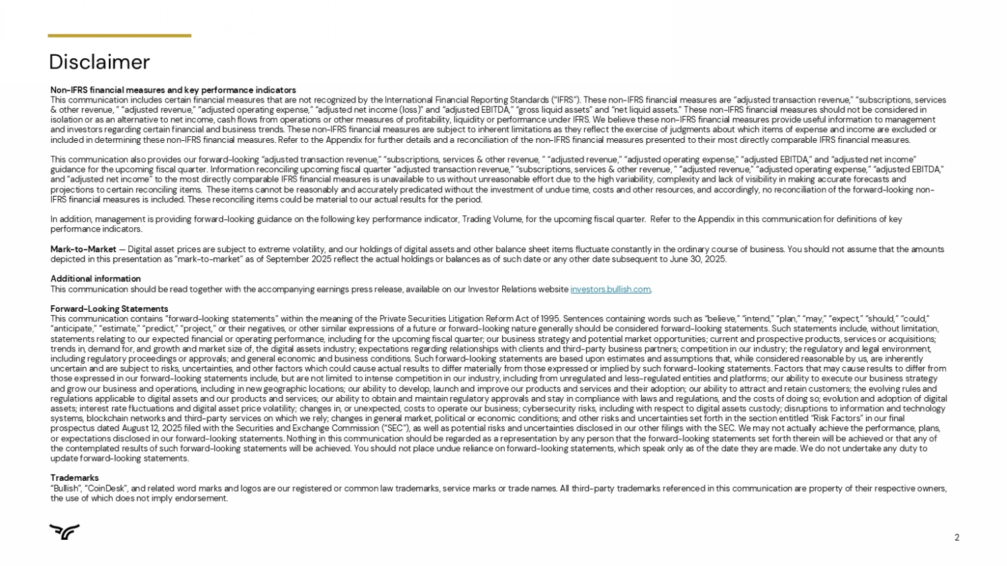
2 Disclaimer Non - IFRS financial measures and key performance indicators This communication includes certain financial measures that are not recognized by the International Financial Reporting Stand ard s (“IFRS”). These non - IFRS financial measures are “adjusted transaction revenue,” “subscriptions, services & other revenue, ” “adjusted revenue,” “adjusted operating expense,” “adjusted net income (loss)” and “adjusted EBITDA,” “gro ss liquid assets” and “net liquid assets.” These non - IFRS financial measures should not be considered in isolation or as an alternative to net income, cash flows from operations or other measures of profitability, liquidity or per for mance under IFRS. We believe these non - IFRS financial measures provide useful information to management and investors regarding certain financial and business trends. These non - IFRS financial measures are subject to inherent limitat ions as they reflect the exercise of judgments about which items of expense and income are excluded or included in determining these non - IFRS financial measures. Refer to the Appendix for further details and a reconciliation of the non - IFRS financial measures presented to their most directly comparable IFRS financial measures. This communication also provides our forward - looking “adjusted transaction revenue,” “subscriptions, services & other revenue, ” “adjusted revenue,” “adjusted operating expense,” “adjusted EBITDA,” and “adjusted net income” guidance for the upcoming fiscal quarter. Information reconciling upcoming fiscal quarter “adjusted transaction revenue,” “su bsc riptions, services & other revenue, ” “adjusted revenue,” “adjusted operating expense,” “adjusted EBITDA,” and “adjusted net income” to the most directly comparable IFRS financial measures is unavailable to us without unreasonable e ffo rt due to the high variability, complexity and lack of visibility in making accurate forecasts and projections to certain reconciling items. These items cannot be reasonably and accurately predicated without the investment of undue time, costs and other resources, and accordingly, no reconciliation of the forward - looking non - IFRS financial measures is included. These reconciling items could be material to our actual results for the period. In addition, management is providing forward - looking guidance on the following key performance indicator, Trading Volume, for th e upcoming fiscal quarter. Refer to the Appendix in this communication for definitions of key performance indicators. Mark - to - Market — Digital asset prices are subject to extreme volatility, and our holdings of digital assets and other balance sheet items fluc tuate constantly in the ordinary course of business. You should not assume that the amounts depicted in this presentation as “mark - to - market” as of September 2025 reflect the actual holdings or balances as of such date o r any other date subsequent to June 30, 2025. Additional information This communication should be read together with the accompanying earnings press release, available on our Investor Relations web site investors.bullish.com . Forward - Looking Statements This communication contains “forward - looking statements” within the meaning of the Private Securities Litigation Reform Act of 1 995. Sentences containing words such as “believe,” “intend,” “plan,” “may,” “expect,” “should,” “could,” “anticipate,” “estimate,” “predict,” “project,” or their negatives, or other similar expressions of a future or forward - looking nature generally should be considered forward - looking statements. Such statements include, without limitation, statements relating to our expected financial or operating performance, including for the upcoming fiscal quarter; our busine ss strategy and potential market opportunities; current and prospective products, services or acquisitions; trends in, demand for, and growth and market size of, the digital assets industry; expectations regarding relationships with cli ents and third - party business partners; competition in our industry; the regulatory and legal environment, including regulatory proceedings or approvals; and general economic and business conditions. Such forward - looking statements are based upon estimates and assumptions that, while considered reasonable by us, are inherently uncertain and are subject to risks, uncertainties, and other factors which could cause actual results to differ materially fr om those expressed or implied by such forward - looking statements. Factors that may cause results to differ from those expressed in our forward - looking statements include, but are not limited to intense competition in our industry, including from unregulated and less - regulated entities and platforms; our ability to execute our business strategy and grow our business and operations, including in new geographic locations; our ability to develop, launch and improve our p rod ucts and services and their adoption; our ability to attract and retain customers; the evolving rules and regulations applicable to digital assets and our products and services; our ability to obtain and maintain regulatory approva ls and stay in compliance with laws and regulations, and the costs of doing so; evolution and adoption of digital assets; interest rate fluctuations and digital asset price volatility; changes in, or unexpected, costs to operate our busine ss; cybersecurity risks, including with respect to digital assets custody; disruptions to information and technology systems, blockchain networks and third - party services on which we rely; changes in general market, political or economic conditi ons; and other risks and uncertainties set forth in the section entitled “Risk Factors” in our final prospectus dated August 12, 2025 filed with the Securities and Exchange Commission (“SEC”), as well as potential risks and un cer tainties disclosed in our other filings with the SEC. We may not actually achieve the performance, plans, or expectations disclosed in our forward - looking statements. Nothing in this communication should be regarded as a representatio n by any person that the forward - looking statements set forth therein will be achieved or that any of the contemplated results of such forward - looking statements will be achieved. You should not place undue reliance on forward - loo king statements, which speak only as of the date they are made. We do not undertake any duty to update forward - looking statements. Trademarks “Bullish”, “CoinDesk”, and related word marks and logos are our registered or common law trademarks, service marks or trade n ame s. All third - party trademarks referenced in this communication are property of their respective owners, the use of which does not imply endorsement.


3 Tom Farley Speaking today David Bonanno Chief Executive Officer Chief Financial Officer

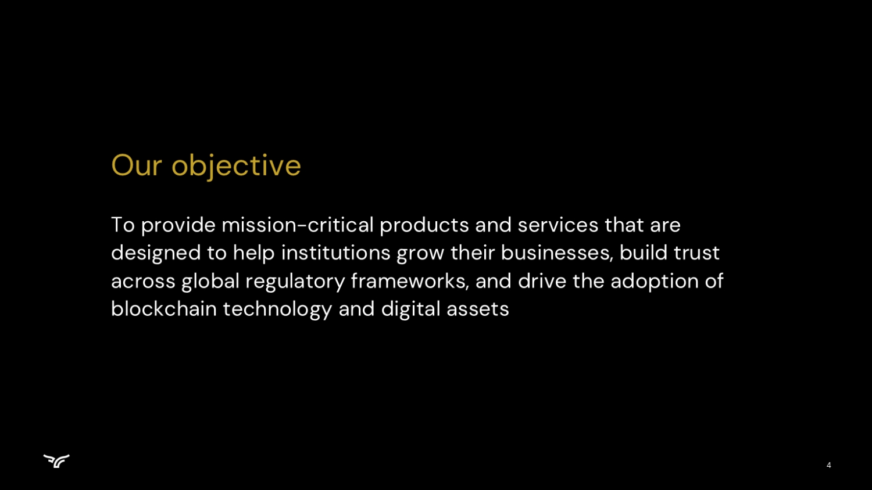
4 To provide mission - critical products and services that are designed to help institutions grow their businesses, build trust across global regulatory frameworks, and drive the adoption of blockchain technology and digital assets Our objective

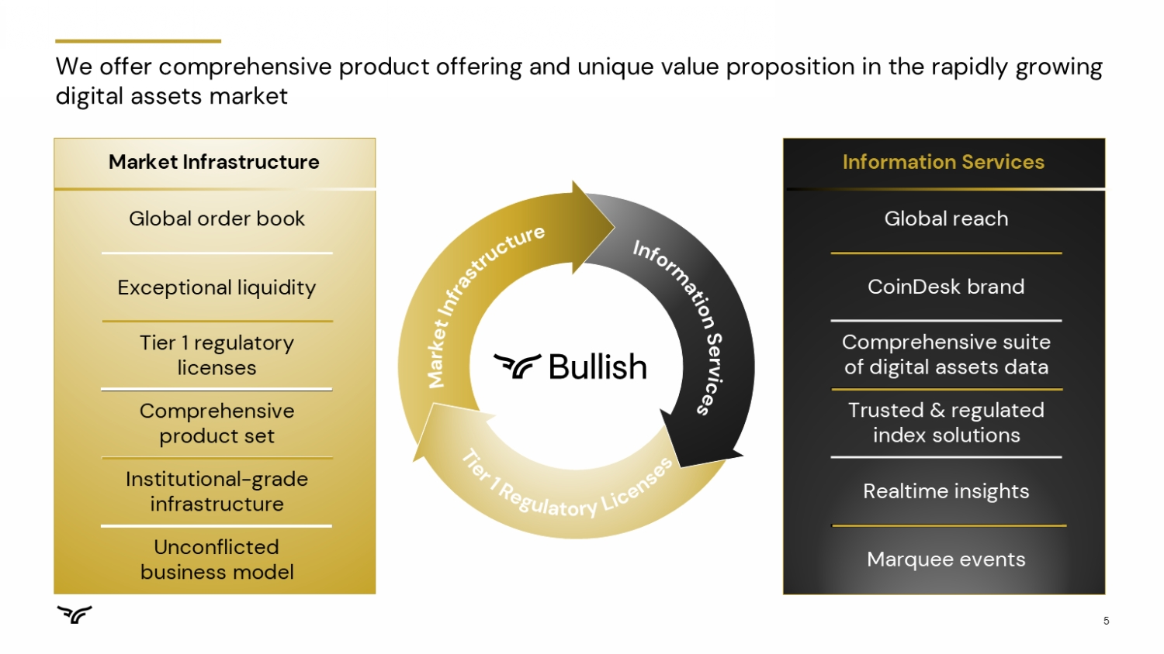
5 We offer comprehensive product offering and unique value proposition in the rapidly growing digital assets market Information Services Global reach CoinDesk brand Comprehensive suite of digital assets data Trusted & regulated index solutions Realtime insights Marquee events Market Infrastructure Global order book Exceptional liquidity Tier 1 regulatory licenses Comprehensive product set Institutional - grade infrastructure Unconflicted business model

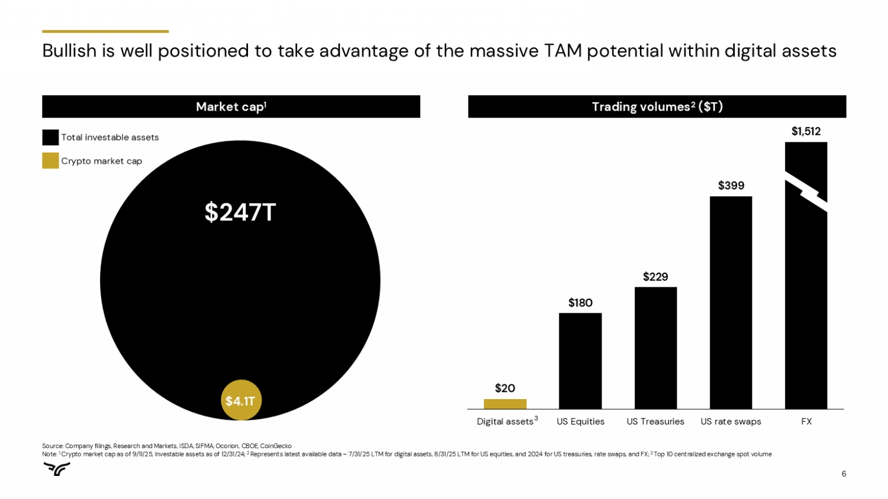
6 Source: Company filings, Research and Markets, ISDA, SIFMA, Ocorion , CBOE, CoinGecko Note: 1 Crypto market cap as of 9/11/25, Investable assets as of 12/31/24; 2 Represents latest available data – 7/31/25 LTM for digital assets, 8/31/25 LTM for US equities, and 2024 for US treasuries, rate swaps, and FX; 3 Top 10 centralized exchange spot volume $1,512 $399 $229 $180 $20 FX US rate swaps US Treasuries US Equities Digital assets $247T $4.1T Total investable assets Crypto market cap $ in Trillions 3 Trading volumes 2 ($T) Market cap 1 Bullish is well positioned to take advantage of the massive TAM potential within digital assets

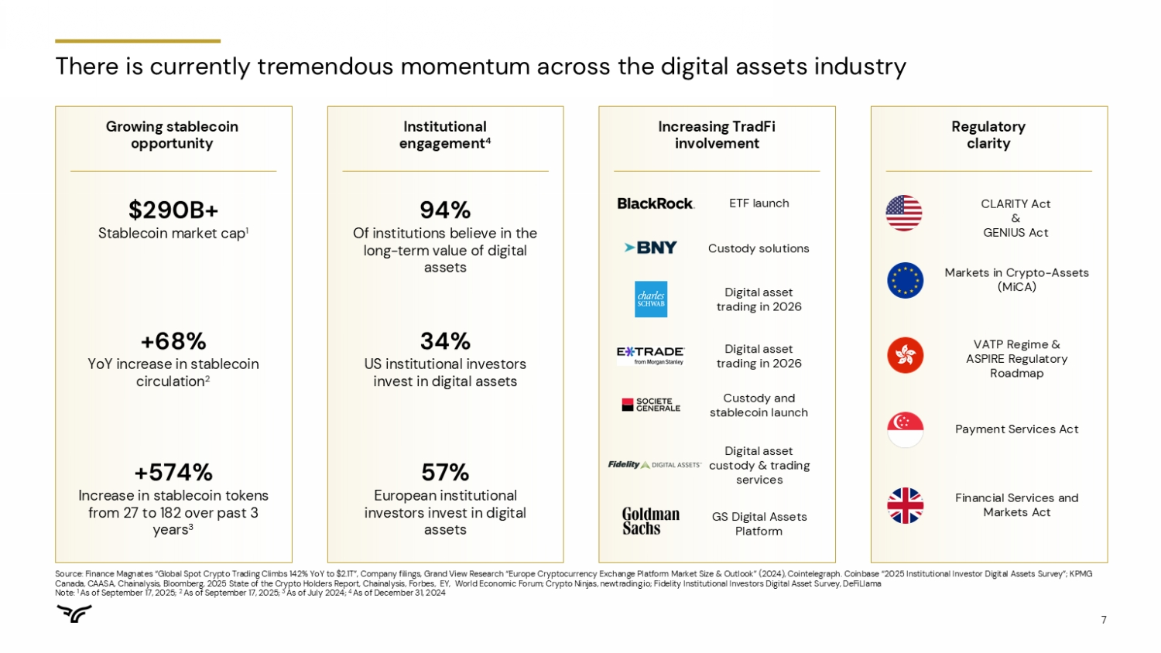
7 There is currently tremendous momentum across the digital assets industry Growing stablecoin opportunity $290B+ Stablecoin market cap 1 +68% YoY increase in stablecoin circulation 2 +574% Increase in stablecoin tokens from 27 to 182 over past 3 years 3 Institutional engagement 4 57% European institutional investors invest in digital assets 34% US institutional investors invest in digital assets 94% Of institutions believe in the long - term value of digital assets Increasing TradFi involvement Custody solutions GS Digital Assets Platform Digital asset trading in 2026 Custody and stablecoin launch Digital asset custody & trading services Digital asset trading in 2026 ETF launch Source: Finance Magnates “Global Spot Crypto Trading Climbs 142% YoY to $2.1T”, Company filings, Grand View Research “Europe Cry ptocurrency Exchange Platform Market Size & Outlook” (2024), Cointelegraph . Coinbase “2025 Institutional Investor Digital Assets Survey”; KPMG Canada, CAASA, Chainalysis , Bloomberg, 2025 State of the Crypto Holders Report, Chainalysis , Forbes, EY, World Economic Forum; Crypto Ninjas, newtrading.io; Fidelity Institutional Investors Digital Asset Survey, DeFiLlama Note: 1 As of September 17, 2025; 2 As of September 17, 2025; 3 As of July 2024; 4 As of December 31, 2024 Regulatory clarity Markets in Crypto - Assets ( MiCA ) VATP Regime & ASPIRE Regulatory Roadmap Payment Services Act Financial Services and Markets Act CLARITY Act & GENIUS Act

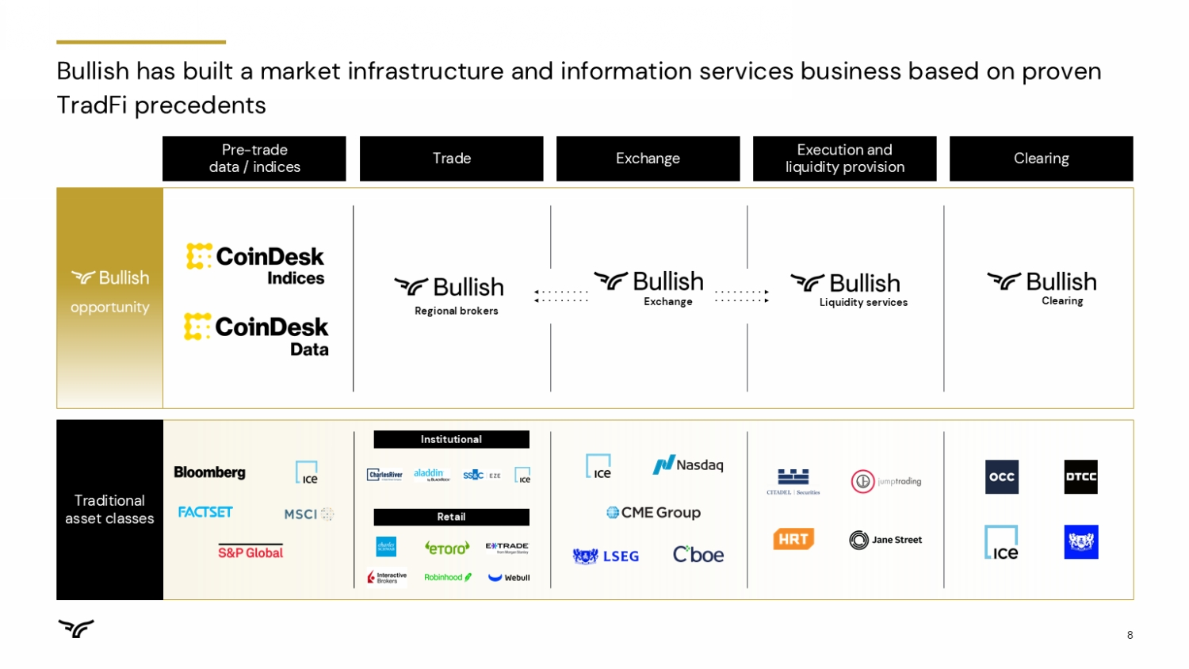
8 Traditional asset classes Bullish has built a market infrastructure and information services business based on proven TradFi precedents opportunity Regional brokers Pre - trade data / indices Trade Exchange Execution and liquidity provision Clearing Institutional Retail Exchange Liquidity services Clearing

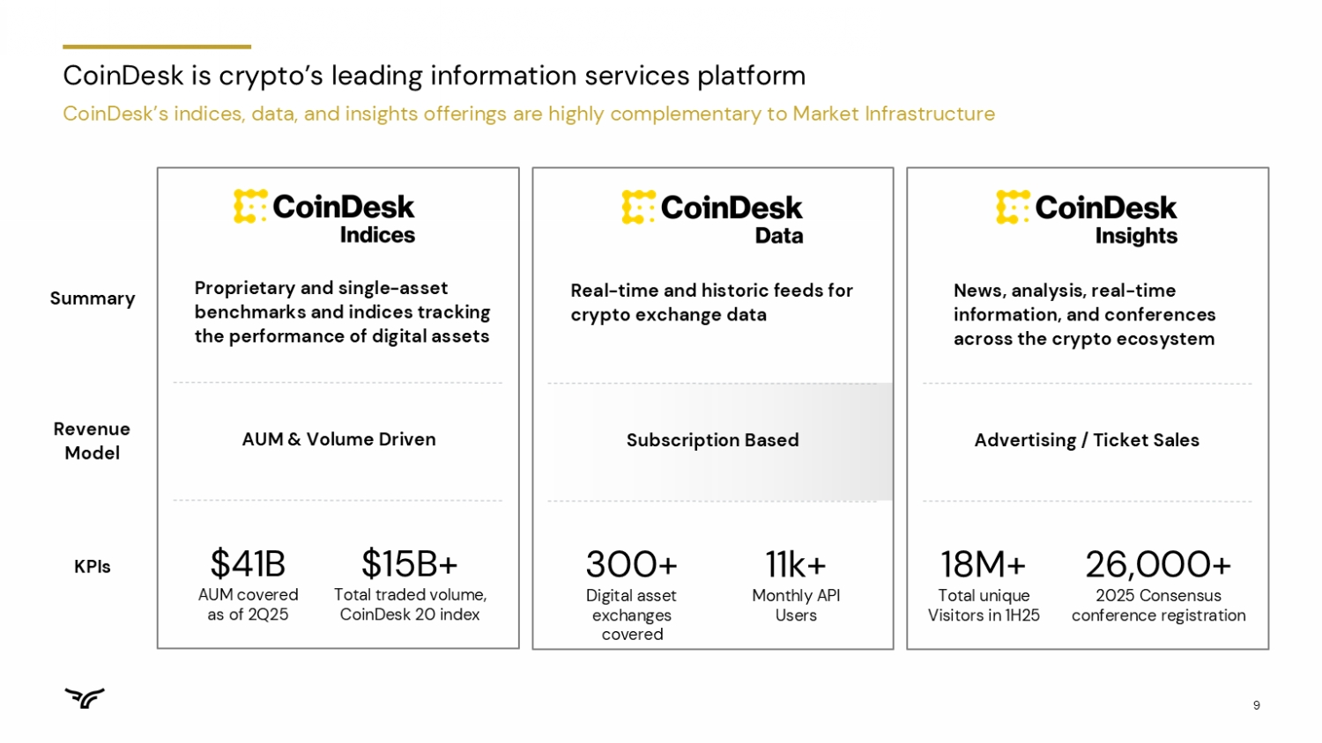
9 CoinDesk is crypto’s leading information services platform CoinDesk’s indices, data, and insights offerings are highly complementary to Market Infrastructure Summary Revenue Model Proprietary and single - asset benchmarks and indices tracking the performance of digital assets AUM & Volume Driven $41B AUM covered as of 2Q25 $15B+ Total traded volume, CoinDesk 20 index News, analysis, real - time information, and conferences across the crypto ecosystem Advertising / Ticket Sales 18M+ Total unique Visitors in 1H25 26,000+ 2025 Consensus conference registration KPIs Real - time and historic feeds for crypto exchange data Subscription Based 300+ Digital asset exchanges covered 11k+ Monthly API Users

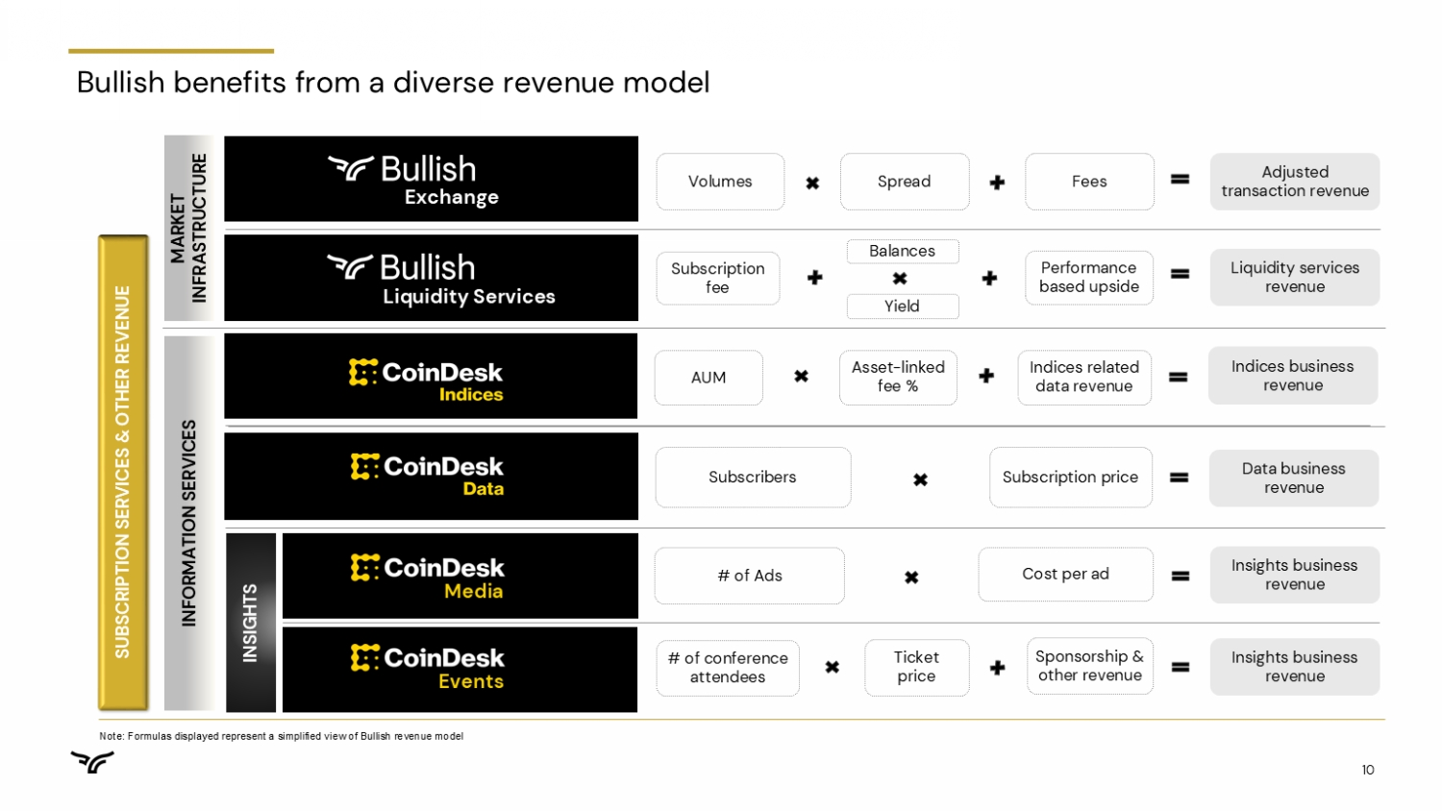
10 Bullish benefits from a diverse revenue model Note: Formulas displayed represent a simplified view of Bullish revenue model Adjusted transaction revenue Insights business revenue Liquidity services revenue # of Ads Balances Subscription fee Exchange Data business revenue Subscribers Subscription price SUBSCRIPTION SERVICES & OTHER REVENUE Indices business revenue AUM Asset - linked fee % Indices related data revenue Insights business revenue # of conference attendees Ticket price Sponsorship & other revenue Media Events Cost per ad INFORMATION SERVICES MARKET INFRASTRUCTURE Performance based upside Liquidity Services Yield Fees Volumes Spread INSIGHTS

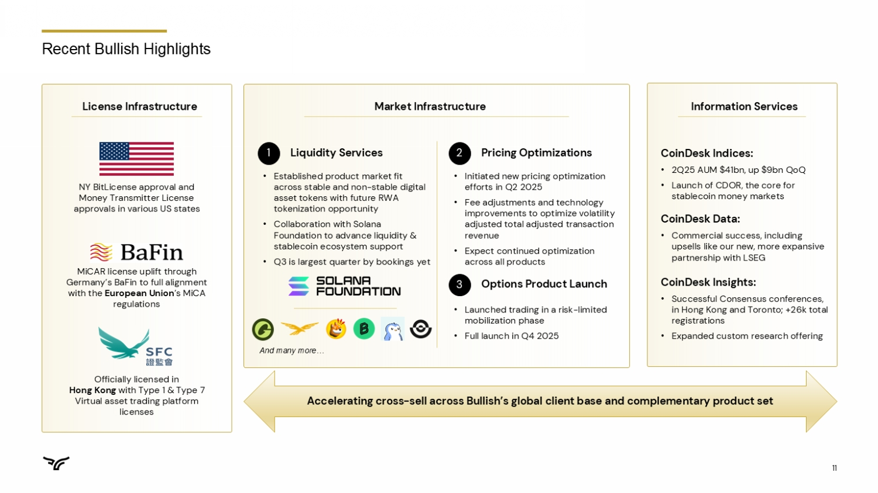
11 Recent Bullish Highlights Officially licensed in Hong Kong with Type 1 & Type 7 Virtual asset trading platform licenses MiCAR license uplift through Germany’s BaFin to full alignment with the European Union ’s MiCA regulations NY BitLicense approval and Money Transmitter License approvals in various US states 1 Liquidity Services Accelerating cross - sell across Bullish’s global client base and complementary product set • Established product market fit across stable and non - stable digital asset tokens with future RWA tokenization opportunity • Collaboration with Solana Foundation to advance liquidity & stablecoin ecosystem support • Q3 is largest quarter by bookings yet And many more… 2 Pricing Optimizations • Initiated new pricing optimization efforts in Q2 2025 • Fee adjustments and technology improvements to optimize volatility adjusted total adjusted transaction revenue • Expect continued optimization across all products 3 Options Product Launch • Launched trading in a risk - limited mobilization phase • Full launch in Q4 2025 License Infrastructure Market Infrastructure Information Services CoinDesk Indices: • 2Q25 AUM $41bn, up $9bn QoQ • Launch of CDOR, the core for stablecoin money markets CoinDesk Data: • Commercial success, including upsells like our new, more expansive partnership with LSEG CoinDesk Insights: • Successful Consensus conferences, in Hong Kong and Toronto; +26k total registrations • Expanded custom research offering


12 Powering our Partners Growth Igloo Inc: Pudgy Penguins and $PENGU 12 ● Pudgy Penguins is onboarding the next generation of crypto users through retail - friendly products, video games, digital content and partnerships with high - profile brands such as Sotheby’s, Nascar and Pez. ● +2 million Pudgy Penguin toys sold across +10,000 global retailers including Walmart and Target. The toys include a scannable QR code to creates a Web3 wallet with an NFT which can be used in Pudgy Penguin’s interactive online and mobile gaming experiences. ● +750k downloads of Pudgy Party mobile game which features an in game, blockchain based, marketplace for skins and other digital assets. Onboarding Users to Crypto through IP and Real World Experiences: ● Scaled Distribution: 220bn lifetime impressions with ~800 million daily impressions. Five million social media followers and more GIPHY impressions than Pokémon, Hello Kitty and Star Wars. ● “Mascot of Crypto”: The Pudgy Penguins profile picture has become a crypto phenomenon and used by Solana, VanEck, Bitwise, Tom Lee, Mike Novogratz , Coinbase and many other prominent crypto companies and personalities. Global IP and Community Powerhouse:


13 13 ● PENGU inclusion in CoinDesk 80, CoinDesk 100 and CoinDesk MEME Indices. ● CBOE 19b - 4 filing for the first - of - its - kind $PENGU and Pudgy Penguins NFT ETF is currently under SEC review. ● PENGU 8th largest airdrop in history with ~$1 billion in current market value given out to Pudgy Penguin NFT holders and other crypto native communities. ● PENGU and NFT collections market capitalization of ~$3.5 billion. IP Capital Markets Goining Mainstream: ● Four multi - year subscription products across market infrastructure and information services. ● $PENGU listed on Bullish with liquidity against USDC, USDT and SOL. ● Pudgy Penguin activation at 2026 Consensus Hong Kong and Miami as well as a CoinDesk and Pudgy Penguin co - branded “Crypto Café” in Seoul, South Korea . ● Strong partnership foundation for future expansion across the Bullish platform and Pudgy Penguin ecosystem. Bullish on Pudgy Penguin Partnership: Powering our Partners Growth Igloo Inc: Pudgy Penguins and $PENGU


14 Financials & KPIs Q2 2025 Update

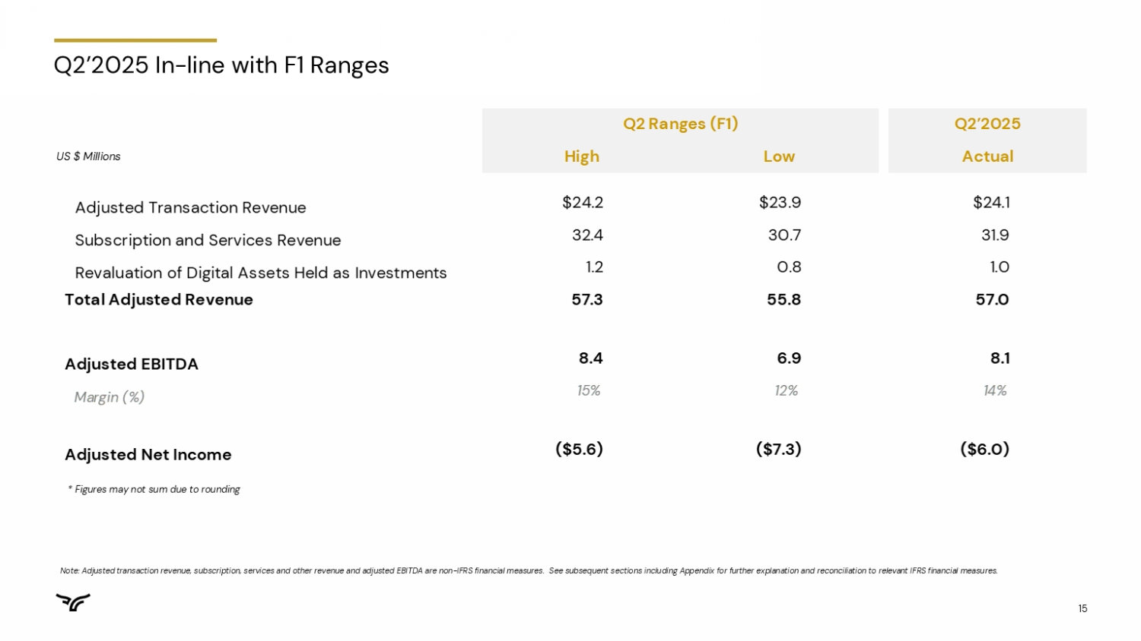
15 Q2’2025 In - line with F1 Ranges * Figures may not sum due to rounding Q2 Ranges (F1) Q2’2025 US $ Millions High Low Actual Adjusted Transaction Revenue $24.2 $23.9 $24.1 Subscription and Services Revenue 32.4 30.7 31.9 Revaluation of Digital Assets Held as Investments 1.2 0.8 1.0 Total Adjusted Revenue 57.3 55.8 57.0 Adjusted EBITDA 8.4 6.9 8.1 Margin (%) 15% 12% 14% Adjusted Net Income ($5.6) ($7.3) ($6.0) Note: Adjusted transaction revenue, subscription, services and other revenue and adjusted EBITDA are non - IFRS financial measures . See subsequent sections including Appendix for further explanation and reconciliation to relevant IFRS financial measures.

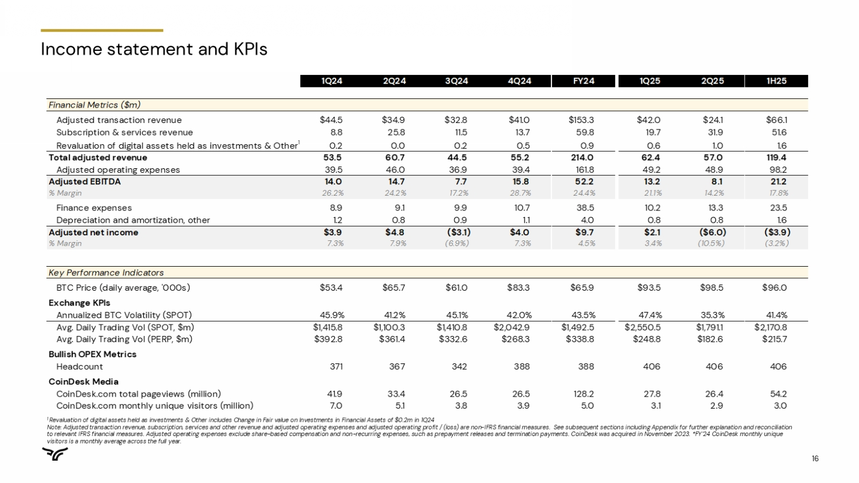
16 1 Revaluation of digital assets held as investments & Other includes Change in Fair value on Investments in Financial Assets of $0 .2m in 1Q24 Note: Adjusted transaction revenue, subscription, services and other revenue and adjusted operating expenses and adjusted ope rat ing profit / (loss) are non - IFRS financial measures. See subsequent sections including Appendix for further explanation and rec onciliation to relevant IFRS financial measures. Adjusted operating expenses exclude share - based compensation and non - recurring expenses, su ch as prepayment releases and termination payments. CoinDesk was acquired in November 2023. *FY’24 CoinDesk monthly unique visitors is a monthly average across the full year. 1Q24 2Q24 3Q24 4Q24 FY24 1Q25 2Q25 1H25 Financial Metrics ($m) Adjusted transaction revenue $44.5 $34.9 $32.8 $41.0 $153.3 $42.0 $24.1 $66.1 Subscription & services revenue 8.8 25.8 11.5 13.7 59.8 19.7 31.9 51.6 Revaluation of digital assets held as investments & Other 1 0.2 0.0 0.2 0.5 0.9 0.6 1.0 1.6 Total adjusted revenue 53.5 60.7 44.5 55.2 214.0 62.4 57.0 119.4 Adjusted operating expenses 39.5 46.0 36.9 39.4 161.8 49.2 48.9 98.2 Adjusted EBITDA 14.0 14.7 7.7 15.8 52.2 13.2 8.1 21.2 % Margin 26.2% 24.2% 17.2% 28.7% 24.4% 21.1% 14.2% 17.8% Finance expenses 8.9 9.1 9.9 10.7 38.5 10.2 13.3 23.5 Depreciation and amortization, other 1.2 0.8 0.9 1.1 4.0 0.8 0.8 1.6 Adjusted net income $3.9 $4.8 ($3.1) $4.0 $9.7 $2.1 ($6.0) ($3.9) % Margin 7.3% 7.9% (6.9%) 7.3% 4.5% 3.4% (10.5%) (3.2%) Key Performance Indicators BTC Price (daily average, '000s) $53.4 $65.7 $61.0 $83.3 $65.9 $93.5 $98.5 $96.0 Exchange KPIs Annualized BTC Volatility (SPOT) 45.9% 41.2% 45.1% 42.0% 43.5% 47.4% 35.3% 41.4% Avg. Daily Trading Vol (SPOT, $m) $1,415.8 $1,100.3 $1,410.8 $2,042.9 $1,492.5 $2,550.5 $1,791.1 $2,170.8 Avg. Daily Trading Vol (PERP, $m) $392.8 $361.4 $332.6 $268.3 $338.8 $248.8 $182.6 $215.7 Bullish OPEX Metrics Headcount 371 367 342 388 388 406 406 406 CoinDesk Media CoinDesk.com total pageviews (million) 41.9 33.4 26.5 26.5 128.2 27.8 26.4 54.2 CoinDesk.com monthly unique visitors (million) 7.0 5.1 3.8 3.9 5.0 3.1 2.9 3.0 Income statement and KPIs

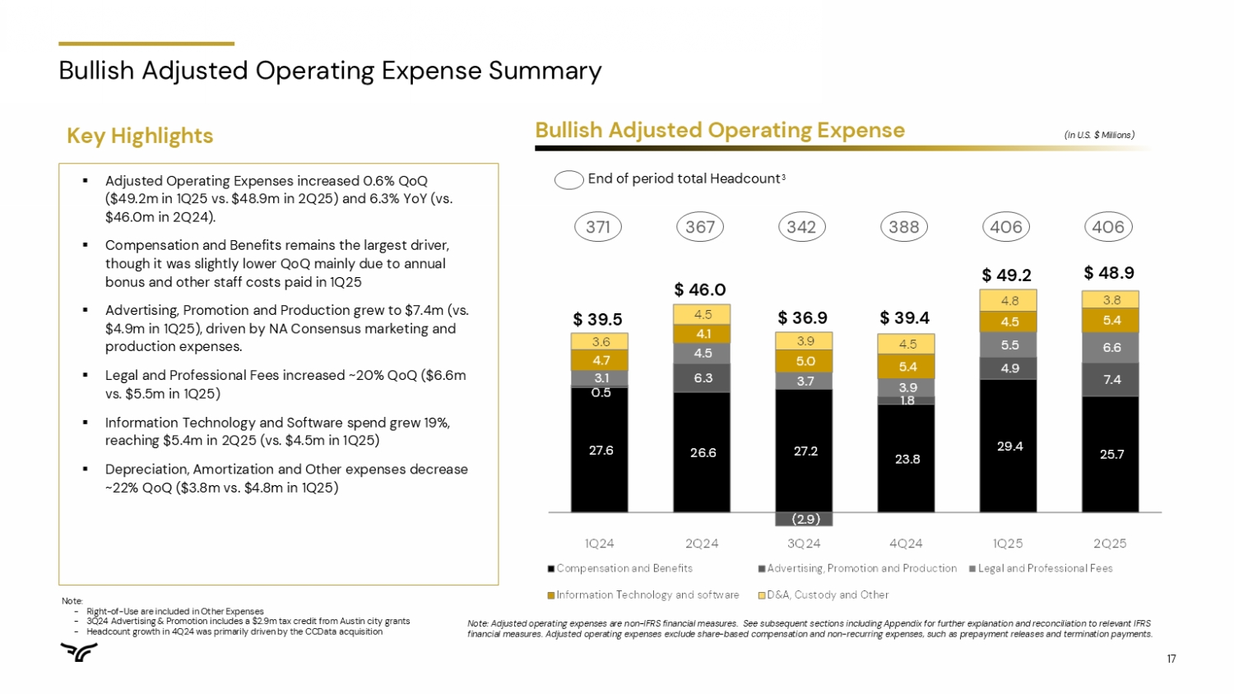
17 Bullish Adjusted Operating Expense Summary ▪ Adjusted Operating Expenses increased 0.6% QoQ ($49.2m in 1Q25 vs. $48.9m in 2Q25) and 6.3% YoY (vs. $46.0m in 2Q24). ▪ Compensation and Benefits remains the largest driver, though it was slightly lower QoQ mainly due to annual bonus and other staff costs paid in 1Q25 ▪ Advertising, Promotion and Production grew to $7.4m (vs. $4.9m in 1Q25), driven by NA Consensus marketing and production expenses. ▪ Legal and Professional Fees increased ~20% QoQ ($6.6m vs. $5.5m in 1Q25) ▪ Information Technology and Software spend grew 19%, reaching $5.4m in 2Q25 (vs. $4.5m in 1Q25) ▪ Depreciation, Amortization and Other expenses decrease ~22% QoQ ($3.8m vs. $4.8m in 1Q25) Bullish Adjusted Operating Expense (In U.S. $ Millions) Key Highlights End of period total Headcount 3 27.6 26.6 27.2 23.8 29.4 25.7 0.5 6.3 (2.9) 1.8 4.9 7.4 3.1 4.5 3.7 3.9 5.5 6.6 4.7 4.1 5.0 5.4 4.5 5.4 3.6 4.5 3.9 4.5 4.8 3.8 1Q24 2Q24 3Q24 4Q24 1Q25 2Q25 Compensation and Benefits Advertising, Promotion and Production Legal and Professional Fees Information Technology and software D&A, Custody and Other 371 367 342 388 406 406 $ 39.5 $ 46.0 $ 36.9 $ 39.4 $ 49.2 $ 48.9 Note : - Right - of - Use are included in Other Expenses - 3 Q 24 Advertising & Promotion includes a $ 2 . 9 m tax credit from Austin city grants - Headcount growth in 4 Q 24 was primarily driven by the CCData acquisition Note: Adjusted operating expenses are non - IFRS financial measures. See subsequent sections including Appendix for further expla nation and reconciliation to relevant IFRS financial measures. Adjusted operating expenses exclude share - based compensation and non - recurring expenses, such as prepayment releases and termination payments.

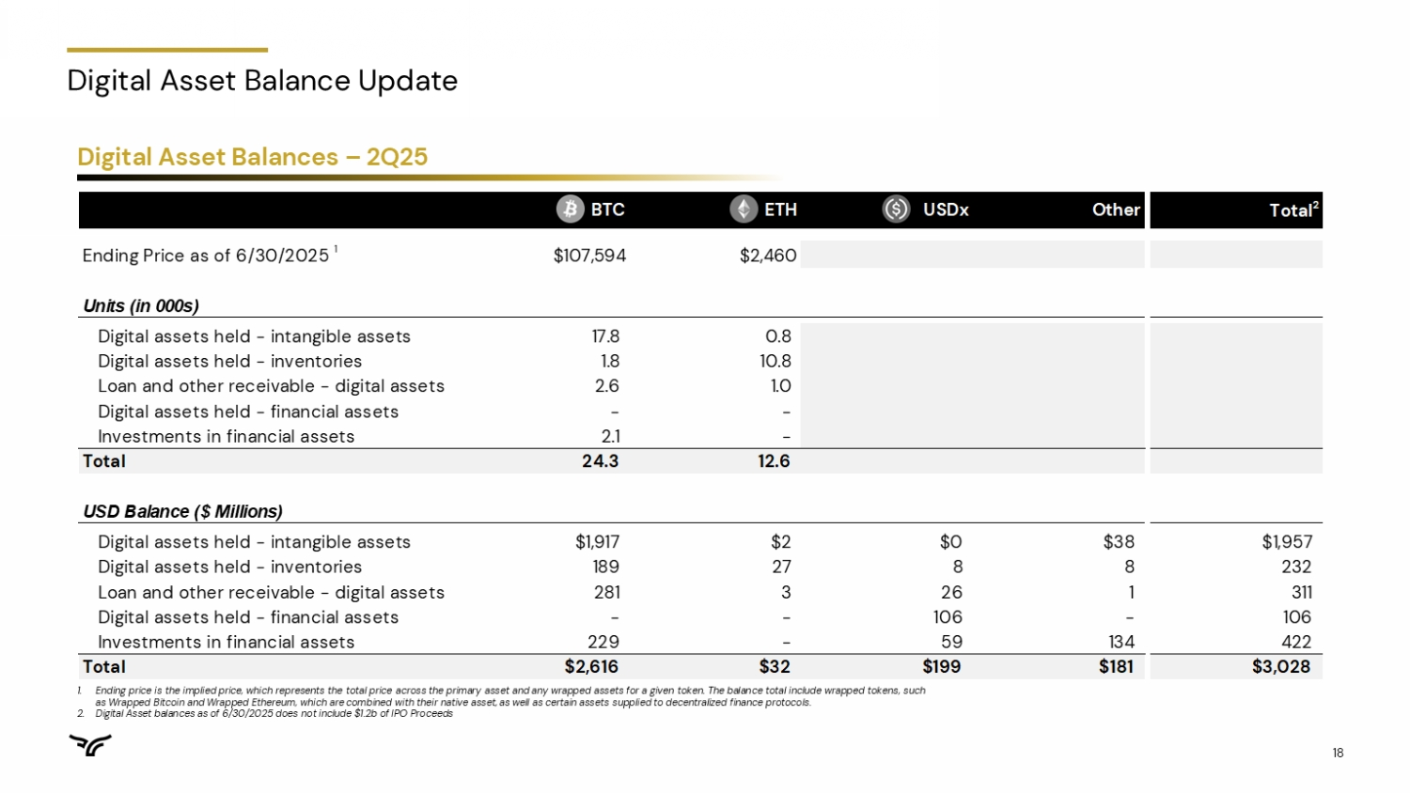
18 Digital Asset Balance Update BTC ETH USDx Other Total 2 Ending Price as of 6/30/2025 1 $107,594 $2,460 Units (in 000s) Digital assets held - intangible assets 17.8 0.8 Digital assets held - inventories 1.8 10.8 Loan and other receivable - digital assets 2.6 1.0 Digital assets held - financial assets - - Investments in financial assets 2.1 - Total 24.3 12.6 USD Balance ($ Millions) Digital assets held - intangible assets $1,917 $2 $0 $38 $1,957 Digital assets held - inventories 189 27 8 8 232 Loan and other receivable - digital assets 281 3 26 1 311 Digital assets held - financial assets - - 106 - 106 Investments in financial assets 229 - 59 134 422 Total $2,616 $32 $199 $181 $3,028 Digital Asset Balances – 2Q25 1. Ending price is the implied price, which represents the total price across the primary asset and any wrapped assets for a given token . The balance total include wrapped tokens, such as Wrapped Bitcoin and Wrapped Ethereum, which are combined with their native asset, as well as certain assets supplied to decentralized finance protocols . 2. Digital Asset balances as of 6 / 30 / 2025 does not include $ 1 . 2 b of IPO Proceeds

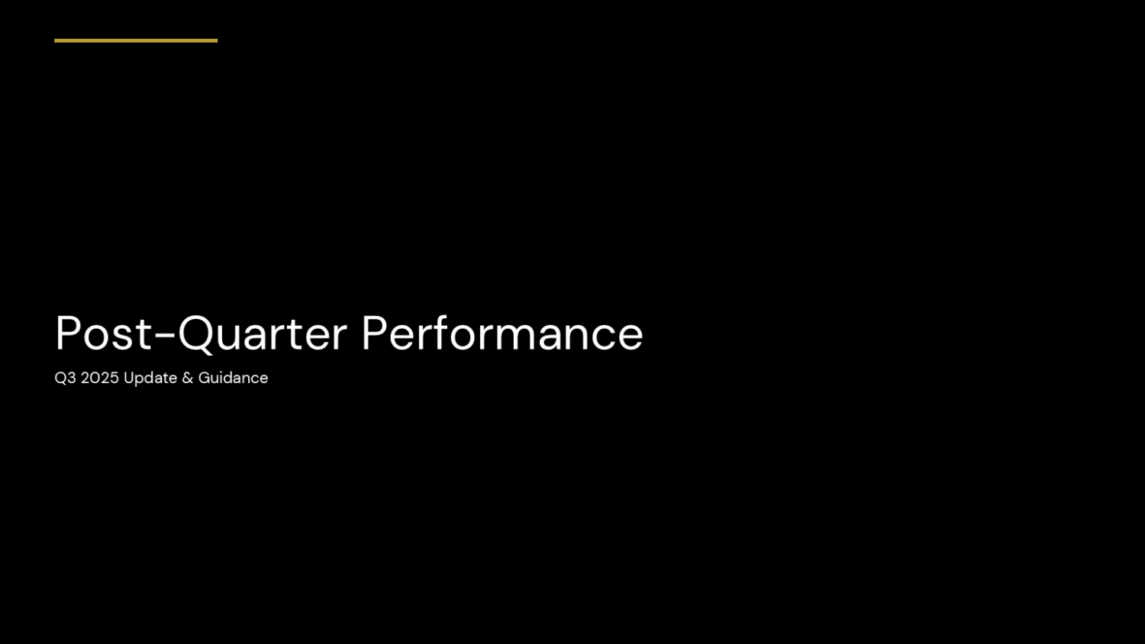
19 Post - Quarter Performance Q3 2025 Update & Guidance

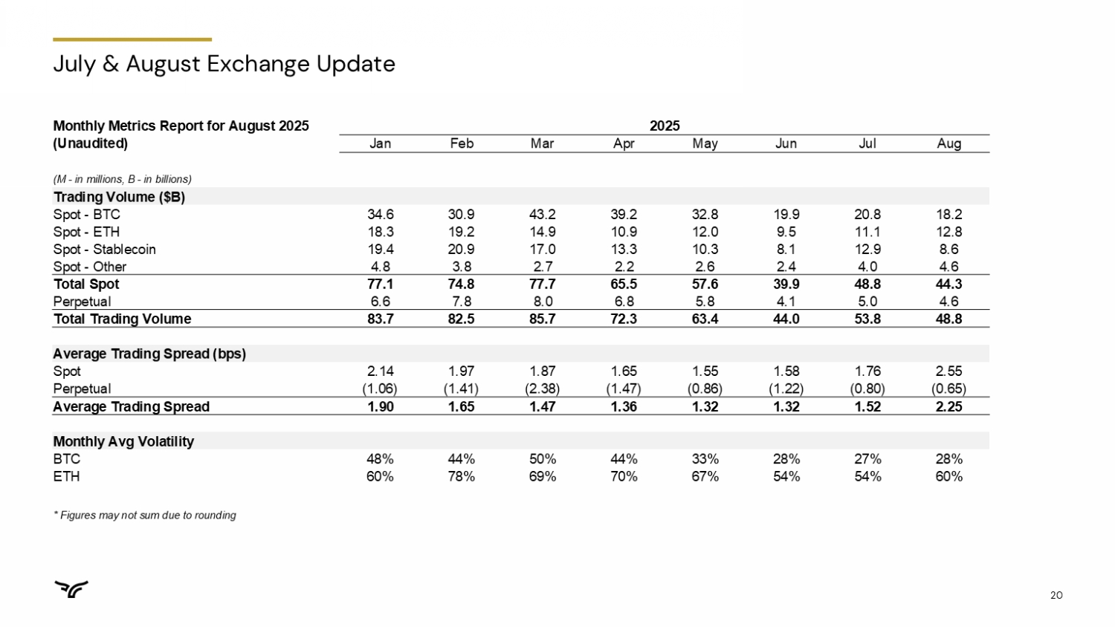
20 July & August Exchange Update 2025 Monthly Metrics Report for August 2025 Aug Jul Jun May Apr Mar Feb Jan (Unaudited) (M - in millions, B - in billions) Trading Volume ($B) 18.2 20.8 19.9 32.8 39.2 43.2 30.9 34.6 Spot - BTC 12.8 11.1 9.5 12.0 10.9 14.9 19.2 18.3 Spot - ETH 8.6 12.9 8.1 10.3 13.3 17.0 20.9 19.4 Spot - Stablecoin 4.6 4.0 2.4 2.6 2.2 2.7 3.8 4.8 Spot - Other 44.3 48.8 39.9 57.6 65.5 77.7 74.8 77.1 Total Spot 4.6 5.0 4.1 5.8 6.8 8.0 7.8 6.6 Perpetual 48.8 53.8 44.0 63.4 72.3 85.7 82.5 83.7 Total Trading Volume Average Trading Spread (bps) 2.55 1.76 1.58 1.55 1.65 1.87 1.97 2.14 Spot (0.65) (0.80) (1.22) (0.86) (1.47) (2.38) (1.41) (1.06) Perpetual 2.25 1.52 1.32 1.32 1.36 1.47 1.65 1.90 Average Trading Spread Monthly Avg Volatility 28% 27% 28% 33% 44% 50% 44% 48% BTC 60% 54% 54% 67% 70% 69% 78% 60% ETH * Figures may not sum due to rounding

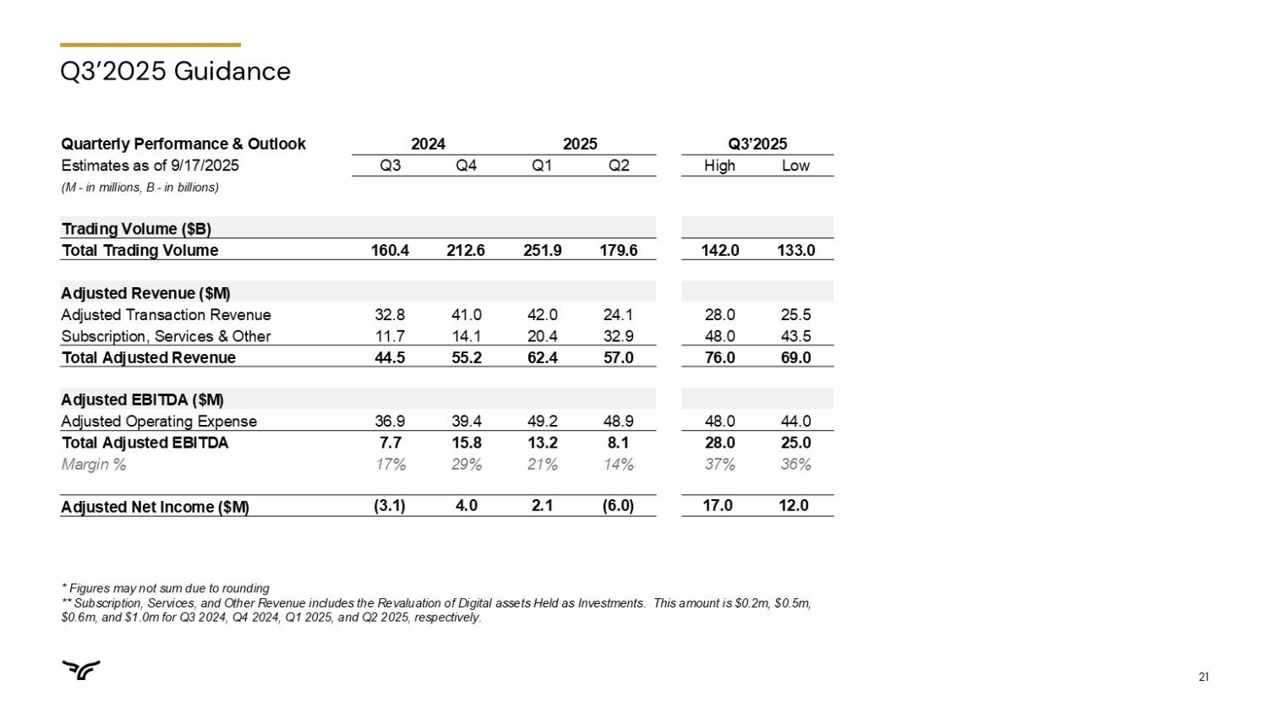
21 Q3’2025 Guidance Q3’2025 2025 2024 Quarterly Performance & Outlook Low High Q2 Q1 Q4 Q3 Estimates as of 9/17/2025 (M - in millions, B - in billions) Trading Volume ($B) 133.0 142.0 179.6 251.9 212.6 160.4 Total Trading Volume Adjusted Revenue ($M) 25.5 28.0 24.1 42.0 41.0 32.8 Adjusted Transaction Revenue 43.5 48.0 32.9 20.4 14.1 11.7 Subscription, Services & Other 69.0 76.0 57.0 62.4 55.2 44.5 Total Adjusted Revenue Adjusted EBITDA ($M) 44.0 48.0 48.9 49.2 39.4 36.9 Adjusted Operating Expense 25.0 28.0 8.1 13.2 15.8 7.7 Total Adjusted EBITDA 36% 37% 14% 21% 29% 17% Margin % 12.0 17.0 (6.0) 2.1 4.0 (3.1) Adjusted Net Income ($M) * Figures may not sum due to rounding ** Subscription, Services, and Other Revenue includes the Revaluation of Digital assets Held as Investments. This amount is $0. 2m, $0.5m, $0.6m, and $1.0m for Q3 2024, Q4 2024, Q1 2025, and Q2 2025, respectively.

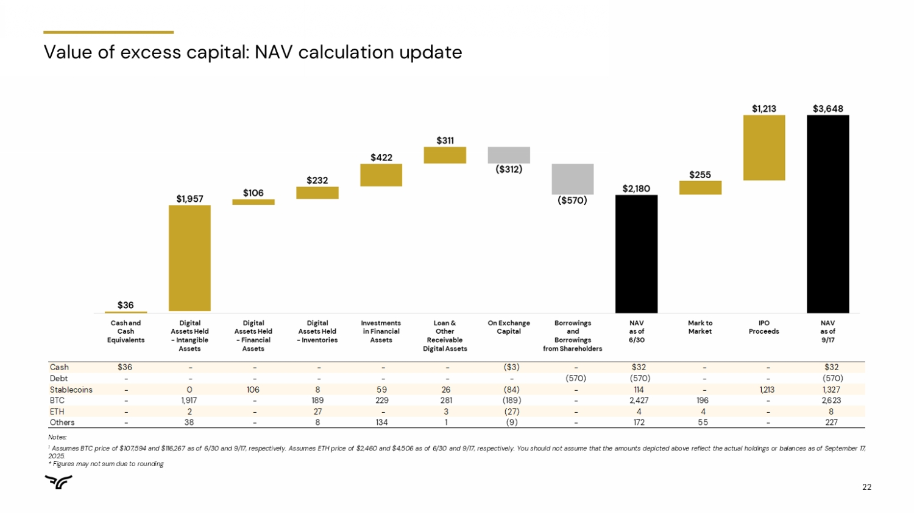
22 Value of excess capital: NAV calculation update Notes : 1 Assumes BTC price of $ 107 , 594 and $ 116 , 267 as of 6 / 30 and 9 / 17 , respectively . Assumes ETH price of $ 2 , 460 and $ 4 , 506 as of 6 / 30 and 9 / 17 , respectively . You should not assume that the amounts depicted above reflect the actual holdings or balances as of September 17 , 2025 . * Figures may not sum due to rounding Cash $36 - - - - - ($3) - $32 - - $32 Debt - - - - - - - (570) (570) - - (570) Stablecoins - 0 106 8 59 26 (84) - 114 - 1,213 1,327 BTC - 1,917 - 189 229 281 (189) - 2,427 196 - 2,623 ETH - 2 - 27 - 3 (27) - 4 4 - 8 Others - 38 - 8 134 1 (9) - 172 55 - 227 1


23 Appendix

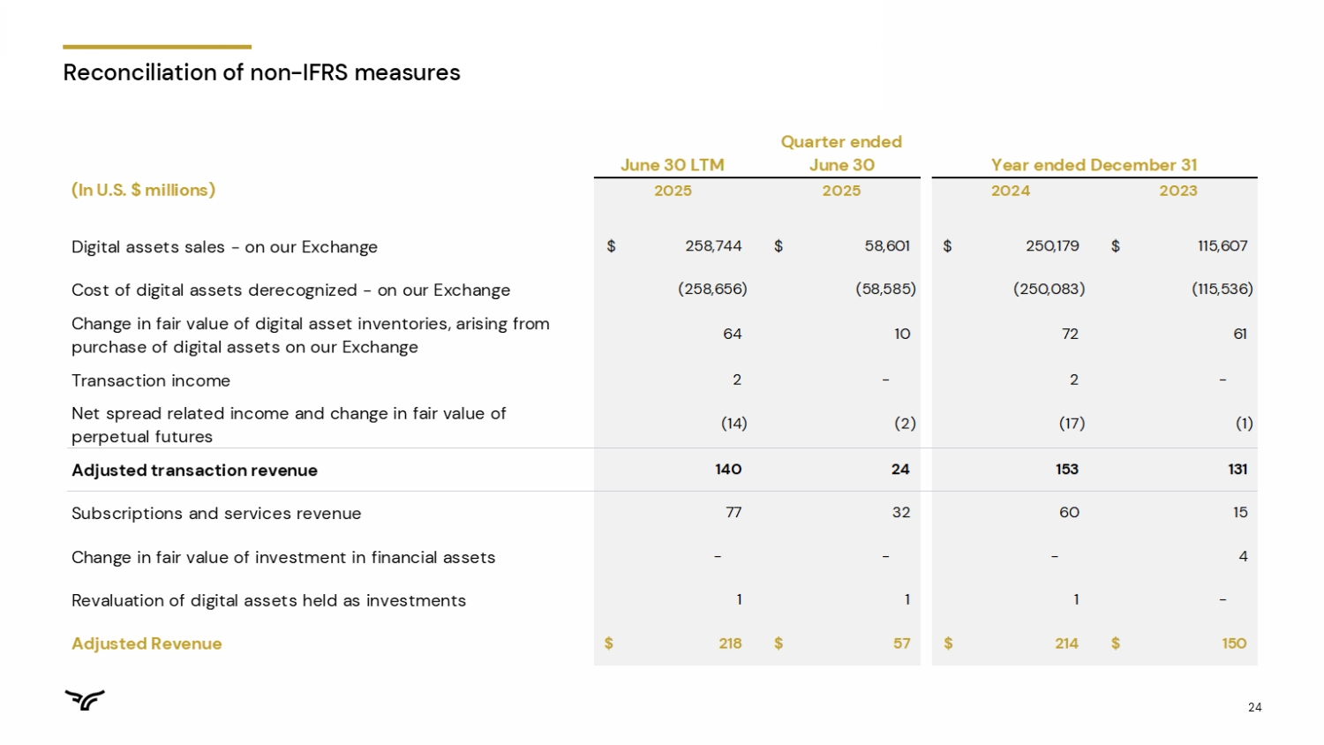
24 Reconciliation of non - IFRS measures June 30 LTM Quarter ended June 30 Year ended December 31 (In U.S. $ millions) 2025 2025 2024 2023 Digital assets sales - on our Exchange 258,744$ 58,601$ 250,179$ 115,607$ Cost of digital assets derecognized - on our Exchange (258,656) (58,585) (250,083) (115,536) Change in fair value of digital asset inventories, arising from purchase of digital assets on our Exchange 64 10 72 61 Transaction income 2 - 2 - Net spread related income and change in fair value of perpetual futures (14) (2) (17) (1) Adjusted transaction revenue 140 24 153 131 Subscriptions and services revenue 77 32 60 15 Change in fair value of investment in financial assets - - - 4 Revaluation of digital assets held as investments 1 1 1 - Adjusted Revenue 218$ 57$ 214$ 150$

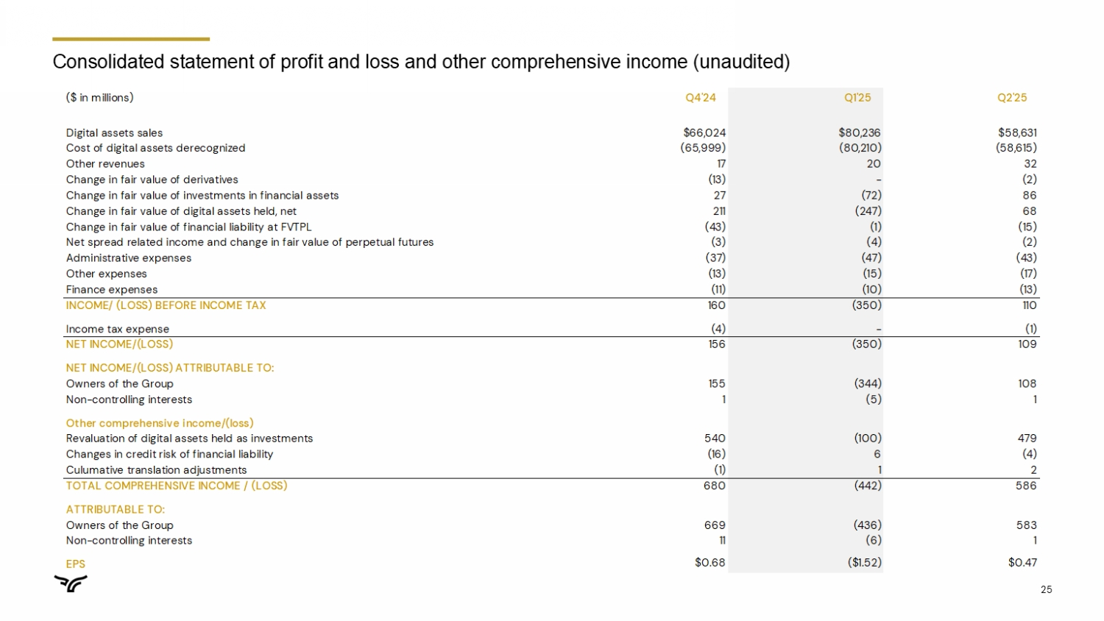
25 ($ in millions) Q4'24 Q1'25 Q2'25 Digital assets sales $66,024 $80,236 $58,631 Cost of digital assets derecognized (65,999) (80,210) (58,615) Other revenues 17 20 32 Change in fair value of derivatives (13) - (2) Change in fair value of investments in financial assets 27 (72) 86 Change in fair value of digital assets held, net 211 (247) 68 Change in fair value of financial liability at FVTPL (43) (1) (15) Net spread related income and change in fair value of perpetual futures (3) (4) (2) Administrative expenses (37) (47) (43) Other expenses (13) (15) (17) Finance expenses (11) (10) (13) INCOME/ (LOSS) BEFORE INCOME TAX 160 (350) 110 Income tax expense (4) - (1) NET INCOME/(LOSS) 156 (350) 109 NET INCOME/(LOSS) ATTRIBUTABLE TO: Owners of the Group 155 (344) 108 Non-controlling interests 1 (5) 1 Other comprehensive income/(loss) Revaluation of digital assets held as investments 540 (100) 479 Changes in credit risk of financial liability (16) 6 (4) Culumative translation adjustments (1) 1 2 TOTAL COMPREHENSIVE INCOME / (LOSS) 680 (442) 586 ATTRIBUTABLE TO: Owners of the Group 669 (436) 583 Non-controlling interests 11 (6) 1 EPS $0.68 ($1.52) $0.47 Consolidated statement of profit and loss and other comprehensive income (unaudited)

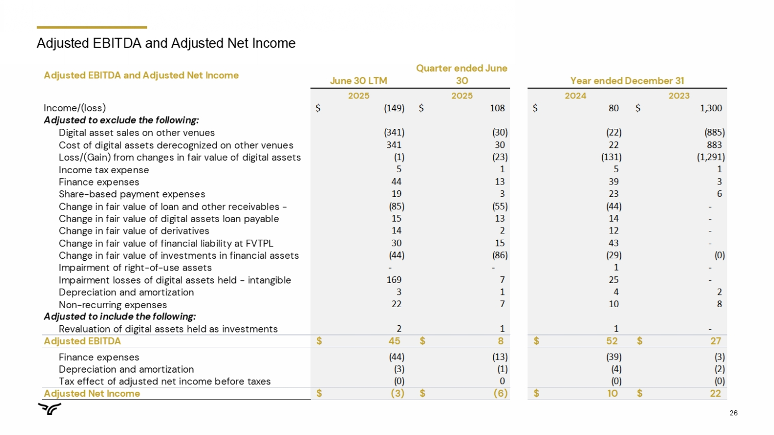
26 Adjusted EBITDA and Adjusted Net Income Adjusted EBITDA and Adjusted Net Income June 30 LTM Quarter ended June 30 Year ended December 31 2025 2025 2024 2023 Income/(loss) (149)$ 108$ 80$ 1,300$ Adjusted to exclude the following: Digital asset sales on other venues (341) (30) (22) (885) Cost of digital assets derecognized on other venues 341 30 22 883 Loss/(Gain) from changes in fair value of digital assets (1) (23) (131) (1,291) Income tax expense 5 1 5 1 Finance expenses 44 13 39 3 Share-based payment expenses 19 3 23 6 Change in fair value of loan and other receivables - (85) (55) (44) - Change in fair value of digital assets loan payable 15 13 14 - Change in fair value of derivatives 14 2 12 - Change in fair value of financial liability at FVTPL 30 15 43 - Change in fair value of investments in financial assets (44) (86) (29) (0) Impairment of right-of-use assets - - 1 - Impairment losses of digital assets held - intangible 169 7 25 - Depreciation and amortization 3 1 4 2 Non-recurring expenses 22 7 10 8 Adjusted to include the following: Revaluation of digital assets held as investments 2 1 1 - Adjusted EBITDA 45$ 8$ 52$ 27$ Finance expenses (44) (13) (39) (3) Depreciation and amortization (3) (1) (4) (2) Tax effect of adjusted net income before taxes (0) 0 (0) (0) Adjusted Net Income (3)$ (6)$ 10$ 22$

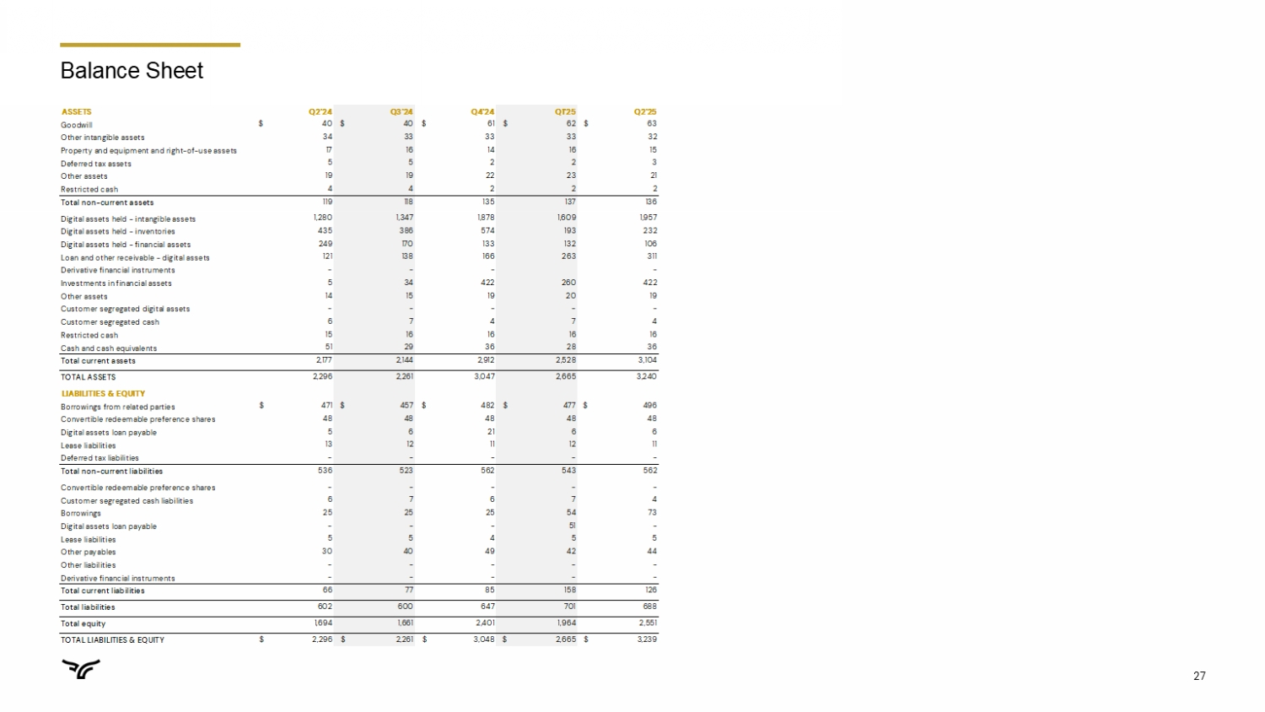
27 Balance Sheet ASSETS Q2'24 Q3'24 Q4'24 Q1'25 Q2'25 Goodwill $ 40 $ 40 $ 61 $ 62 $ 63 Other intangible assets 34 33 33 33 32 Property and equipment and right-of-use assets 17 16 14 16 15 Deferred tax assets 5 5 2 2 3 Other assets 19 19 22 23 21 Restricted cash 4 4 2 2 2 Total non-current assets 119 118 135 137 136 Digital assets held - intangible assets 1,280 1,347 1,878 1,609 1,957 Digital assets held - inventories 435 386 574 193 232 Digital assets held - financial assets 249 170 133 132 106 Loan and other receivable - digital assets 121 138 166 263 311 Derivative financial instruments - - - - Investments in financial assets 5 34 422 260 422 Other assets 14 15 19 20 19 Customer segregated digital assets - - - - - Customer segregated cash 6 7 4 7 4 Restricted cash 15 16 16 16 16 Cash and cash equivalents 51 29 36 28 36 Total current assets 2,177 2,144 2,912 2,528 3,104 TOTAL ASSETS 2,296 2,261 3,047 2,665 3,240 LIABILITIES & EQUITY Borrowings from related parties $ 471 $ 457 $ 482 $ 477 $ 496 Convertible redeemable preference shares 48 48 48 48 48 Digital assets loan payable 5 6 21 6 6 Lease liabilities 13 12 11 12 11 Deferred tax liabilities - - - - - Total non-current liabilities 536 523 562 543 562 Convertible redeemable preference shares - - - - - Customer segregated cash liabilities 6 7 6 7 4 Borrowings 25 25 25 54 73 Digital assets loan payable - - - 51 - Lease liabilities 5 5 4 5 5 Other payables 30 40 49 42 44 Other liabilities - - - - - Derivative financial instruments - - - - - Total current liabilities 66 77 85 158 126 Total liabilities 602 600 647 701 688 Total equity 1,694 1,661 2,401 1,964 2,551 TOTAL LIABILITIES & EQUITY $ 2,296 $ 2,261 $ 3,048 $ 2,665 $ 3,239

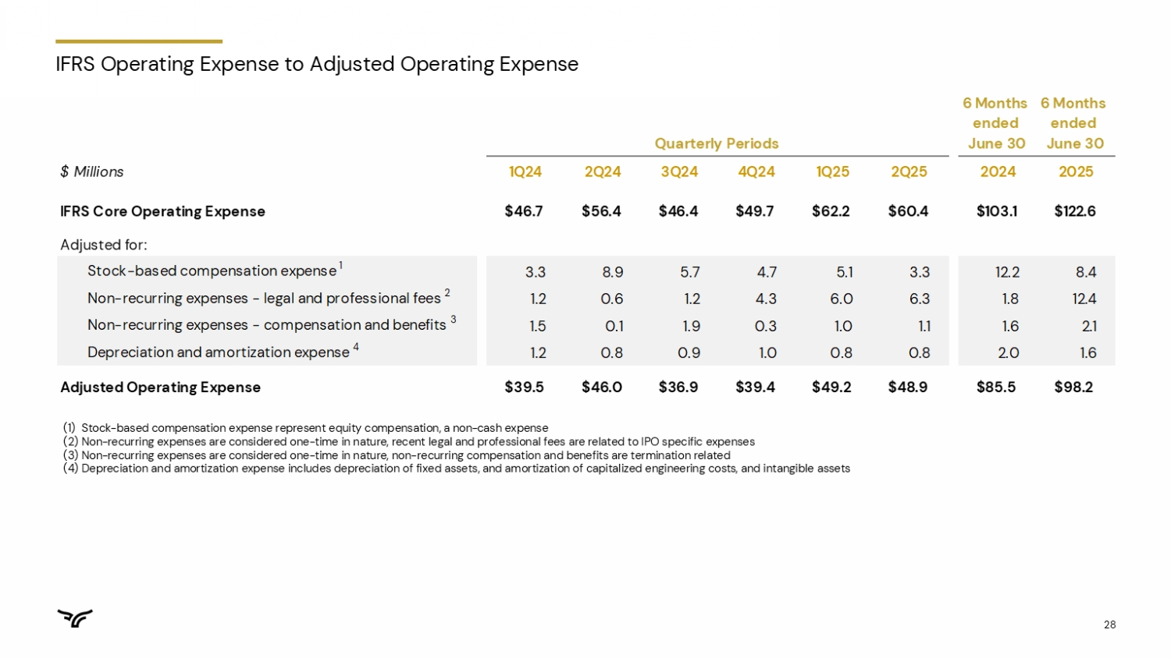
28 IFRS Operating Expense to Adjusted Operating Expense Quarterly Periods 6 Months ended June 30 6 Months ended June 30 $ Millions 1Q24 2Q24 3Q24 4Q24 1Q25 2Q25 2024 2025 IFRS Core Operating Expense $46.7 $56.4 $46.4 $49.7 $62.2 $60.4 $103.1 $122.6 Adjusted for: Stock-based compensation expense 1 3.3 8.9 5.7 4.7 5.1 3.3 12.2 8.4 Non-recurring expenses - legal and professional fees 2 1.2 0.6 1.2 4.3 6.0 6.3 1.8 12.4 Non-recurring expenses - compensation and benefits 3 1.5 0.1 1.9 0.3 1.0 1.1 1.6 2.1 Depreciation and amortization expense 4 1.2 0.8 0.9 1.0 0.8 0.8 2.0 1.6 Adjusted Operating Expense $39.5 $46.0 $36.9 $39.4 $49.2 $48.9 $85.5 $98.2 (1) Stock - based compensation expense represent equity compensation, a non - cash expense (2) Non - recurring expenses are considered one - time in nature, recent legal and professional fees are related to IPO specific expense s (3) Non - recurring expenses are considered one - time in nature, non - recurring compensation and benefits are termination related (4) Depreciation and amortization expense includes depreciation of fixed assets, and amortization of capitalized engineering cost s, and intangible assets

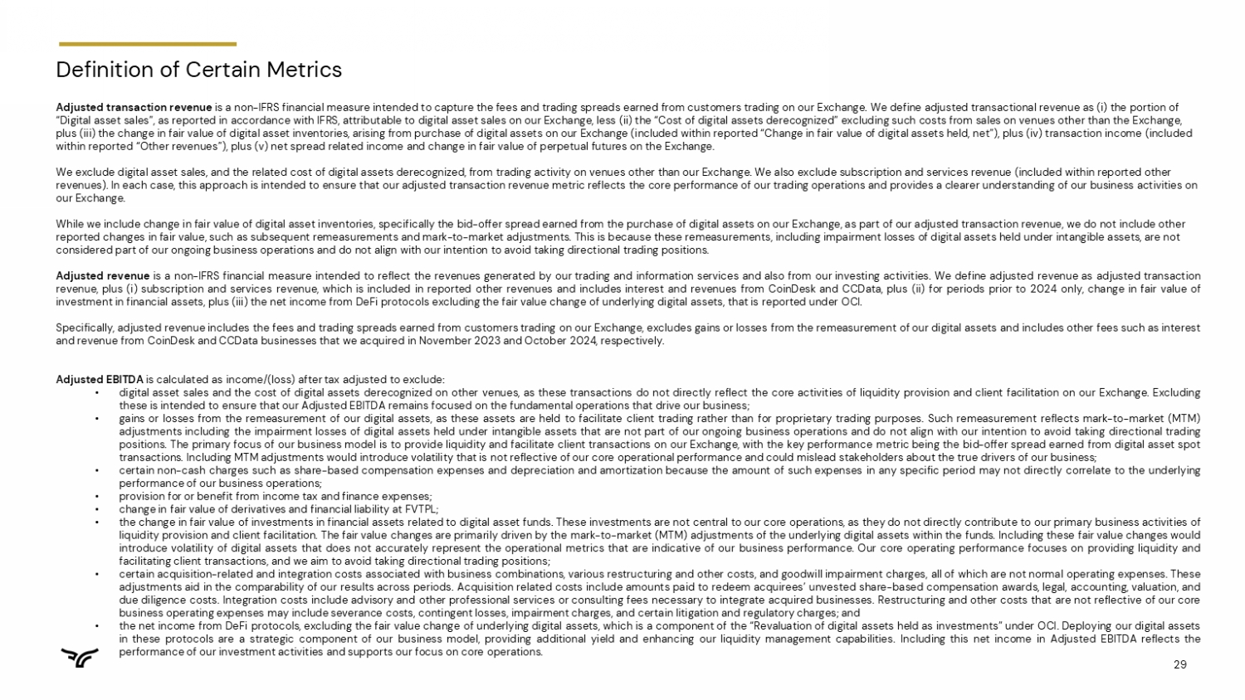
29 Definition of Certain Metrics Adjusted transaction revenue is a non - IFRS financial measure intended to capture the fees and trading spreads earned from customers trading on our Exchange. We define adjusted transactional revenue as ( i ) the portion of “Digital asset sales”, as reported in accordance with IFRS, attributable to digital asset sales on our Exchange, less (ii) th e “ Cost of digital assets derecognized” excluding such costs from sales on venues other than the Exchange, plus (iii) the change in fair value of digital asset inventories, arising from purchase of digital assets on our Exchange (in clu ded within reported “Change in fair value of digital assets held, net”), plus (iv) transaction income (included within reported “Other revenues”), plus (v) net spread related income and change in fair value of perpetual futures on the Ex cha nge. We exclude digital asset sales, and the related cost of digital assets derecognized, from trading activity on venues other th an our Exchange. We also exclude subscription and services revenue (included within reported other revenues). In each case, this approach is intended to ensure that our adjusted transaction revenue metric reflects the core p erf ormance of our trading operations and provides a clearer understanding of our business activities on our Exchange. While we include change in fair value of digital asset inventories, specifically the bid - offer spread earned from the purchase o f digital assets on our Exchange, as part of our adjusted transaction revenue, we do not include other reported changes in fair value, such as subsequent remeasurements and mark - to - market adjustments. This is because these remeasur ements, including impairment losses of digital assets held under intangible assets, are not considered part of our ongoing business operations and do not align with our intention to avoid taking directional trading po sit ions. Adjusted revenue is a non - IFRS financial measure intended to reflect the revenues generated by our trading and information services and also from our investing activities . We define adjusted revenue as adjusted transaction revenue, plus ( i ) subscription and services revenue, which is included in reported other revenues and includes interest and revenues from CoinDesk and CCData , plus (ii) for periods prior to 2024 only, change in fair value of investment in financial assets, plus (iii) the net income from DeFi protocols excluding the fair value change of underlying digital assets, that is reported under OCI . Specifically, adjusted revenue includes the fees and trading spreads earned from customers trading on our Exchange, excludes gains or losses from the remeasurement of our digital assets and includes other fees such as interest and revenue from CoinDesk and CCData businesses that we acquired in November 2023 and October 2024 , respectively . Adjusted EBITDA is calculated as income/(loss) after tax adjusted to exclude : • digital asset sales and the cost of digital assets derecognized on other venues, as these transactions do not directly reflect the core activities of liquidity provision and client facilitation on our Exchange . Excluding these is intended to ensure that our Adjusted EBITDA remains focused on the fundamental operations that drive our business ; • gains or losses from the remeasurement of our digital assets, as these assets are held to facilitate client trading rather than for proprietary trading purposes . Such remeasurement reflects mark - to - market (MTM) adjustments including the impairment losses of digital assets held under intangible assets that are not part of our ongoing business operations and do not align with our intention to avoid taking directional trading positions . The primary focus of our business model is to provide liquidity and facilitate client transactions on our Exchange, with the key performance metric being the bid - offer spread earned from digital asset spot transactions . Including MTM adjustments would introduce volatility that is not reflective of our core operational performance and could mislead stakeholders about the true drivers of our business ; • certain non - cash charges such as share - based compensation expenses and depreciation and amortization because the amount of such expenses in any specific period may not directly correlate to the underlying performance of our business operations ; • provision for or benefit from income tax and finance expenses ; • change in fair value of derivatives and financial liability at FVTPL ; • the change in fair value of investments in financial assets related to digital asset funds . These investments are not central to our core operations, as they do not directly contribute to our primary business activities of liquidity provision and client facilitation . The fair value changes are primarily driven by the mark - to - market (MTM) adjustments of the underlying digital assets within the funds . Including these fair value changes would introduce volatility of digital assets that does not accurately represent the operational metrics that are indicative of our business performance . Our core operating performance focuses on providing liquidity and facilitating client transactions, and we aim to avoid taking directional trading positions ; • certain acquisition - related and integration costs associated with business combinations, various restructuring and other costs, and goodwill impairment charges, all of which are not normal operating expenses . These adjustments aid in the comparability of our results across periods . Acquisition related costs include amounts paid to redeem acquirees’ unvested share - based compensation awards, legal, accounting, valuation, and due diligence costs . Integration costs include advisory and other professional services or consulting fees necessary to integrate acquired businesses . Restructuring and other costs that are not reflective of our core business operating expenses may include severance costs, contingent losses, impairment charges, and certain litigation and regulatory charges ; and • the net income from DeFi protocols, excluding the fair value change of underlying digital assets, which is a component of the “Revaluation of digital assets held as investments” under OCI . Deploying our digital assets in these protocols are a strategic component of our business model, providing additional yield and enhancing our liquidity management capabilities . Including this net income in Adjusted EBITDA reflects the performance of our investment activities and supports our focus on core operations .

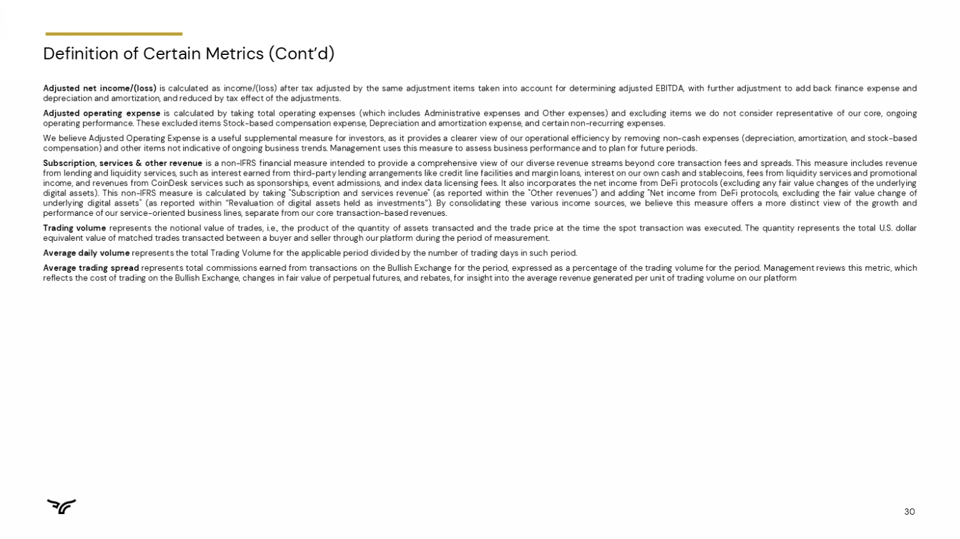
30 Adjusted net income/(loss) is calculated as income/(loss) after tax adjusted by the same adjustment items taken into account for determining adjusted EBITDA, with further adjustment to add back finance expense and depreciation and amortization, and reduced by tax effect of the adjustments . Adjusted operating expense is calculated by taking total operating expenses (which includes Administrative expenses and Other expenses) and excluding items we do not consider representative of our core, ongoing operating performance . These excluded items Stock - based compensation expense, Depreciation and amortization expense, and certain non - recurring expenses . We believe Adjusted Operating Expense is a useful supplemental measure for investors, as it provides a clearer view of our operational efficiency by removing non - cash expenses (depreciation, amortization, and stock - based compensation) and other items not indicative of ongoing business trends . Management uses this measure to assess business performance and to plan for future periods . Subscription, services & other revenue is a non - IFRS financial measure intended to provide a comprehensive view of our diverse revenue streams beyond core transaction fees and spreads . This measure includes revenue from lending and liquidity services, such as interest earned from third - party lending arrangements like credit line facilities and margin loans, interest on our own cash and stablecoins, fees from liquidity services and promotional income, and revenues from CoinDesk services such as sponsorships, event admissions, and index data licensing fees . It also incorporates the net income from DeFi protocols (excluding any fair value changes of the underlying digital assets) . This non - IFRS measure is calculated by taking "Subscription and services revenue" (as reported within the "Other revenues") and adding "Net income from DeFi protocols, excluding the fair value change of underlying digital assets" (as reported within “Revaluation of digital assets held as investments”) . By consolidating these various income sources, we believe this measure offers a more distinct view of the growth and performance of our service - oriented business lines, separate from our core transaction - based revenues . Trading volume represents the notional value of trades, i . e . , the product of the quantity of assets transacted and the trade price at the time the spot transaction was executed . The quantity represents the total U . S . dollar equivalent value of matched trades transacted between a buyer and seller through our platform during the period of measurement . Average daily volume represents the total Trading Volume for the applicable period divided by the number of trading days in such period . Average trading spread represents total commissions earned from transactions on the Bullish Exchange for the period, expressed as a percentage of the trading volume for the period . Management reviews this metric, which reflects the cost of trading on the Bullish Exchange, changes in fair value of perpetual futures, and rebates, for insight into the average revenue generated per unit of trading volume on our platform Definition of Certain Metrics (Cont’d)


31

